THE SHOOTARING CANYON MILL AND VELVET-WOOD AND SLICK ROCK URANIUM PROJECTS,

PRELIMINARY ECONOMIC ASSESSMENT

NATIONAL INSTRUMENT 43-101
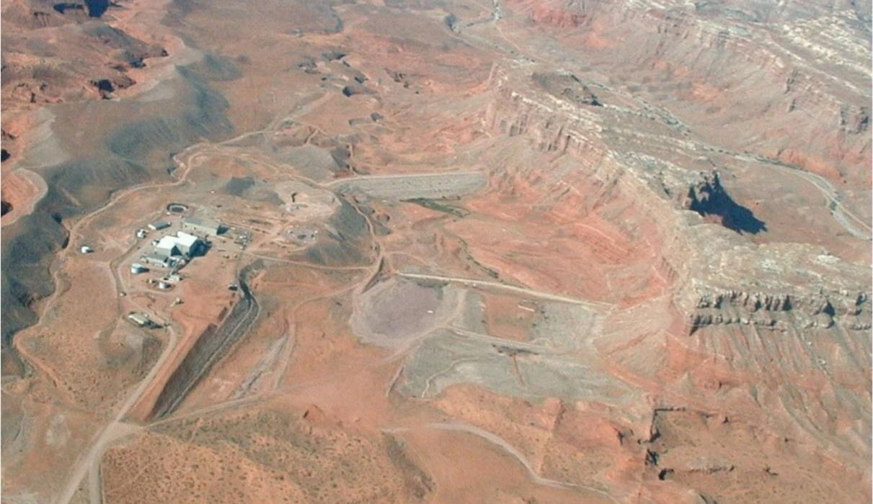

PREPARED FOR:
Anfield Energy Inc.

AUTHORED BY:
Douglas L. Beahm, P.E., P.G.
Principal Engineer, BRS Inc. -Principal Author
Harold H. Hutson, P.E., P.G.
Senior Engineer BRS Inc.- Coauthor
Carl D. Warren, P.E., P.G.
Project Engineer BRS Inc.- Coauthor
Terrence (Terry) McNulty, P.E., D. Sc.
T.P. McNulty and Associates, Inc. - Coauthor

Dated: May 6, 2023
Table of Contents
Section 1: Summary 8
1.1 Project Overview 8
1.1.1 Velvet-Wood Overview 8
1.1.2 Slick Rock Overview 8
1.1.3 Shootaring Canyon Mill Overview 2
1.2 Project Description and Ownership 3
1.2.1 Velvet-Wood Description and Ownership 3
1.2.2 Slick Rock Description and Ownership 3
1.2.3 Shootaring Canyon Mill Description and Ownership 4
1.3 Development Status 4
1.3.1 Velvet-Wood Development Status 4
1.3.2 Slick Rock Development Status 4
1.3.3 Shootaring Canyon Mill Development Status 4
1.4 History 5
1.4.1 Velvet-Wood History 5
1.4.2 Slick Rock History 5
1.4.3 Shootaring Canyon Mill History 5
1.5 Regulatory Status 6
1.6 Geology and Mineralization 6
1.6.1 Velvet-Wood Geology 6
1.6.2 Slick Rock Geology 7
1.7 Exploration and Drilling Status 7
1.7.1 Velvet-Wood Exploration and Drilling 7
1.7.2 Slick Rock Exploration and Drilling 7
1.8 Mineral Resource Summary 7
1.9 Preliminary Economic Assessment 8
1.10 Summary of Risks 11
1.11 Recommendations 12
1.12 Terms and Abbreviations 13
Section 2: Introduction 14
2.1 Purpose of Report and Authors 14
2.2 Extent of Authors’ Field Involvement 14
2.2.1 Velvet-Wood Site Visits 14
2.2.2 Slick Rock Site Visits 15
2.2.3 Shootaring Canyon Mill Site Visits 15
2.3 Sources of Information and Data 16
2.4 Report Terms of Reference 16
Section 3: Reliance on Other Experts 17
Section 4: Property Description 18
4.1 Property Description and Location 18
4.1.1 Velvet-Wood Property Description 18
4.1.2 Slick Rock Property Description 18
4.1.3 Shootaring Canyon Mill Property Description 19
4.2 Ownership and Mineral Tenure 21
4.2.1 Velvet-Wood Mineral Tenure 21
4.2.2 Slick Rock Mineral Tenure 21
4.2.3 Shootaring Canyon Mill Mineral Tenure 21
4.3 Permitting 22
4.3.1 Velvet-Wood Permitting 22
4.3.2 Slick Rock Permitting 22
4.3.3 Shootaring Canyon Mill Permitting 22
4.4 Environmental Liabilities 22
4.4.1 Velvet-Wood and Shootaring Canyon Mill Environmental Liabilities 22
4.4.2 Slick Rock Environmental Liabilities 23
4.5 State and Local Taxes and Royalties 23
4.5.1 Velvet-Wood and Shootaring Canyon Mill Taxes and Royalties 23
4.5.2 Slick Rock Taxes and Royalties 23
4.6 Encumbrances and Risks 23
Section 5: Accessibility, Climate, Local Resources, Infrastructure, and Physiography 24
5.1 Physiographic Features 24
5.1.1 Velvet-Wood Physiographic Features 24
5.1.2 Slick Rock Physiographic Features 24
5.2 Access 24
5.2.1 Velvet-Wood Access 24
5.2.2 Slick Rock Access 25
5.2.3 Shootaring Canyon Mill Access 26
5.3 Climate 26
5.3.1 Velvet-Wood Climate 26
5.3.2 Slick Rock Climate 27
5.3.3 Shootaring Canyon Mill Climate 28
5.4 Property Infrastructure 28
5.4.1 Velvet-Wood Infrastructure 28
5.4.2 Slick Rock Infrastructure 28
5.4.2 Shootaring Canyon Mill Infrastructure 29
5.5 Land Use 29
5.5.1 Velvet-Wood Land Use 29
5.5.2 Slick Rock Land Use 29
5.5.3 Shootaring Canyon Land Use 29
5.6 Flora and Fauna 29
5.7 Surface Rights and Local Resources 29
5.7.1 Velvet-Wood Surface Rights 29
5.7.2 Slick Rock Surface Rights 30
5.7.3 Shootaring Canyon Surface Rights 30
Section 6: History 31
6.1 Project History 31
6.1.1 Velvet-Wood Project History 31
6.1.2 Slick Rock Project History 31
6.1.3 Shootaring Canyon Mill Ownership History 33
6.2 Previous Mineral Resource Estimates 34
6.2.1 Velvet-Wood Historic Mineral Resource Estimates 34
6.2.2 Slick Rock Historic Mineral Resource Estimates 34
6.3 Past Production 34
6.3.1 Velvet-Wood Past Production 34
6.3.2 Slick Rock Past Production 34
Section 7: Geological Setting and Mineralization 35
7.1 Regional Geological Setting: The Colorado Plateau 35
7.2 Velvet-Wood Project Local Geology 38
7.2 Slick Rock Project Local Geology 41
Section 8: Deposit Types 46
8.1 Velvet-Wood Deposit Type 46
8.2 Slick Rock Deposit Type 47
Section 9: Exploration 51
Section 10: Drilling 52
10.1 Drill Summary 52
10.2.1 Velvet-Wood Drilling 52
10.2.2 Slick Rock 55
Section 11: Sample Preparation, Analyses, and Security 58
11.1 Velvet-Wood Sampling 58
11.2 Slick Rock Sampling 59
Section 12: Data Verification 60
12.1 Velvet-Wood Data Verification 60
12.2 Slick Rock Data Verification 61
12.3 Density 62
12.3.1 Velvet-Wood Density 62
12.3.2 Slick Rock Density 62
12.4 Downhole Deviation 62
12.5 Radiometric Equilibrium General Information 62
Section 13: Mineral Processing and Metallurgical Testing 64
13.1 Velvet-Wood Metallurgical Studies 64
13.2 Slick Rock Metallurgical Studies 66
13.3 Recommended Metallurgical Recoveries 66
Section 14: Mineral Resource Estimates 67
14.1 Mineral Resource Estimation 67
14.1.1 Definitions 67
14.1.2 General Methodology 68
14.3 Project GT Resource Modeling - Key Assumptions and Criteria 69
14.4 Reasonable Prospects for Economic Extraction and Cutoff Criteria 70
14.5 Measured Mineral Resources, New Velvet Mine 71
14.6 Indicated Mineral Resources, Old Velvet Mine 71
14.7 Indicated Mineral Resources, Wood Mine 73
14.8 Inferred Mineral Resources, Velvet-Wood 73
14.9 Inferred Mineral Resources, Slick Rock 74
14.10 Uranium Mineral Resource Summary 75
14.11 Vanadium Mineral Resource Summary 76
Section 15: Mineral Reserve Estimates 85
Section 16: Mining Methods 86
16.1 Mining Basis 86
16.2 Mining Methods 91
16.3 Pre-Production Mine Development 93
16.4 Mine Equipment 93
16.4.1 Operating Parameters 94
16.6 Mine Production Schedule 95
16.7 Mine Labor 97
16.8 Mine Support and Utilities 98
16.9 Mine Ventilation 98
Section 17: Recovery Methods 99
17.1 Summary 99
17.2 Shootaring Canyon Mill Partial Refurbishment 100
17.3 Vanadium Recovery Circuit 106
Section 18: Project Infrastructure 110
18.1 Existing Infrastructure 110
18.2 Access 110
18.3 Power and Utilities 110
18.4 Water 111
18.4 Surface Mine Facilities 111
18.5 Shootaring Canyon Mill Facilities 111
Section 19: Market Studies and Contracts 113
19.1 Uranium Price Forecast 113
19.2 Vanadium Price Forecast 114
Section 20: Environmental Studies, Permitting, and Social or Community Impact 115
20.1 Regulatory Status 116
20.2 Social and Community Impact 117
Section 21: Capital and Operating Costs 121
Section 22: Economic Analysis 125
22.1 Summary 125
22.2 Breakeven Commodity Price 125
22.3 Sensitivity Analysis 125
22.2 Sensitivity to Price 126
22.3 Sensitivity to Other Factors 127
22.4 Alternative CAPEX and Recovery 128
22.5 Cash Flow Model 128
Section 23: Adjacent Properties 130
Section 24: Other Relevant Data and Information 131
Section 25: Interpretations and Conclusions 132
25.1 Economic Analysis 132
25.2 Summary of Risks 133
Section 26: Recommendations 135
26.1 Phase 1 135
26.2 Phase 2 135
Section 27: References 137
Section 28: Signature Page and Certification of Qualified Person 140

Tables
Table 1.1 - Velvet-Wood & Slick Rock Uranium Mineral Resource Summary* 8
Table 1.2 - Velvet-Wood & Slick Rock Vanadium Mineral Resource Summary* 8
Table 1.5 - Terms and Abbreviations 13
Table 6.2 - Slick Rock District Total Production 34
Table 7.1 - Stratigraphy of Slick Rock District and Vicinity (Shawe, 1970) 36
Table 10.1 - Historic Drill Results Velvet Area* 53
Table 10.2 - Historic Drill Results Wood Area* 53
Table 10.3 - 2007/2008 Drill Results Velvet-Wood 53
Table 10.4 - Slick Rock Drill Hole Intercepts by Zone 55
Table 14.1 - Velvet-Wood & Slick Rock Uranium Mineral Resource Summary* 67
Table 14.2 - Velvet-Wood & Slick Rock Vanadium Mineral Resource Summary* 67
Table 14.3 - Modeling Assumption Parameters by GT Contour Model 69
Table 14.4 – New Velvet Measured Mineral Resources* 71
Table 14.5 – Old Velvet Mine Area III Indicated Mineral Resources* 72
Table 14.6 - Old Velvet Areas I, II, IV, and East Side Indicated Mineral Resources* 73
Table 14.7 - Total Indicated Mineral Resources Old Velvet Mine Area** 73
Table 14.8 - Total Indicated Mineral Resources Wood Mine 73
Table 14.9 - Total Inferred Mineral Resources Velvet-Wood Areas 74
Table 14.10 - Slick Rock Inferred Resource Sensitivity Analysis 75
Table 14.11 - Total Inferred Mineral Resources Slick Rock Area 75
Table 14.12 - Velvet-Wood & Slick Rock Uranium Mineral Resource Summary* 76
Table 14.13 - Velvet-Wood & Slick Rock Vanadium Mineral Resource Summary* 78
Table 16.1 - Mineral Resources Included in PEA 86
Table 16.2 - Velvet-Wood Existing Stockpiles 87
Table 16.3 - Options for Entry into the Wood Mine 92
Table 16.4 - Mining Equipment List 94
Table 16.5 - Summary of Equipment Cycle Times 95
Table 16.6 - Production Schedule (units x 1,000) 96
Table 16.7 - Labor Requirements 97
Table 16.8 - Surface Facilities 98
Table 20.1 - Summary of Regulatory Status for Required Permits and Licenses 118
Table 20.2 - Summary of Environmental Data and Studies 120
Table 21.1 - Capital Expenditure Summary 123
Table 21.2 - Operating Expenditure Summary 124
Table 21.3 - OPEX and CAPEX Summary 124
Table 22.1 - Base Case Economic Criterion ($ x 1,000) 125
Table 22.2 - Sensitivity to Commodity Price and Discount Rate 126
Table 22.3 - Sensitivity to Other Factors 127
Table 22.4 - Cash Flow 129
Table 26.1 - Slick Rock Phase 1: Verification Drilling Cost Estimate 135
Table 26.2 - Velvet-Wood Exploration Drilling Cost Estimate 136
Table 26.3 - Slick Rock Phase 2: Exploration Drilling Cost Estimate 136

Figures
Figure 1.1 - Overall Project Location Map 2
Figure 1.2 - Velvet-Wood and Slick Rock Location and Access Map 3
Figure 1.3 – NPV Price Pre-Tax Sensitivity Chart 10
Figure 1.4 – NPV Price Post-Tax Sensitivity Chart 10
Figure 4.1 - Velvet-Wood Ownership and Claim Map 18
Figure 4.2 - Slick Rock Ownership and Claim Map 19
Figure 4.3 - Shootaring Canyon Mill Ownership Map 20
Figure 5.3 - Velvet-Wood Access Map 25
Figure 5.4 - Slick Rock Access Map 26
Figure 5.1 - Velvet-Wood Climate Summary 27
Figure 5.2 - Slick Rock Climate Summary 27
Figure 5.3 - Shootaring Canyon Mill Climate Summary 28
Figure 6.1 - 2006-2008 Borehole Map 33
Figure 7.1 - Uravan Mineral Belt (adopted from Chenoweth, 1981) 37
Figure 7.2 - Velvet-Wood Project Local Geologic Map (from Doelling, 2004) 38
Figure 7.3 - Velvet-Wood Project Regional Cross Section (Doelling, 2004) 39
Figure 7.4a - Geologic Map of Slick Rock Project Area (from USGS/Carter 1955) 41
Figure 7.4b - Geologic Map of Slick Rock Project Area Legend (from USGS/Carter 1955) 42
Figure 7.5 - Slick Rock Structural Geology Map (from Williams, 1964) 44
Figure 8.1 - Velvet-Wood Project Stratigraphic Column (Chenowith, 1990) 47
Figure 8.2a - Uranium/Vanadium Deposits of the Slick Rock District, Colorado 49
Perspective Geologic Cross Section of Roll Ore Bodies (Shawe, 2011, paper 576-f) 49
Figure 8.2b - Uranium/Vanadium Deposits of the Slick Rock District, Colorado 49
Perspective Geologic Cross Section of Tabular Ore Bodies (Shawe, 2011, paper 576-f) 49
Figure 8.3 – Slick Rock Sample and Scintillometer 50
Figure 10.1 - Velvet-Wood Drill Hole Map 54
Figure 10.2 - Slick Rock Drill Hole Map 56
Figure 10.3 - Slick Rock Cross Sections 57
Figure 14.1 - Old Velvet Mine GT and Resource Map 79
Figure 14.2 - Wood Resource GT Map 80
Figure 14.3 – New Velvet GT Map 81
Figure 14.4 - Slick Rock Zone A GT Map 82
Figure 14.5 - Slick Rock Zone B GT Map 83
Figure 14.6 - Slick Rock Zone C GT Map 84
Figure 16.1 - Velvet-Wood Mine Surface Facilities Plan 88
Figure 16.2 - Isometric of Wood and Velvet Underground Mine Plan 89
Figure 16.3 - Slick Rock Conceptual Mine Layout 90
Figure 17.1 - Original Flowsheet for the Shootaring Canyon Uranium Circuit 105
Figure 17.2 - Vanadium Concentration Circuit, Page 1 of 2 107
Figure 17.3 - Vanadium Purification and Precipitation Circuit, Page 2 of 2 108
Figure 17.4 - Shootaring Canyon Property with Existing Facilities at Ticaboo, Utah 109
Figure 18.1 - Velvet-Wood Existing Infrastructure 112
Figure 19.1 - TradeTech Uranium Market Price Projections- FAM2 (Nominal US$) 113
Figure 22.1 – NPV Price Pre-Tax Sensitivity Chart 126
Figure 22.2 – NPV Price Post-Tax Sensitivity Chart 127

Section 1: Summary
This Technical Report was prepared for Anfield Energy Inc. (Anfield) by Douglas Beahm, P.E., P.G., of BRS Engineering (author) with contributions by Harold J. Hutson, P.E., P.G. and Carl D. Warren, P.E., P.G., of BRS Inc. and Terrence (Terry) McNulty, P.E., D. Sc., of T.P. McNulty and Associates Inc. to provide a Preliminary Economic Assessment (PEA) of the project based on the reactivation of the Shootaring Canyon mill with feed from the Velvet Wood and Slick Rock mines. The project is planned to recover two mineral products, uranium and vanadium oxides based on the Mineral Resource estimates for the project.
The effective date of this report is May 6, 2023. The effective date of the resource estimation and cost modeling is April 30, 2023.
The author and co-authors are independent “qualified persons” as defined by CIM's National Instrument 43-101 Standards of Disclosure for Mineral Projects (NI 43-101) and as described in Section 28 (Certificates and Signatures).
Mineral Reserves are not estimated herein. This is a restricted disclosure as allowed under section 2.3(3) of NI 43-101 which includes a Preliminary Economic Assessment (PEA) and is preliminary in nature such that it includes a portion of the inferred mineral resources as reported in Section 14 of the report. Mineral resources are not mineral reserves and do not have demonstrated economic viability in accordance with CIM standards. Inferred mineral resources are too speculative to have the economic considerations applied to them that would enable them to be categorized as mineral reserves, and there is no certainty that the outcomes estimated in the PEA will be realized.

1.1 Project Overview

1.1.1 Velvet-Wood Overview
The Velvet and Wood mine projects are located within the Lisbon Valley physiographic province in San Juan County, Utah, as shown in Figure 1.1 and 1.2. The Velvet Mine produced a reported 400,000 tons of ore containing some 4.2 million pounds of uranium (U₃O₈) and 4.8 million pounds of vanadium (V₂O₅) (Chenoweth, 1990).

1.1.2 Slick Rock Overview
The Slick Rock property is located in the southern end of the Uravan mineral belt of the Colorado Plateau physiographic province and at the southeastern edge of the Paradox fold and fault belt in the proximal Disappointment syncline as shown on Figures 1.1 and 1.2. The Slick Rock District is also a past producer with reported production of 2,236,723 pounds of uranium (U₃O₈) and 13,941,457 pounds of vanadium (V₂O₅) (Chenoweth, 1990)

1.1.3 Shootaring Canyon Mill Overview
For the purposes of this PEA, it is assumed that mineral processing will take place at Anfield’s mineral processing facility, the Shootaring Canyon Mill, which lies approximately 180 miles from the Velvet-Wood mine area and approximately 200 miles from the Slick Rock mine area, following existing roads as shown on Figure 1.1.
Figure 1.1 - Overall Project Location Map
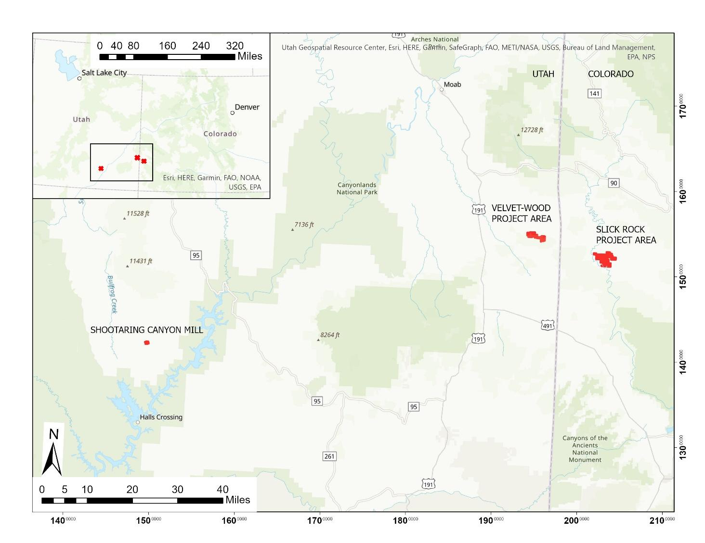
Figure 1.2 - Velvet-Wood and Slick Rock Location and Access Map
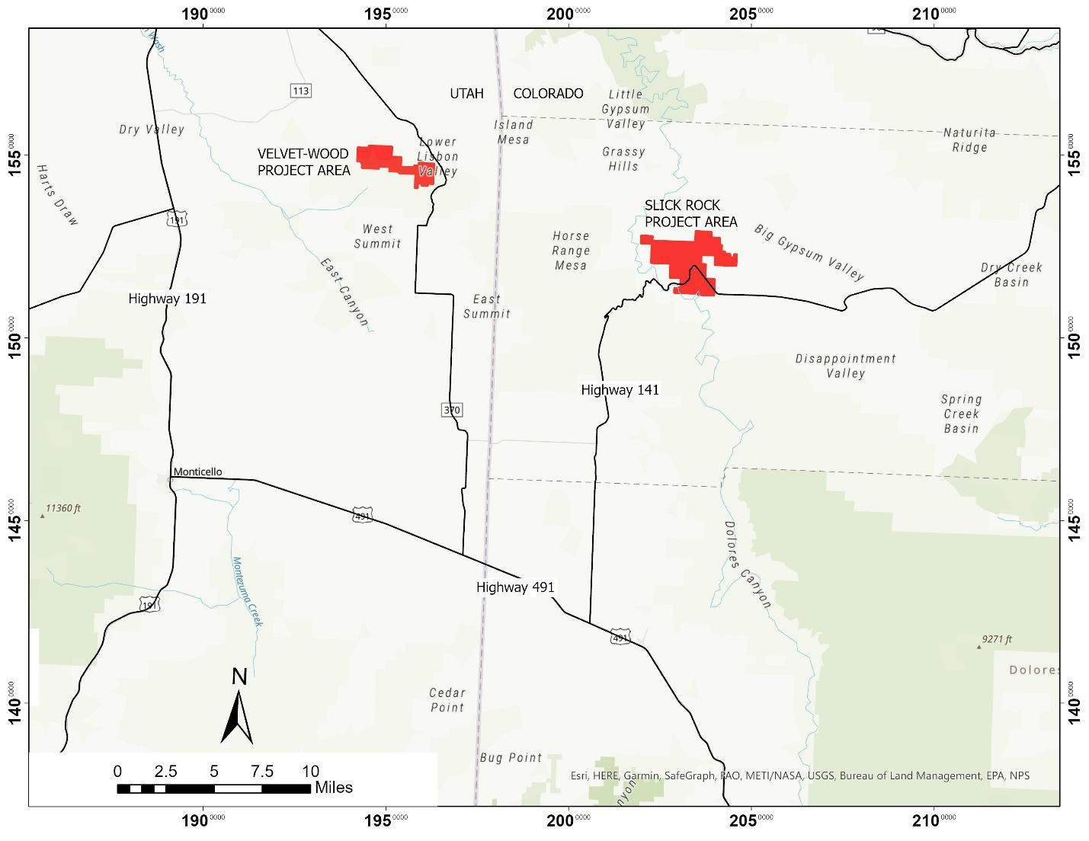

1.2 Project Description and Ownership

1.2.1 Velvet-Wood Description and Ownership
The Velvet area is located in San Juan County, Utah, approximately 31 miles from Monticello, Utah, in Township 31 South, Range 25 East, Sections 2, 3, 4 and 10, at Latitude 38º 07’ 00” North and Longitude 109º 09’ 00” West. The Wood area is located in Township 31 South, Range 26 East, Sections 6 and 7 and Township 31 South, Range 25 East, Sections 1, 11, and 12 at Latitude 38º 08’ 00” North and Longitude 109º 06’ 00” West. Project ownership includes unpatented mining claims and a State of Utah mineral lease as shown on Figure 4.1, totaling approximately 2,166 acres related to the Velvet and Wood mine areas as shown on Figure 4.1.

1.2.2 Slick Rock Description and Ownership
The Slick Rock project is located in San Miguel County, Southwest Colorado, approximately 23.9 miles north of the town of Dove Creek, Colorado and east of the Dolores River in the Slick Rock District of the Uravan mineral belt. The approximate geographic center of the property is Latitude 38° 2' 51.7" North, Longitude 108° 51' 42.3" West.
Anfield Energy Inc. entered into a definitive agreement to acquire Slick Rock Property from Uranium Energy Corp. in an asset swap transaction on April 21, 2022. The Slick Rock project is comprised of 268 mineral lode claims included in this report and encompasses an area of approximately 4,976 acres or 7.8 square miles as shown in Figure 4.2. Certain claims within the block are subject to 1% to 3% royalties of net uranium and vanadium production.

1.2.3 Shootaring Canyon Mill Description and Ownership
The Shootaring Canyon Mill is located in Garfield County Utah approximately 52 miles south of Hanksville, Utah in Township 36 South, Range 11 East, Sections 3 and 4 and Township 35 South, Range 11 East, Sections 33 and 34 at approximate Latitude 37º 43’ 00” North and Longitude 110º 41’ 00” West. The Shootaring Canyon Mill is located on lands which are split estate, with the surface estate being fee land held by Anfield, and the mineral estate being Utah State Trust Land held by Anfield through two mineral leases totaling approximately 905 acres of surface and mineral fee lands as shown on Figure 4.3.

1.3 Development Status

1.3.1 Velvet-Wood Development Status
A portion of the Velvet area has been mined by underground mine methods. The mined material from this area was transported to the Atlas mill in Moab, Utah for conventional processing. A mine permit is held for the Velvet Mine. Re-opening of the Velvet Mine would require updating of the mine permit as well as additional permits as subsequently discussed. Access from the former mine operations remain in place. The upper portion of the decline and portal has been closed by backfill and the vent shafts capped at the surface. It is the authors’ opinion that the decline and vents can be re-opened; however, underground conditions are unknown.
The Wood area has not been mined. Site access and drill roads which were not already pre-existing were established under this exploration permit.

1.3.2 Slick Rock Development Status
The Burro No. 3, 5, and 7 Mines were historically operated adjacent to the Slick Rock project and within the northwest corner of the Project Area. These mines were operated as underground random room and pillar mines through the early 1980s. No access agreement currently exists to access the Slick Rock project through the Burro Mines. This PEA is based on the sinking of new mine shafts to access the mineral resources at Slick Rock.

1.3.3 Shootaring Canyon Mill Development Status
The Shootaring Canyon Mill has a Radioactive Materials License (RML) that is administrated by the UDEQ- DWMRC. This license currently authorizes possession of byproduct material (tailings and other milling wastes) and reclamation activities only. A license amendment to return to operational status is needed as are capital improvements, as subsequently discussed in this report.

1.4 History

1.4.1 Velvet-Wood History
The Velvet-Wood mineral holdings have gone through a succession of ownership. Anfield purchased the Velvet-Wood mine along with other conventional uranium assets from Uranium One including the Velvet-Wood project in August 2015.
The Velvet-Wood Uranium Project, as discussed herein, consists of two areas which were historically held by separate companies. The Velvet area was held by Atlas Minerals who mined portions of the mineralization. The Wood area was held during a similar time frame by Uranerz. Uranerz drilled 120 rotary holes from 1985 through 1991 and outlined the current Wood mineral resource area (Chenoweth, 1990). The Wood area as described in this report was drilled but not mined.

1.4.2 Slick Rock History
Surficial to shallow uranium/vanadium mineralization has been known in the Slick Rock area since the early 1900s (then called the McIntyre district). First mined for radium and minor uranium until 1923, numerous companies sporadically operated small scale mining and processing facilities along the Dolores River. In 1931, a mill was constructed by Shattuck Chemical Co. to process vanadium ore. In 1944, the area was worked by the Union Mines Development Corp. for uranium/vanadium ore.
By December of 1955, Union Carbide Nuclear Corp. (UCNC) had drilled out a sufficient resource on the north side of Burro Canyon and began sinking three shafts. In December 1957, the shaft sinking was complete on the Burro No. 3, 5, and 7 mines to total depths of 408 feet, 414 feet, and 474 feet, respectively. In the same year, initial ore shipments were made to UCNC’s concentrating mill at Slick Rock.
Anfield Energy Inc. entered into a definitive agreement to acquire Slick Rock Property from Uranium Energy Corp. in an asset swap transaction on April 21, 2022. The Slick Rock project is comprised of 268 mineral lode claims and encompasses an area of approximately 4,976 acres or 7.8 square miles. Certain claims within the block are subject to 1% to 3% royalties of net uranium and vanadium production.

1.4.3 Shootaring Canyon Mill History
The Shootaring Canyon Mill was licensed and constructed by Plateau Resources and has had a succession of owners including US Energy and Uranium One prior to Anfield’s acquisition. The mill was constructed by Plateau Resources and operated briefly in 1982. The mill has not been decommissioned and has been under care and maintenance since cessation of operations.
Anfield purchased the Shootaring Canyon mill along with other conventional uranium assets from Uranium One including the Velvet-Wood project in August 2015.

1.5 Regulatory Status
Permitting for Velvet-Wood and Slick Rock mining operations and the reactivation of the Shootaring Canyon mill requires various approvals from the state of Utah, the US Bureau of Land Management, and other agencies including but not limited to the following.
Major actions needed include:
- Reactivation of the mill
  - The existing Source Material License, UT0900480, issued by UDEQ/DRC, requires an amendment to convert from the current care and maintenance status to operational status.
  - Current updates include an investigation by PSE which will provide both substantial designs for the rehabilitation of the mill and a basis for amending the mill license; and a reclamation design for the mill tailings by Engineering Analytics. These studies are scheduled to be completed by June and fall 2023, respectively.
  - The mill is being maintained along with all additional permits and licenses and required environmental monitoring programs.
- Velvet-Wood Mine
  - The existing Large Mine Permit, UTU68060, issued by DOGM and the Plan of Operations issued by BLM require an amendment to convert from current care and maintenance status of operational status and to include the Wood portion of the mine.
  - The existing ground water discharge permit, UGW170003, issued by UDEQ/WQD will require amendment. If uranium is recovered from the ground water this would require licensing action by UDEQ/DRC.
- Slick Rock Mine
  - A new Large Mine Permit and Plan of Operations is required to be issued by CMLRB and BLM, respectively.
  - If it were necessary to recover uranium onsite from ground water treatment in order to meet discharge permit requirements, a source materials license from CDPHE would be required.
- Permits common to all operations.
  - Air quality permits.
  - Water quality permits, storm water discharge (construction and operations).
  - Monitor well permits.
  - Water rights for consumptive use.
  - Federal Mine Safety for mine and mill under the Mine Safety and Health Administration (MSHA).

1.6 Geology and Mineralization

1.6.1 Velvet-Wood Geology
The Velvet-Wood project is located in the Lisbon Valley uranium district which was the largest uranium producing district in Utah. The Lisbon Valley or Big Indian Wash District produced 5 times as much uranium as any other district in Utah from the period of 1948 through 1988 totaling some 77,913,378 pounds U₃0₈ at an average grade of 0.30 % U₃0₈ (Chenoweth, 1990). Uranium mineralization in the Velvet and Wood areas is found in sandstone units within the Cutler Formation. The sandstones are fluvial arkose that has been bleached. The mineral deposits are irregular tabular bodies (Denis, 1982) located at the base, at the top, or close to pinch-outs of the sandstone bodies (Campbell and Mallory, 1979). The major producing zone in the Cutler occurs near the unconformity between the Cutler and the overlying Chinle Formation.

1.6.2 Slick Rock Geology
Uranium/vanadium mineralization is hosted by the Upper Jurassic Morrison Formation and is typical of Colorado Plateau-style uranium/vanadium deposits. Past production came from the upper or third-rim sandstone of the Salt Wash member of the Morrison Formation. This is the target host for uranium/vanadium mineralization within Anfield’s Slick Rock project area.
Uranium and vanadium-bearing minerals occur as fine-grained coatings in detrital grains filling pore spaces between the sand grains and replacing carbonaceous material and some detrital grains (Weeks et al., 1956). The primary uranium minerals are uraninite (UO₂) with minor amounts of coffinite (USiO₄OH). Montroseite (VOOH) is the primary vanadium mineral, along with vanadium clays and hydromica. Metal sulfides occur in trace amounts. Mineralization occurs within tabular to lenticular bodies that are peneconcordant within sedimentary bedding. Mineralization may also cut across sedimentary bedding to form irregular shapes.

1.7 Exploration and Drilling Status

1.7.1 Velvet-Wood Exploration and Drilling
Drill data is available for a total of 325 drill holes. Of this total 268 drill holes are of a historic nature and 57 were completed by Uranium One in the 2007/2008 time period. Relevant data including geophysical and lithological logs are available for both recent and historic drilling. 46% of the drill holes encountered uranium mineralization in excess of the recommended cutoff criteria, an additional 41% showed low grade to trace mineralization, and the remaining drill holes were barren and/or not completed to the host horizon.

1.7.2 Slick Rock Exploration and Drilling
A total of 312 drill holes are available for the Slick Rock Project Area. All of the drill holes are considered historic. Of this total, 27 holes have location data but no additional data associated with them. These 27 holes were excluded from the resource modeling. The remaining 285 holes contain 346 unique intercepts.

1.8 Mineral Resource Summary
This report summarizes mineral resource for the Velvet-Wood and Slick Rock mines with mineral processing at common facility, the Shootaring Canyon mill. A detailed description of the mineral resource estimation methodology and results is provided in Section 14. Mineral resources have been estimated for both uranium and vanadium as the mineralization occurs primarily as uranyl-vanadates, and the refurbishment of the Shootaring Canyon mill will include a vanadium circuit to recover the vanadium as a co-product with the uranium.
The total estimated uranium mineral resources are summarized in Table 1.1. The associated vanadium mineral resource which will be mined as a co-product is summarized in Table 14.2.
Table 1.1 - Velvet-Wood & Slick Rock Uranium Mineral Resource Summary*
Area/Classification | GT Cutoff | Pounds eU₃O₈ | Tons | Average Grade %eU₃O₈
TOTAL MEASURED AND INDICATED MINERAL RESOURCE URANIUM | 0.25 – 0.50 | 4,627,000 | 811,000 | 0.29
TOTAL INFERRED  MINERAL RESOURCE URANIUM | 0.25 – 0.40 | 8,410,000 | 1,836,000 | 0.24
*Numbers rounded
Table 1.2 - Velvet-Wood & Slick Rock Vanadium Mineral Resource Summary*
Area/Classification | GT cutoff  (Based on Uranium) | V:U  Ratio | Pounds V₂O₅ | Tons | Avg Grade %V₂O₅
TOTAL INFERRED  MINERAL RESOURCE VANADIUM | 0.25-0.50 | 4.2 | 54,399,000 | 2,647,000 | 1.03
*Numbers rounded
While mineral resources are not mineral reserves and do not have demonstrated economic viability, reasonable prospects for future economic extraction were applied to the mineral resource estimates herein through consideration of grade and GT cutoffs as well as mineralization proximity to existing and proposed conceptual mining. As such, economic considerations were exercised by screening out areas which were below these cutoffs or of isolated mineralization and thus would not support the cost of conventional mining under current and reasonably foreseeable conditions.

1.9 Preliminary Economic Assessment
Project cost estimates are based on a conventional random room and pillar underground mine operation at the Velvet-Wood and Slick Rock mine areas. Mined material would be hauled by truck to the Shootaring Canyon Mill approximately 180 miles from Velvet-Wood and 200 miles from Slick Rock. The mill would be fully refurbished and would process mined material for both uranium and vanadium recovery.
All costs are estimated in constant 2022 US Dollars. Operating (OPEX) and Capital (CAPEX) costs reflect a full and complete operating cost going forward including all pre-production costs, permitting costs, mine costs, and complete reclamation and closure costs for of the mine and mineral processing facility. CAPEX does not include sunk costs or acquisition costs.
Commodity prices used in this PEA are discussed in Section 19 and are $70 per pound for uranium oxide and $12 per pound for vanadium pentoxide.
A current investigation and design study for the reactivation of the Shootaring Canyon Mill has been commissioned by Anfield who has engaged the firm of Precision Systems Engineering (PSE) of Salt Lake City, Utah for this study. The PSE study will provide substantial designs for the rehabilitation of the mill, will provide a basis updating the mill license, and will consider options for increasing the mill throughput. The initial study is scheduled to be completed by June 2023, while a report outlining advanced engineering and design is expected to be completed in fall 2023.
Mine design and permitting for the Velvet Wood and Slick Rock mines are also ongoing. It is recommended that this PEA be revised following completion of this investigation and study.
Mining and mineral recovery methods are described in Sections 16 and 17, respectively. Capital and operating costs, CAPEX and OPEX, are discussed in Section 21.
- Total initial CAPEX, not including current and sunk costs, is estimated at $122.3 million USD (refer to table 21.1).
- Total weighted average OPEX is estimated at $244 USD per ton mined and processed (refer to Table 21.3).
- The total cost per ton to produce saleable uranium and vanadium products is estimated at $290 USD per ton. This compares to an estimated gross value of $741 USD per ton (refer to Table 21.3).
For the purposes of this PEA, it was assumed that the Shootaring Canyon Mill would be refurbished to its original 750 tons per day capacity and a vanadium recovery circuit would be added. The PEA considers simultaneous mine feed from the Velvet-Wood decline and two production shafts at Slick Rock. Given the selective nature of the mining and the geometry of the mineralization, three production centers are needed to meet the mill tonnage capacity. Referring to the cash flow model Table 22.4 at the end of this section, the currently defined mineral resource at Velvet-Wood would be mined out in 8 years while production from the two shafts at Slick Rock would continue for 15 years. Thus, additional mill tonnage capacity would be available beginning in year 9. Additional mill feed could be sourced as captive feed from other Anfield mineral resource holdings in the Colorado Plateau or from mineral resource holdings of others under toll milling agreements.
The base case is based on commodity prices of $70 per pound for uranium oxide and $12 per pound for vanadium pentoxide with respective mill recoveries of 92% and 75%, respectively. The base case economic evaluation shows:
- Pre-tax IRR 40%
- Post-tax IRR 33%
- Pre-Tax NPV (8% discount rate) $238,398 $US x 1,000
- Post-Tax NPV (8% discount rate) $196,768 $US x 1,000

Breakeven with respect to commodity price occurs when the base case commodity prices are reduced by 40% to $42/lb and $7.20/lb, respectively.
This project, like all similar projects, is quite sensitive to commodity prices as shown in Figures 1.31 and 1.4 for pre and post income tax NPV, respectively.

Figure 1.3 – NPV Price Pre-Tax Sensitivity Chart
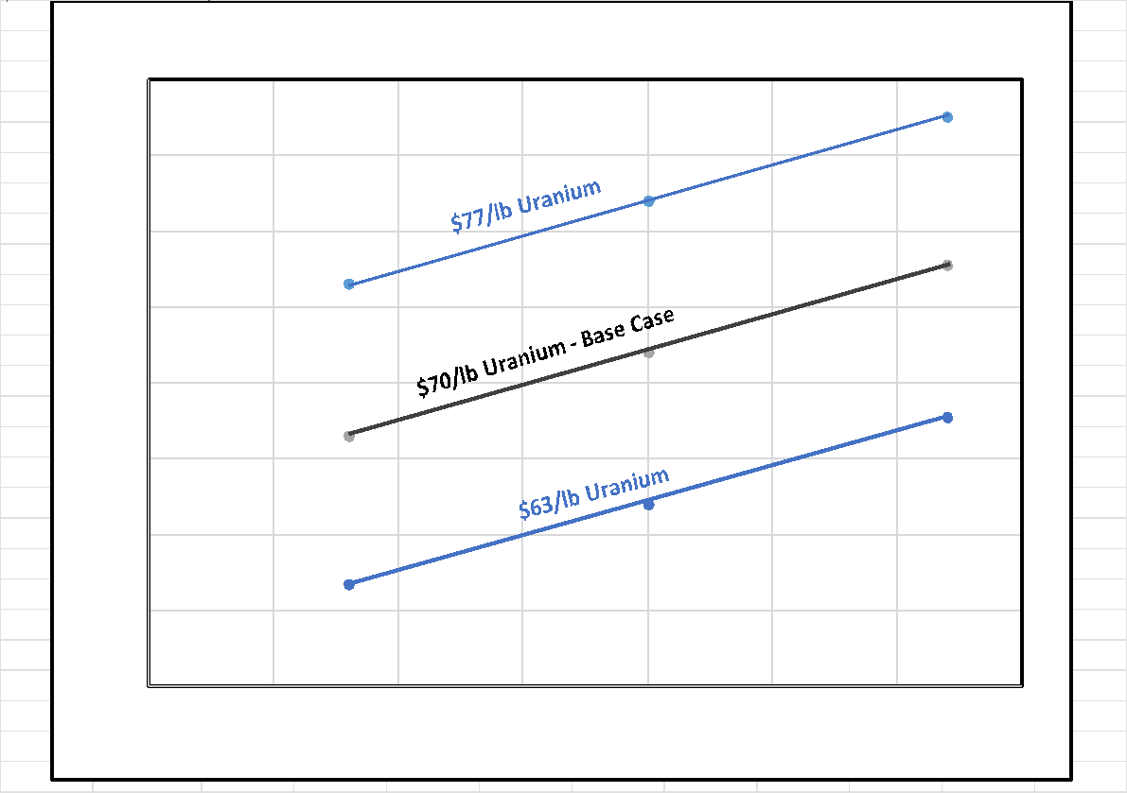
Figure 1.4 – NPV Price Post-Tax Sensitivity Chart
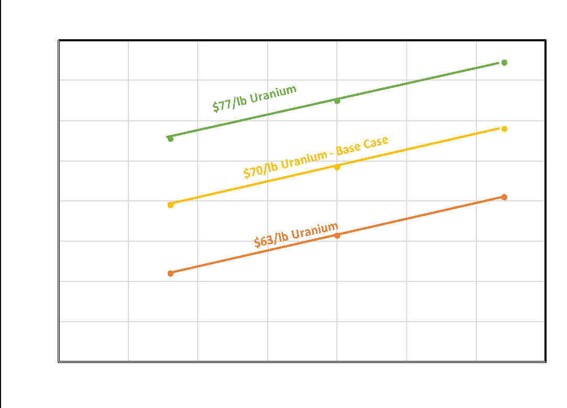

This is a restricted disclosure as allowed under section 2.3(3) of NI 43-101 which includes a Preliminary Economic Assessment (PEA) and is preliminary in nature such that it includes a portion of the inferred mineral resources as reported in Section 14 of the report. Mineral resources are not mineral reserves and do not have demonstrated economic viability in accordance with CIM standards. Inferred mineral resources are too speculative to have the economic considerations applied to them that would enable them to be categorized as mineral reserves, and there is no certainty that the outcomes estimated in the PEA will be realized.

1.10 Summary of Risks
The authors are not aware of environmental, permitting, legal, title, taxation, socio-economic, marketing, political, or other relevant factors not stated herein which would materially affect the mineral resource estimates or the results of the PEA. To the authors’ knowledge there are no other significant factors that may affect access, title, or the right or ability to perform work on the property, provided the conditions of all mineral leases and options and relevant operating permits and licenses are met. A summary of risks follows, categorized in terms of economic, technical, and permitting and licensing risks.
Economic Risks:
This report includes disclosure permitted under Section 2.3(3) of NI 43-101 as the Preliminary Economic Assessment (PEA) includes a portion of the inferred mineral resources reported in Section 14 of the report. Mineral resources are not mineral reserves and do not have demonstrated economic viability. A Preliminary Feasibility Study (PFS) is required, at a minimum, to demonstrate the economic viability of the measured and indicated mineral resources and qualify an initial estimate of mineral reserves.
The PEA is preliminary in nature and includes inferred mineral resources that are considered too speculative geologically to have economic considerations applied to them that would enable them to be categorized as mineral reserves, and there is no certainty that the preliminary economic assessment will be realized.
Technical Risks:
It is the authors’ opinion that the technical risks associated are low for the following reasons:
- Portions of deposit have been successfully mined in the past.
- Uranium has been successfully extracted from mined material via conventional milling.
- The Project has some of the required operating permits and facilities in place.
The Project does have some risks similar in nature to other mining projects in general and uranium mining projects specially, i.e., risks common to mining projects including:
- Future commodity demand and pricing.
- Environmental and political acceptance of the project.
- Variance in capital and operating costs.
- Mine and mineral processing recovery and dilution.
- Continuity of mineralization with respect to thickness and grade may vary.
- Mining claims are subject to the Mining Law of 1872. Changes in the mining law could affect the mineral tenure.
- There is a risk that underground conditions at the Velvet Mine and/or the Slick Rock Mine may limit access to mineral resources.
The authors are not aware of environmental, permitting, legal, title, taxation, socio-economic, marketing, political, or other relevant factors which would materially affect the mineral resource estimates, provided the conditions of all mineral leases and options, and relevant operating permits and licenses are met.
Permitting and Licensing Risks:
- The BLM could require updated baseline environmental studies and initiate the National Environmental Policy Act (NEPA) process if the updated mine plan deviates significantly from the scope of the currently approved but outdated plan. This could have substantial cost and schedule impacts, as discussed in Section 20.
- The Colorado Department of Health and/or Utah Department of Environmental Quality - Division of Waste Management and Radiation Control could require a Source Materials License if mine dewatering treatment wastes exceed the minimum quantities identified in 10 CFR §40.22 (more than 150 lbs of material with greater than 0.05% natural uranium), which would incur risks of additional costs and extended schedule.

1.11 Recommendations
The following recommendations relate to potential improvement and/or advancement of the Project and fall within two categories; recommendations to potentially enhance the resource base and recommendations to advance the Project towards development. Both may be conducted contemporaneously.
The Slick Rock project will require a Phase 1 verification drilling program to confirm the existing database and upgrade the resource category. This would be followed by Phase 2 of work, including delineation drilling, updating resource model, and preparation of a PEA update or PFS. The Velvet mine does not require an initial phase of verification and would be included along with Slick Rock in Phase 2.
Phase 1 costs total $550,000 USD and are summarized on Table 26.1.
The Phase 2 recommendations and cost estimates for the Velvet-Wood Project are provided in Table 26.2. The Phase 2 recommendations and cost estimates for the Slick Rock Project are provided for future reference in Table 26.3.
Total Phase 2 cost is estimated at $4.5 million USD.

1.12 Terms and Abbreviations
Table 1.5 provides a brief list of terms and abbreviations used in this report:
Table 1.5 - Terms and Abbreviations
 | GENERAL TERMS AND ABBREVATIONS
 | METRIC US |  |  |  | Metric: US
 | Term | Abbreviation | Term | Abbreviation | Conversion
Area | Square Meters | M² | Square Feet | Ft² | 10.76
 | hectare | Ha | Acre | Ac | 2.47
Volume | Cubic Meters | m³ | Cubic Yards | Cy | 1.308
Length | Meter | m | Feet | Ft | 3.28
 | Meter | m | Yard | Yd | 1.09
Distance | Kilometer | km | Mile | mile | 0.6214
Weight | Kilogram | Kg | Pound | Lb | 2.20
 | Metric Ton | km³ | Short Ton | Ton | 1.10
Currency |  |  | US Dollars | $US
 | URANIUM / VANADIUM SPECIFC TERMS AND ABREVATIONS
Uranium Oxide Grade | Parts Per Million | ppm U₃O₈ | Weight Percent | %U₃O₈
Vanadium Oxide Grade | Parts Per Million | Ppm V₂O₅ | Weight Percent | %V₂O₅
Radiometric Equivalent Grade |  | ppm eU₃O₈ |  | % eU₃O₈
Thickness | meters | m | Feet | Ft
Grade Thickness Product | grade x meters | GT(m) | grade x feet | GT(Ft)

Section 2: Introduction

2.1 Purpose of Report and Authors
This Technical Report was prepared for Anfield Energy Inc. (Anfield) by Douglas Beahm, P.E., P.G., of BRS Engineering (author) with contributions by Harold J. Hutson, P.E., P.G. and Carl D. Warren, P.E., P.G., of BRS Inc. and Terrence (Terry) McNulty, P.E., D. Sc., of T.P. McNulty and Associates Inc. to provide a Preliminary Economic Assessment (PEA) of the project based on the Mineral Resource estimates for the project.
The portions of the report completed by BRS were written under the direction of Douglas Beahm, P.E., P.G. The author and co-authors are independent “qualified persons” as defined by CIM's National Instrument 43-101 Standards of Disclosure for Mineral Projects (NI 43-101) and as described in Section 28 (Certificates and Signatures).

2.2 Extent of Authors’ Field Involvement

2.2.1 Velvet-Wood Site Visits
Mr. Beahm attempted to visit the Velvet-Wood site on February 14, 2023, however, the site was inaccessible due to winter conditions. Previously Mr. Beahm visited the project and Uranium One’s Moab office, which at the time was the repository of the project data, on September 16, 2014. During this time Mr. Beahm inspected drill sites from the latest period of drilling completed by Uranium One (2007 and 2008) and obtained copies of this and previous data including copies of geophysical logs, location maps, and database summaries. Mr. Beahm was also present on site on numerous occasions during 2007 and 2008 and participated in the verification drilling and coring programs.
Mr. Warren and Mr. Hutson inspected the Velvet-Wood mine area on April 13, 2023. The access road to the closed portal and reclaimed waste pile area was utilized to access the portal location. The waste dump was observed to be reclaimed with vegetative cover on the top. No elevated gamma readings were observed at any location on the Velvet or Wood properties due to the depth to the mineralized zone.
The powerlines to the site have been recently removed and the right of ways remain cleared. The upper closed fan shaft with water sampling access and the upper well were accessible from drill access leaving the county road. All of the wells were locked.
The water treatment site was inspected. The site has been reclaimed and revegetated. Diversion ditches around the site remain but require maintenance.
Multiple historic drill access routes exist on site where the pinon and juniper trees have been removed. Historic drill pad locations were observed at the Velvet area but no open holes were located. Historic drill pad locations and an open drill hole were observed on Three Step Hill above the Wood deposit area.

2.2.2 Slick Rock Site Visits
Mr. Beahm conducted a recent site visit on February 14, 2023. Mr. Beahm previously completed a site visit on April 2, 2013. At the time he was able to access the Burro mine workings which were above the ground water table. In addition to observing the decline, approximately 1,500 feet of mine workings were examined. In addition, Mr. Beahm inspected evidence of previous drilling, the existing vent shaft on the Slick Rock property, and examined potential sites for mine entry. Based on his recent site visit, the only significant change was related to reclamation of the DOE legacy site and mine waste pile associated with the Burro mine. None of these changes materially affect the Slick Rock property.
Mr. Warren and Mr. Hutson visited the Slick Rock Site on April 12, 2023 and met with the Burro Mine’s owner, Don Coram, who provided access to the Burro Mine. The Burro Mine is adjacent to the Slick Rock project in the same mineralized horizon, and was historically used for access to the Slick Rock mineralized zone as discussed in Section 6. Mr. Warren and Mr. Hutson entered the Burro mine through a grated entry gate. The adit was 8 feet in height by 9 to 10 feet wide, and the ground conditions were good. The mineralized zone was measured at the first crosscut within 200 feet of the portal, in the rib near the floor at approximately 3,000 microRem per hour. The mineralized material was tested with a portable XRF unit, which measured 1.02% U and 4.52% V. The use of the Burro Mine to access Anfield’s resources was discussed and was of interest to Mr. Coram.
Mr. Warren and Mr. Hutson then inspected the top of the mesa above the Slick Rock mineralized area. Claim posts and historic drill pads were observed. Core was found lying on the surface at most of the historic drill pads but was in disarray. No mineralized core was observed. Shallow mud pits were partially filled by erosion at each historic drill pad location. An overhead powerline and a gas line passed through the site as shown on Figure 16.3.

2.2.3 Shootaring Canyon Mill Site Visits
Mr. Beahm recently visited the Shootaring Canyon mill on February 16, 2023. During this time Mr. Beahm observed that the mill stockpiles remained in place, the tailings impoundment was intact, the general condition of the mill was similar to its condition in during Mr. Beahm’s previous visits in 2007 and 2008, and the mill, office and general facility was well kept and maintained.
Dr. McNulty did not conduct a recent site visit to the mill but was present at the site on numerous occasions during the period of 2007 and 2008 when the evaluation of the mill was being conducted by Lyntek and the report entitled “Definitive Cost Estimate for the Restart of Shootaring Canyon Mill Ticaboo, Utah” was completed on March 28, 2008, by Lyntek, Inc. (Lyntek, 2008). Dr. McNulty contributed to this report and provided peer review of the report.

2.3 Sources of Information and Data
In preparing the Technical Report, the authors relied on geological reports, maps, and miscellaneous technical papers listed in Section 27, References. The information, conclusions, opinions, and estimates contained herein are based on:
- The qualified person’s field observations.
- Data, reports, and other information publicly available or provided by Anfield.
- Previous experience with similar deposits.
- Drill hole data as discussed in Section 12.

2.4 Report Terms of Reference
All measurement units used in the report are imperial units, and currency is expressed in U.S. dollars (US$) unless stated otherwise.
Reported mineral resources are in situ.

Section 3: Reliance on Other Experts
The location, extent, and terms relating to mineral tenure were provided by Anfield and were relied upon as defining the mineral holdings of Anfield in the development of this report.
For the purpose of Sections 4, Property Description and Location, Mineral Tenure, and Ownership of this report, the authors have relied on ownership data (mineral, surface, and access rights) provided by Anfield. The accuracy of the information was not verified by the authors. The authors have not researched the property title or mineral rights for the project and express no legal opinion as to the ownership status of the property. However, Anfield provided copies of the mineral claim lease and purchase agreement which were reviewed for content by the authors. All mining claims whether leased, purchased, or located by Anfield were verified as to their validity by searching the BLM online LR2000 web site. BLM lists the mining claims as current.
The terms of the Asset Purchase Agreement with Uranium One were provided by Anfield and were relied upon in the development of this report.
The authors have fully relied upon the Frasier Institute Annual Survey of Mining Companies 2021 for the assessment of public policies that affect mining investment.
Section 20 of the report in its entirety and the portions of Section 1, 4, 25, and 26 related to permitting requirements, bonding, and related conclusions and recommendations were provided by Mr. Toby Wright, Wright Environmental under a third-party contract with Anfield. The authors have worked with Mr. Wright on several other uranium projects and consider the information provided for this report to be reliable.
The authors have reviewed the information provided by Anfield with respect to mineral tenure, the Asset Purchase Agreement, and status of environmental permits to the extent available through the public record and finds the information provided by Anfield to be in keeping with industry standards as appropriate for inclusion in the PEA.

Section 4: Property Description

4.1 Property Description and Location

4.1.1 Velvet-Wood Property Description
The Velvet area is located in San Juan County, Utah, approximately 31 miles from Monticello, Utah in Township 31 South, Range 25 East, Sections 2, 3, 4 and 10, at Latitude 38º 07’ 00” North and Longitude 109º 09’ 00” West. The Wood area is located in Township 31 South, Range 26 East, Sections 6 and 7 and Township 31 South, Range 25 East, Sections 1, 11, and 12 at Latitude 38º 08’ 00” North and Longitude 109º 06’ 00” West.
In total the mineral holdings within the Project area comprise approximately 2,140 acres. (See Figure 4.1, Overall Project Location Map).
Figure 4.1 - Velvet-Wood Ownership and Claim Map
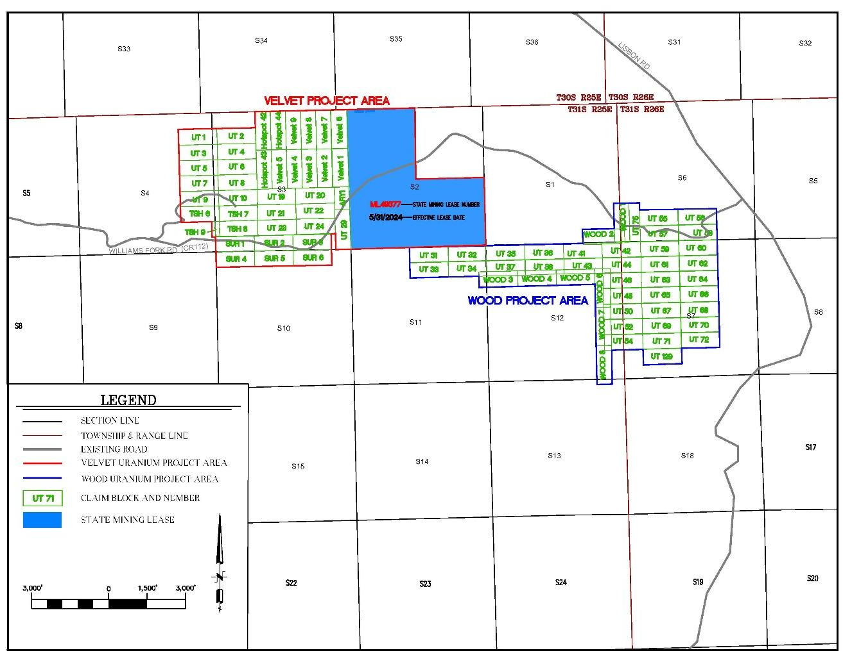

4.1.2 Slick Rock Property Description
The Slick Rock project is located in San Miguel County, Southwest Colorado, approximately 24 miles north of the town of Dove Creek and east of the Dolores River in the Slick Rock District of the Uravan mineral belt. The Slick Rock project is located in Township 44 North, Range 18 West, Sections 15, 16, 19, 20, 21, 22, 23, 24, 25, 26, 27, 28, 29, 30, 32, 33, and 34 and in Township 43 North, Range 18 West, Sections 3, 4, and 5. The approximate geographic center of the property is Latitude 38° 2' 51.7" North, Longitude 108° 51' 42.3" West. In total the mineral holdings within the Project area comprise approximately 4,976 acres as shown on Figure 4.2.
The Slick Rock project is bordered to the west by Department of Energy (DOE) uranium lease tracts C-SR-13 and C-SR-13A; to the southwest by DOE uranium lease tract C-SR-14; and to the north and northeast by Energy Fuels’ recently acquired Sunday-Carnation-Topaz-St. Jude mine complex, formerly operated by Denison Mines Corp.
Figure 4.2 - Slick Rock Ownership and Claim Map
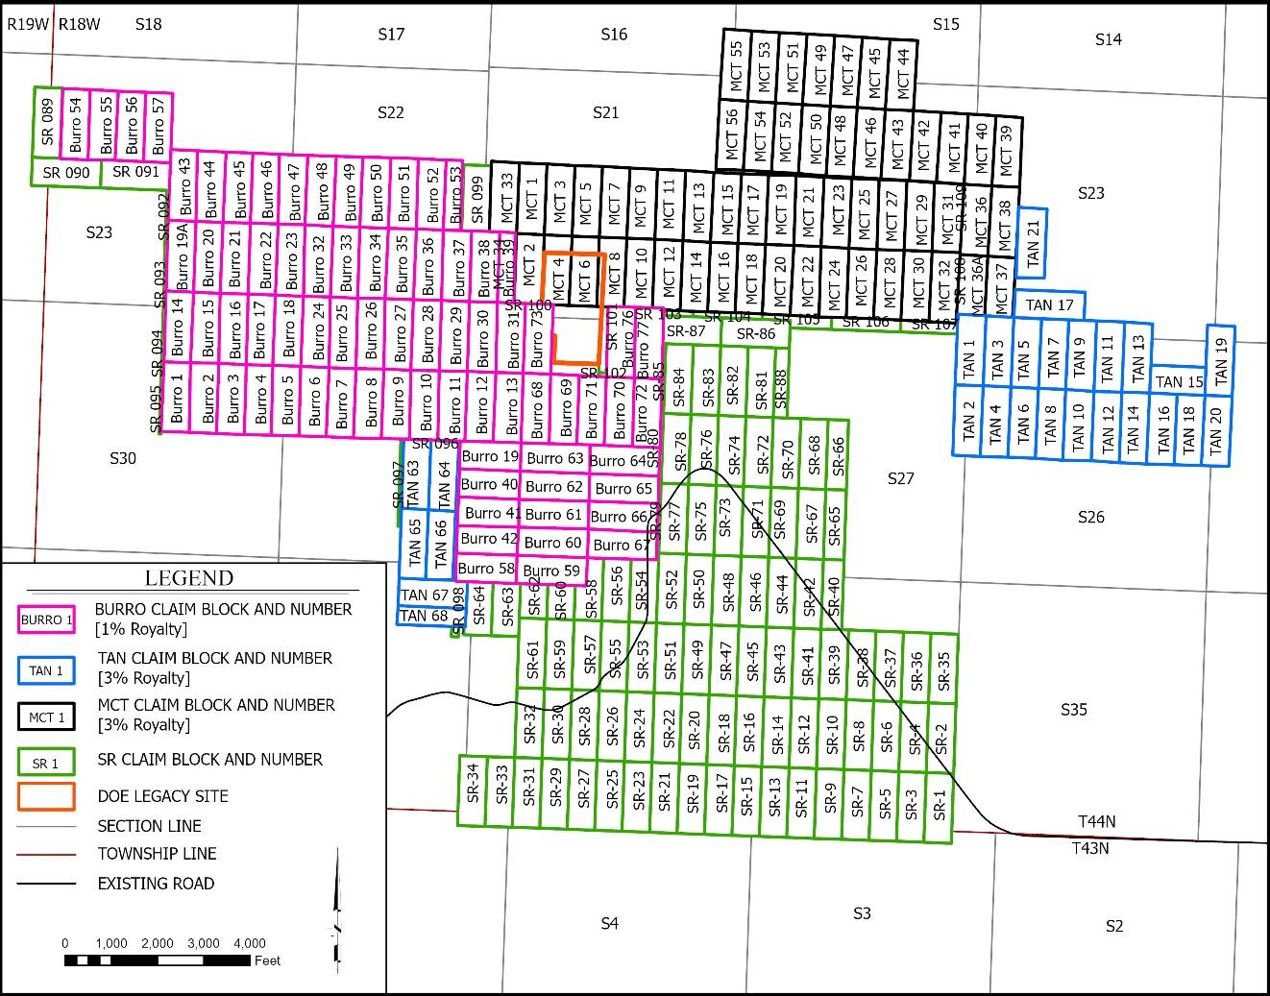

4.1.3 Shootaring Canyon Mill Property Description
The Shootaring Canyon Mill is located in Garfield County Utah approximately 52 miles south of Hanksville, Utah in Township 36 South, Range 11 East, Sections 3 and 4 and Township 35 South, Range 11 East, Sections 33 and 34 at approximate Latitude 37º 43’ 00” North and Longitude 110º 41’ 00” West.
The Shootaring Canyon Mill is located on lands which are split estate as shown on Figure 4.3, Shootaring Canyon Mill Ownership Map. The surface estate is fee land held by Anfield, and the mineral estate is Utah State Trust Land held by Anfield through two mineral leases.

Figure 4.3 - Shootaring Canyon Mill Ownership Map
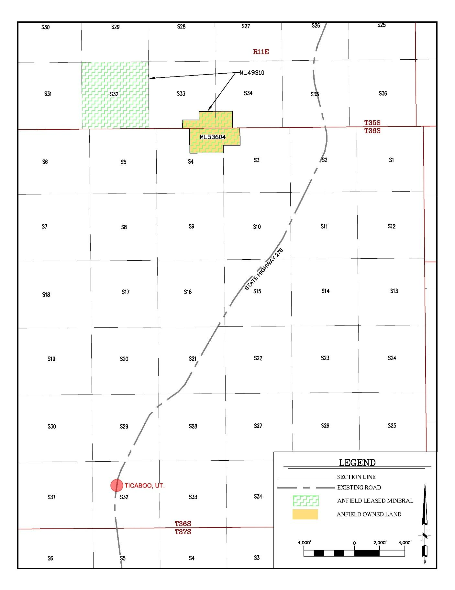

4.2 Ownership and Mineral Tenure

4.2.1 Velvet-Wood Mineral Tenure
Figure 4.1, Velvet-Wood Mineral Ownership and Claim Map, shows the approximate location of unpatented mining lode claims and state leases that are part of the Velvet-Wood Project. Copies of recent claim filings with the BLM for unpatented mining lode claims were provided by Anfield. The entire Velvet Wood project encompasses an area of approximately 2,140 acres.
Unpatented mining claims, both lode and placer, are under the authority of the Mining Law of 1872 on federal lands administered by the Bureau of Land Management (BLM). Under the Mining Law, the locator has the right to explore, develop, and mine on unpatented mining claims without paying production royalties to the federal government. Claim maintenance fees of $165 per claim are due by September 1st of each year. Unpatented federal lode mining claims are designated in the field by four corner posts, two end-center posts, and a location monument. Claim location notices for each unpatented claim are recorded in the county recorder’s office of the county in which the claims are located, and then filed with the BLM State office.
In addition to the mining lode claims, three quarters of Section 2 is a State of Utah lease ML 49377. To maintain these mineral rights Anfield must comply with the state lease provisions including annual payments to State of Utah for leases ML 49377 and BLM and San Juan County, Utah filing and/or annual payment requirements to maintain the validity of the unpatented mining lode claims.

4.2.2 Slick Rock Mineral Tenure
Figure 4.2, Slick Rock Ownership and Claim Map, shows the approximate location of the unpatented mining claims on the project. The project contains four claim blocks. The Burro claim block consists of 76 claims. The SR claim block consists of 131 claims, of which 109 were included in the study area for this report, with the remainder located outside of the project area. The TAN claim block consists of 27 claims. The MCT claim block consists of 56 claims. The MCT and TAN claims are leased from UR Energy. A total of 268 mineral lode claims were utilized for the Slick Rock mineral resource estimate in this report, encompassing an area of approximately 4,976 acres or 7.8 square miles.
To maintain these mineral rights Anfield must comply with the BLM and San Miguel County, Colorado filing and/or annual payment requirements to maintain the validity of the unpatented mining lode claims.

4.2.3 Shootaring Canyon Mill Mineral Tenure
The Shootaring Canyon Mill is located on lands which are split estate as shown on Figure 4.3, Shootaring Canyon Mill Ownership Map. The surface estate is fee land held by Anfield, and the mineral estate is Utah State Trust Land held by Anfield through two mineral leases as follows.
Surface Ownership:
- Township 35 South, Range 11 East, SLB&M, Section 33: S/2SW/4SE/4, SE/4SE/4, Section 34: SW/4SW/4, W/2SE/4SW/4
- Township 36 South, Range 11 East, SLB&M, Section 3: Lot 4, Section 4: Lots 1, 2, N/2S/2NE/4
- Approximately 264.52 Acres
Mineral Ownership:
- State of Utah Lease ML 53604, Township 36 South, Range 11 East, Section 3: Lot 4, Section 4: Lots 1, 2, N/2S/2NE/4
- Approximately 144.5 Acres
- State of Utah Lease ML 49310, Township 35 South, Range 11 East, Section 32: All, Section 33: S/2SW/4SE/4, SE/4SE/4, Section 34: SW/4SW/4, W/2SE/4SW/4
- Approximately 760 Acres
To maintain these mineral rights Anfield must comply with the state lease provisions including annual payments with respect to State of Utah leases ML 49310, and ML 53604.

4.3 Permitting

4.3.1 Velvet-Wood Permitting
Permitting for Velvet-Wood mining operations requires various approvals from the state of Utah Division of Oil, Gas and Mining (DOGM) and the US Bureau of Land Management (BLM). There is an existing Large Mine permit for the Velvet Mine which will need to be updated and revised. Refer to Section 20.

4.3.2 Slick Rock Permitting
Exploration and mining activities for the mining claims of the Slick Rock project are administrated by the Durango, Colorado BLM field office. Exploration drilling and associated activities require an exploration permit and a reclamation bond that must be posted with the State of Colorado, Department of Natural Resources Division of Reclamation, Mining, and Safety. At the time of the report, Anfield does not possess an exploration permit nor has a reclamation bond been posted.

4.3.3 Shootaring Canyon Mill Permitting
The Shootaring Canyon Mill has a radioactive source materials license which will need to be amended to allow mill operations to resume, as discussed in Section 20.

4.4 Environmental Liabilities

4.4.1 Velvet-Wood and Shootaring Canyon Mill Environmental Liabilities
Financial assurance instruments are required by Utah for the mine and exploration permits. There are currently two bonds in place for the Velvet-Wood Project. The first is associated with the Large Mining Operation Permit in the amount of $52,274.20 relating to the Velvet Mine. The second is associated with a Notice of Intent to Conduct Exploration in the amount of $17,770.00 related to the combined Velvet-Wood Project. The current surety bond for the Shootaring Canyon Mill totals $12,294,452.00.
No other outstanding environmental liabilities are known to the authors.

4.4.2 Slick Rock Environmental Liabilities
Anfield is unaware of any significant environmental liabilities on the property. DOE also maintains a legacy site within the property boundary. No exploration, development, or mining may take place within or below the DOE legacy site.

4.5 State and Local Taxes and Royalties

4.5.1 Velvet-Wood and Shootaring Canyon Mill Taxes and Royalties
Uranium mining in Utah is subject to Mineral Production Tax. Mineral Production Tax Withholding was increased from 4% to its current level of 5% effective July 1, 1993. (Refer to Utah Senate Bill 180, 1993). On the Section 2 State of Utah lease, an 8% royalty is levied on uranium, and a 4% royalty applies to vanadium production or other minerals. Additional state taxes would include property and sales taxes. At the federal level, profit from mining ventures is taxable at corporate income tax rates. However, for mineral properties depletion tax credits are available on a cost or percentage basis, whichever is greater. For uranium, the percentage depletion tax credit is 22%, among the highest for mineral commodities. (See IRS Pub. 535).
The estate of Mr. Jim Butt holds a 2.5% gross production royalty on all uranium and vanadium recovered at the Shootaring Canyon Mill from material mined from the Velvet 1-9 claims. Mr. Kelly Dearth holds a 1% gross royalty for all uranium mined from the Wood claims, including UT 31-38, 41-44, 48, 50, 52, 54-72, and 129, a total of 37 claims.

4.5.2 Slick Rock Taxes and Royalties
Uranium mining in Colorado is subject to Minerals Severance Tax of 2.25% after the first $19 million of gross product. In addition, two claim blocks are associated with royalties of 1% related to the Holley BC claims and 3% associated with the MCT claims. At the federal level, profit from mining ventures is taxable at corporate income tax rates. However, for mineral properties depletion tax credits are available on a cost or percentage basis whichever is greater. For uranium, the percentage depletion tax credit is 22%, among the highest for mineral commodities. (See IRS Pub. 535).

4.6 Encumbrances and Risks
To the authors’ knowledge there are no other forms of encumbrance related to the Project. The Velvet project has an existing mine permit, and the Shootaring Canyon Mill has a radioactive source materials license. There is no permit on the Slick Rock or Wood mine area. Both mines and the mill have operated in the past. As discussed in Section 20, there are existing reclamation/closure requirements and bonds associated with these permits and licenses. The Project does have some risks similar in nature to other mining projects in general and uranium mining projects specifically, i.e., risks common to mining projects as discussed in Section 25.
To the authors’ knowledge there are no other significant factors that may affect access, title, or the right or ability to perform work on the property if the aforementioned requirements, payments, and notifications are met.

Section 5: Accessibility, Climate, Local Resources, Infrastructure, and Physiography

5.1 Physiographic Features

5.1.1 Velvet-Wood Physiographic Features
The Velvet-Wood Uranium Project is located within the Lisbon Valley physiographic province in San Juan County, Utah. The project area is located primarily on a dipping bench above the Lisbon Valley, with elevations averaging 6,750 feet above sea level. Nearly 500 feet of elevation differential exists between the highest and lowest drill hole collars on the property. The site is located overlooking the Lisbon Valley. The Lisbon Valley drains through the Little Indian Canyon into Colorado where it joins the Dolores River, which enters the Colorado River northeast of Moab.

5.1.2 Slick Rock Physiographic Features
The Slick Rock property is located in the southern end of the Uravan mineral belt of the Colorado Plateau physiographic province. It is located in the southeastern edge of the Paradox fold and fault belt in the proximal Disappointment syncline. Elevations within the project area range from approximately 5,500 feet to 6,250 feet above sea level. The majority of the project area lies within the broad Disappointment Valley floor. It is bounded on the west by the Dolores River and incised to the west and south by Burro Canyon, Joe Davis Canyon, and Nicholas Wash. To the north is a dip-slope of an escarpment formed from erosion of the northern limb of the Disappointment Valley syncline.

5.2 Access

5.2.1 Velvet-Wood Access
Portions of the Velvet deposit were previously mined. Mineralization was accessed via a portal and decline. The mine entrance has been closed by backfill. However, in the authors’ opinion the decline could be re-opened. The Velvet portal is accessible by good quality roads beginning with the Big Indian Road, a hard surface road that exits U.S. Highway 191 about 19 miles north of Monticello, Utah or 34 miles south of Moab, Utah (See Figure 5.3).
The Big Indian Road extends eastward and loops into the Lisbon Road to serve properties in the Lisbon Valley area. A gravel road, San Juan County Road 112 (Williams Fork) exits the Big Indian Road about 5.5 miles east of its intersection with Highway 191. A private access road connects with County Road 112 about 6 miles southeast of its intersection with the Big Indian Road. The Velvet Mine portal is about one mile northeast along this road. The site, as described above, is accessible via 2-wheel drive on existing county and/or two-track roads. The project is located approximately 10 miles south of La Sal, Utah. Most transport will occur via over-the-road commercial trucks. Access to exploratory drill sites and vent locations are provided by existing roads connecting to the main access at the Velvet portal and the Lisbon Road.
The Wood mine area is located about 3 miles east of Velvet along County Road 112 and is also accessible from the east via the Lisbon Valley Road and County Road 112.

Figure 5.3 - Velvet-Wood Access Map
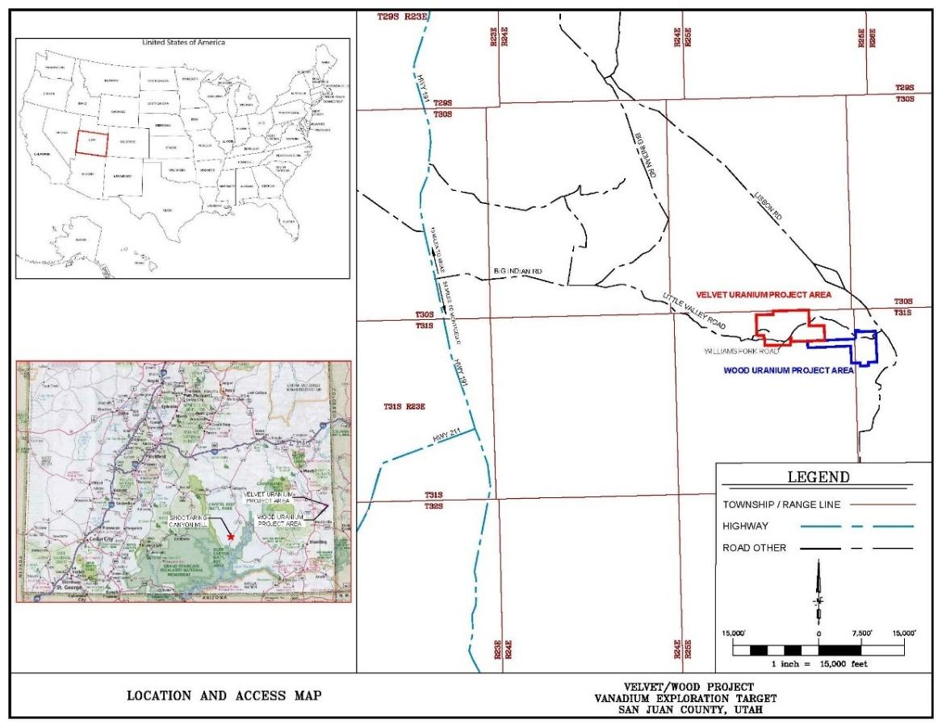

5.2.2 Slick Rock Access
The Slick Rock project can be accessed via Colorado State Highway 141, County Road CR-T11, and numerous historic drill roads and trails (See Figure 5.4). To access the site: from the post office in Dove Creek, Colorado, drive 2.0 miles west-northwest on State Highway 491; turn right (north) onto State Highway 141; continue for 23.7 miles to County Road CR-T11, and then turn left onto the well-maintained gravel road.

Figure 5.4 - Slick Rock Access Map
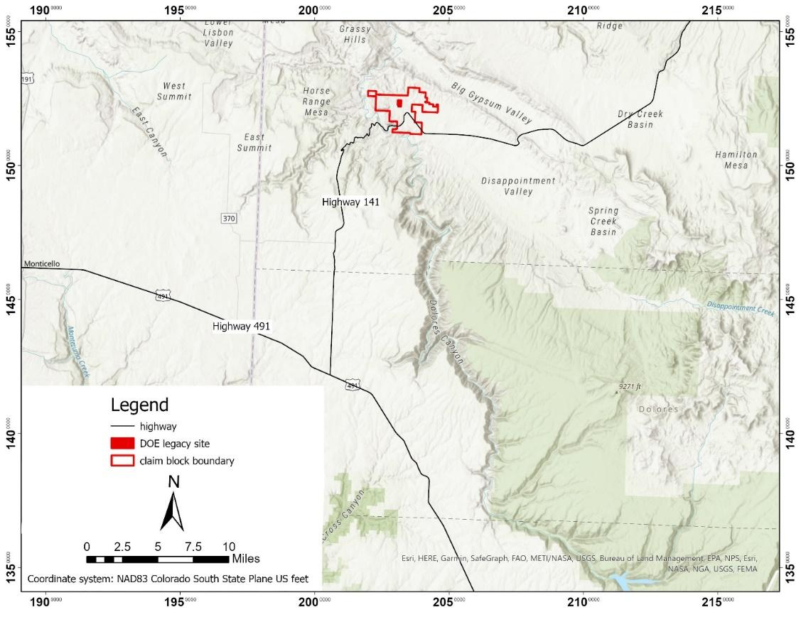

5.2.3 Shootaring Canyon Mill Access
The Shootaring Canyon Mill is located approximately 2 miles west of Utah Highway 276 and approximately 3 miles north of Ticaboo, Utah as shown in Figure 1.1. By road it is approximately 180 miles from the mill to the Velvet Mine area. Access to the mill is via paved highways with the exception of the 2-mile gravel road from the mill to Highway 276.

5.3 Climate

5.3.1 Velvet-Wood Climate
The climate is semi-arid. Average temperatures in July range from a high of 85ºF and a low of 56ºF. The average temperatures in January range from a high of 36ºF and a low of 16ºF. The average annual precipitation is thirteen inches. Winters are generally mild, and the length of the operating season should not be affected by the climate. A climate summary follows.

Figure 5.1 - Velvet-Wood Climate Summary
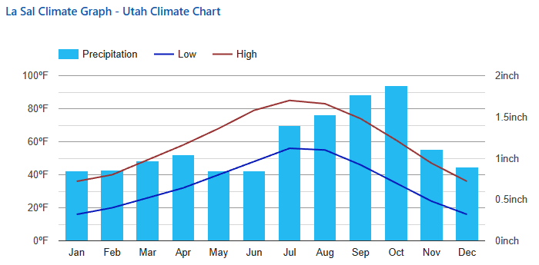
(https://www.usclimatedata.com/climate/la-sal/utah/united-states/usut0134#geo_map)

5.3.2 Slick Rock Climate
The climate is semi-arid and is characterized by mild winters with moderate snowfalls which are seldom heavy enough to cause access problems. The summers are warm with temperatures occasionally reaching 100°F. Annual precipitation for the area averages approximately 12 inches occurring mostly during summer thunderstorms; the remaining precipitation comes from winter snow and spring rain. Climate is only a minimally limiting factor for year-round mining operations. Vegetation in the area is sparse and consists of junipers and pinion pines in rocky soils along with sage and other brush, forbs, grasses, and cacti typical of a semi-arid climate.
Figure 5.2 - Slick Rock Climate Summary
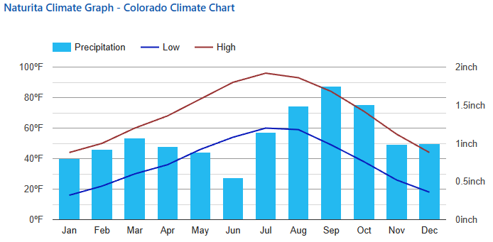
(https://www.usclimatedata.com/climate/naturita/colorado/united-states/usco0651)

5.3.3 Shootaring Canyon Mill Climate
The climate is arid. Average temperatures in July range from a high of 99ºF and a low of 60ºF. The average temperatures in January range from a high of 42ºF and a low of 11ºF. The average annual precipitation is less than 6 inches. Winters are generally mild, and the length of the operating season should not be affected by the climate. A climate summary follows.
Figure 5.3 - Shootaring Canyon Mill Climate Summary
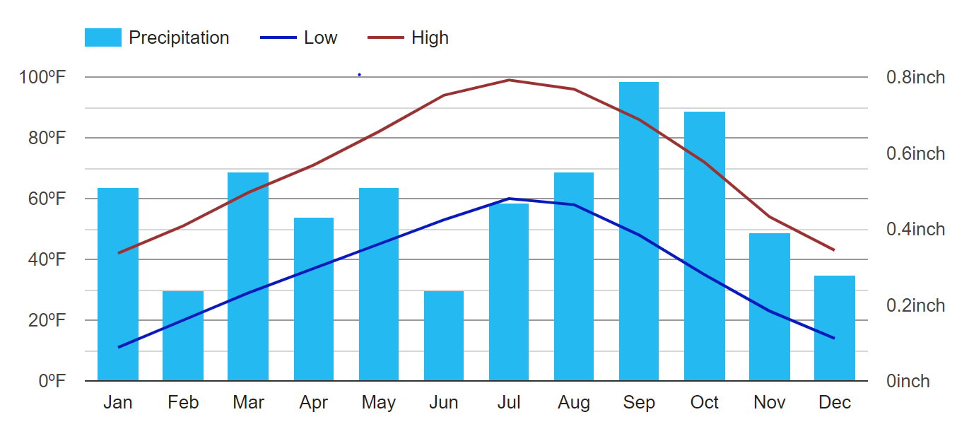
(https://www.usclimatedata.com/climate/hanksville/utah/united-states/usut0101)

5.4 Property Infrastructure

5.4.1 Velvet-Wood Infrastructure
The Velvet-Wood Mine is located between Monticello, Moab, and La Sal, Utah. In addition to access roads, some infrastructure is present on the Velvet-Wood site. The site is accessible over the multiple historic drill trails covering the area. An active copper mine, Lisbon Valley Copper Mine, is located 3 air miles north of the property. The presence of the copper mine and other industrial facilities in the area is significant in context of mine permitting, in that the Velvet-Wood Mine will be compatible with current land use. A power line terminates within 1mile of the old Velvet Mine portal, which is located in the SE ¼ of Section 3, T31S, R25E. Water for industrial use has been previously supplied by wells. Two of the previous underground mine ventilation shafts have been capped with access for water sampling retained. A third vent shaft has been reclaimed at the surface.

5.4.2 Slick Rock Infrastructure
Cortez, Colorado (population 8,500) is the nearest major community, located approximately 57 miles south-southeast from the Slick Rock project area. It has sufficient services, fuel, accommodations, and supplies to serve as a staging area for any future exploration program.
The Slick Rock project area has multiple access roads in addition to overhead power lines and a buried natural gas line. A ventilation shaft exists on site to the Burro underground mine. The shaft has been grated and is open. The Burro portal and underground mine workings are open and ground conditions are stable on an adjacent property. It is possible that an agreement to access the Slick Rock Mineralization from the Burro underground could be negotiated but was not considered for the purposes of this report and the preliminary economic analysis.

5.4.2 Shootaring Canyon Mill Infrastructure
The Shootaring Canyon Mill infrastructure is discussed in Sections 17 and 18.

5.5 Land Use

5.5.1 Velvet-Wood Land Use
The Velvet-Wood project area is generally used for livestock grazing and recreational uses such as hunting. An active copper mine and heap leach facility, the Lisbon Valley Copper Mine, is located 3 air miles north of the property. The presence of the copper mine and other industrial facilities in the area is significant in the context of mine permitting in that the Velvet-Wood project will be compatible with current land use.

5.5.2 Slick Rock Land Use
The Slick Rock project area is generally used for livestock grazing and recreational uses such as hunting. Historic mining occurred in the area including the neighboring Burro and Ellison Mines. A legacy Department of Energy site is centrally located within the site.

5.5.3 Shootaring Canyon Land Use
The Shootaring Canyon mill is an existing mineral processing facility that is located on private land with no public access.

5.6 Flora and Fauna
All of the project areas are arid or semi-arid areas with little to no vegetation. Vegetation at Velvet-Wood is characteristically pinion, cedar, and juniper forest, with some ponderosas in the higher areas. Slick Rock and the Shootaring Canyon Mill site are sparsely vegetated. Bare rock with sparse vegetation such as yucca is common, and sagebrush is thick in drainages where soil forms. Common mammals include the desert cottontail, squirrels, and mule deer. Common birds include jays, ravens, golden eagles, and hawks. There are also a variety of reptiles including lizards and snakes.

5.7 Surface Rights and Local Resources

5.7.1 Velvet-Wood Surface Rights
The Velvet-Wood mining claims are on public lands; the surface and mineral rights are administered by the BLM. The Mining Law of 1872 provides for surface rights associated with mining claims provided the use and occupancy of the public lands in association with the development of locatable mineral deposits is reasonably incident including prospecting, mining, or processing operations and is approved by the appropriate BLM Field Office; see 43 CFR Subpart 3715. The state lease has similar provisions for surface use.

5.7.2 Slick Rock Surface Rights
The 1872 Mining Law grants certain surface rights to mineral claimants along with the right to mine provided the surface use is incident to the mine operations. In order to exercise those rights, the operator must comply with a variety of State and Federal regulations (refer to section 20.1). For the mine operations, as described in Section 16, the author concludes that Anfield has and/or can obtain sufficient surface rights for the planned operations through permitting and licensing of site activities.

5.7.3 Shootaring Canyon Surface Rights
The surface leases associated with the mill convey the necessary rights for operation of the mill and associated tailings facility provided all environmental regulations and license conditions are met.

Section 6: History

6.1 Project History

6.1.1 Velvet-Wood Project History
The original locator of the Velvet area of the project was Gulf Minerals Corporation (Gulf). The Velvet Mine Uranium Project was initially drilled during the 1970s with the principal exploratory work and drilling completed by Gulf.
The Wood mineralization was discovered in 1975 by Atlas in Section 6, Township 31 South, Range 26 East (Chenoweth, 1990). Uranerz U.S.A. Inc. (Uranerz) later controlled the Wood area of the project during the 1980s when most of the initial exploration took place. A total of 120 known historic rotary drill holes were completed by Uranerz from 1985 through 1991. The exploration resulted in the discovery of three mineralized zones in the Cutler Formation. The most important of these, the Wood mineralized body, was outlined in 14 holes that intercepted high grade material. Sometime in the 1990s, Uranerz’s mining claims were allowed to lapse.
Gulf sold the Velvet property to Atlas in the late 1970s. Atlas’ Velvet Mine commenced operations in 1979 in Section 3 and advanced to the property line with Section 2. Atlas completed feasibility studies for mining the Section 2 mineral resources including hoisting and haulage of mined product to their Moab mill for processing in 1980. These plans were never executed due to low uranium prices in the 1980s, and the Section 2 property was sold by Atlas Minerals as they were experiencing an economic downturn. The Velvet Mine was closed in 1984. Subsequent changes in ownership include:
- The Velvet Mine property was acquired by Umetco Minerals Corp. in 1989.
- Umetco held the Section 3 property until the mid-1990s at which time the property was transferred to US Energy (USE).
- Mr. William Sheriff secured the Section 2 state lease by competitive bid and staked the adjoining mining claims. The property was then transferred to Energy Metals Corporation (EMC).
- In 2004, Energy Metals Corporation staked new mining claims over the Wood area.
- Uranium One gained control of the Velvet-Wood property through the purchase of Energy Metals Corporation in 2007.
As discussed in Section 4.2, Anfield purchased the Velvet-Wood Uranium Project and other conventional uranium assets including the Shootaring Canyon Mill located near Ticaboo, Utah from Uranium One in August 2015.

6.1.2 Slick Rock Project History
Surficial to shallow uranium/vanadium mineralization has been known in the Slick Rock area since the early 1900s, originally known as the McIntyre district. First mined for radium and minor uranium until 1923, numerous companies sporadically operated small scale mining and processing facilities along the Dolores River. In 1931, a mill was constructed by Shattuck Chemical Co. to process vanadium ore. Beginning in 1944, the area was worked by Union Mines Development Corp. for uranium/vanadium ore. The uranium was used to develop and construct the first atomic bombs. This sparked intensive exploration efforts throughout the Uravan mineral belt.
Between November 1948 and March 1956, the USGS drilled 2,641 holes in the Slick Rock district to explore for uranium- and vanadium-bearing deposits. The drilling was part of an exploration program conducted for the U.S. Atomic Energy Commission (OFR70-348). Fifty-two of these drill holes were located within the boundary of Anfield’s Slick Rock project area. The first phase of the USGS’s exploration was to obtain geological data and delineate areas of favorable ground. This widely spaced drilling program was done on approximately 1,000 foot centers. The second phase was drilled with more moderate spacing (100-300 foot centers) to discover ore deposits. The third phase was drilled on more closely spaced intervals (50-100 foot centers) to extend and outline any deposits discovered by earlier drilling (Weir, 1952). At this time, private industry was also actively exploring the area. By 1954, an estimated 212,000 feet of drilling was completed district wide (Shawe, 2011).
By December 1955, Union Carbide Nuclear Corp. (UCNC) had drilled out a sufficient resource on the north side of Burro Canyon and began sinking three shafts. In December 1957, the shaft sinking was complete on the Burro No. 3, 5, and 7 mines to total depths of 408 feet, 414 feet, and 474 feet, respectively. In the same year, initial ore shipments to UCNC’s concentrating mill at Slick Rock were also made. The concentrated ore was processed at the UCNC mill in Rifle, Colorado until the mid-1960s when a vanadium circuit was constructed at the Uravan mill site.
The Anfield Slick Rock project has received more recent interest by the exploration activities of USEC, Energy Fuels, and Homeland Uranium. In 2006, USEC drilled 17 boreholes. All boreholes were completed to target depth, except one borehole SR-1011 which was abandoned.
In 2007, Energy Fuels drilled five boreholes on the extreme northern portion of the project. Four of the boreholes were oxidized and barren. The fifth borehole was abandoned due to excessive water encountered in the Burro Canyon Formation and the upper Salt Wash Member of the Morrison Formation (Bill Thompson, Manager, Ur-Energy, LLC).
In 2008, Homeland Uranium drilled four boreholes in an attempt to twin the mineralized boreholes drilled by the AEC in the 1950s. All boreholes were completed to target depth.

Figure 6.1 - 2006-2008 Borehole Map
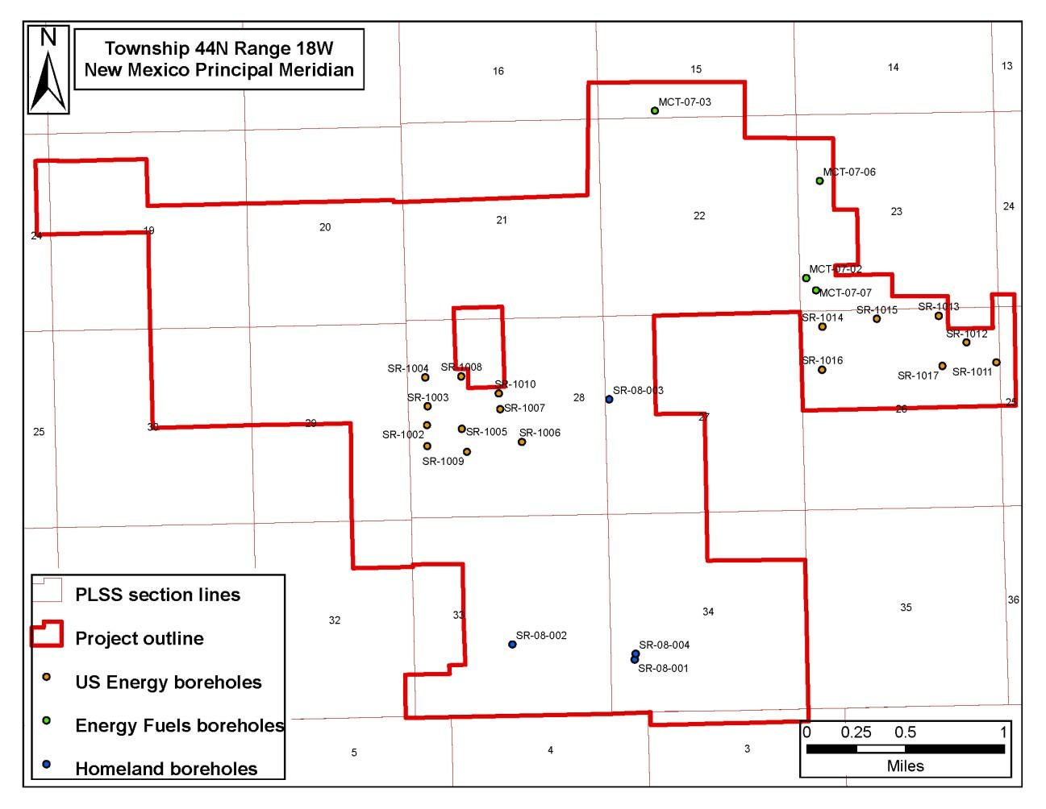

UEC began acquiring mineral interests in the Slick Rock project area beginning in December of 2010 by staking areas where the previous owner had allowed the mining claims to lapse. UEC then held 293 mineral lode claims encompassing an area of approximately 4,858.5 acres. UEC also began leasing additional claims from UR Energy on November 30, 2011. Anfield acquired all of UEC’s Slickrock holdings including claims and claims leases on April 12, 2022, as part of the overall acquisition agreement as described in Section 6.1.1.

6.1.3 Shootaring Canyon Mill Ownership History
The Shootaring Canyon Mill was licensed and constructed by Plateau Resources and has had a succession of owners including US Energy and Uranium One prior to Anfield.
On August 27, 2015 Anfield closed the Asset Purchase Agreement (APA) with Uranium One Americas Inc. (“Uranium One”) and subsequently amended to acquire the Shootaring Canyon Mill located in Utah and a portfolio of conventional uranium mine assets as described in Section 6.1.1.

6.2 Previous Mineral Resource Estimates

6.2.1 Velvet-Wood Historic Mineral Resource Estimates
A historic mineral resource estimate for the Velvet area within Section 2 was completed by MRC using a polygonal method. A similar historical mineral resource estimate for the Velvet area within Section 3 was completed by Price, 1987. Mineral resources related to the Wood area, located in T31S, R26E, Section 7, is referenced in the literature (Chenoweth, 1990). However, the original source and basis of this estimate is not known and thus cannot be stated herein.
Section 14 provides a current estimate of mineral resources in accordance with National Instrument 43-101.

6.2.2 Slick Rock Historic Mineral Resource Estimates
There are no historical mineral resource estimates for Slick Rock known to the authors.

6.3 Past Production

6.3.1 Velvet-Wood Past Production
The Velvet Mine operated into the early 1980s. According to Chenowith, due to continued low uranium prices, Atlas Minerals closed all of their mines and mill, which included the Velvet in southeastern Lisbon Valley in March 1984. When the Velvet mine was closed it had produced approximately 400,000 tons of ore which graded 0.46 percent U₃O₈ and 0.64 percent V₂O₅ with total production estimated at 4.2 million pounds of U₃O₈ (Chenoweth 1990).

6.3.2 Slick Rock Past Production
In 1971, the final year that the Atomic Energy Commission reported production figures, the Burro mines had produced 404,804 tons of ore at an average grade of 0.25% U₃O₈ yielding 1,992,898 lbs U₃O₈, and 1.5% average grade V₂O₅ yielding 12,149,659 lbs V₂O₅ (Nelson-Moore et al., 1978). According to the Colorado Bureau of Mines' annual reports, the Burro mines produced an additional 243,825 lbs U₃O₈ at an average grade of 0.20% and 1,791,798 lbs V₂O₅ at an average grade of 1.4% up until 1983 when depressed uranium prices forced an end to mining activities. The total production of the Burro mines was 2,236,723 lbs U₃O₈ and 13,941,457 lbs V₂O₅ as summarized in Table 6.2.
Table 6.2 - Slick Rock District Total Production
Production Years | U₃O₈ (lbs) | V₂O₅ (lbs)
1957-1971 | 1,992,898 | 12,149,659
1971-1983 | 243,825 | 1,791,798
Total | 2,236,723 | 13,941,457

Section 7: Geological Setting and Mineralization

7.1 Regional Geological Setting: The Colorado Plateau
The Colorado Plateau is a regional geologic feature characterized by high elevation mesas and deeply incised canyons in southwestern Colorado and much of eastern Utah. The sedimentary units which dominate the Colorado Plateau were deposited during a period of tectonic stability beginning in the early Paleozoic and running through the Mesozoic Eras. During this time, a stable shelf depositional environment allowed thick accumulations of clastic, carbonate, and evaporitic sediments. Beginning approximately 6 million years ago, the entire Colorado Plateau was subject to epeirogenic uplift of 4,000-6,000 feet. This geologically rapid uplift caused the existing rivers and streams to aggressively downcut resulting in the canyon lands topography of today (Hunt, 1956). The Velvet-Wood and Slick Rock projects are both situated in the central portion of the Colorado Plateau. The Velvet-Wood lies along the western flank of the Lisbon Valley anticline in the Lisbon Valley Utah while Slick Rock Project is located along the spine of the Disappointment syncline in the Paradox Basin of Colorado.
Sedimentary strata within the Colorado Plateau hosts numerous uranium/vanadium deposits. Uranium deposits are hosted by the Pennsylvanian Hermosa Formation, the Permian Cutler Formation, the Triassic Chinle Formation, and the Jurassic Morrison Formation as shown on the stratigraphic description in Table 7.1. The majority of the uranium production in the Colorado Plateau was from the Morrison Formation, specifically the Salt Wash Member. In the Salt Wash Member, deposits are concentrated along a thin, one to several mile-wide arcuate belt that extends from the Gateway district through the Uravan district and south to the Slick Rock district. This concentration of deposits was termed the Uravan mineral belt as shown on Figure 7.1 (Fischer and Hilpert, 1952). This crescent-shaped area in the Jurassic Morrison formation has closely spaced, larger-sized, and higher-grade uranium deposits than the adjoining areas.
Slick Rock lies within the southern half of Uravan Mineral Belt which has been a historically significant producer of uranium and vanadium since the early 20th century. The Lisbon Valley anticline along which the Velvet-Wood project is located is the most productive uranium producing area in Utah (Chenoweth, 1990). Among the rock units exposed along the Lisbon Valley Anticline, those that contain documented uranium mineralization are the Permian Cutler Formation, the Triassic Chinle Formation (Moss Back Member) and the Morrison Formation (Salt Wash Member). Both projects have significant adjacent and adjoining uranium and vanadium production histories, as discussed in Section 6, History.

Table 7.1 - Stratigraphy of Slick Rock District and Vicinity (Shawe, 1970)
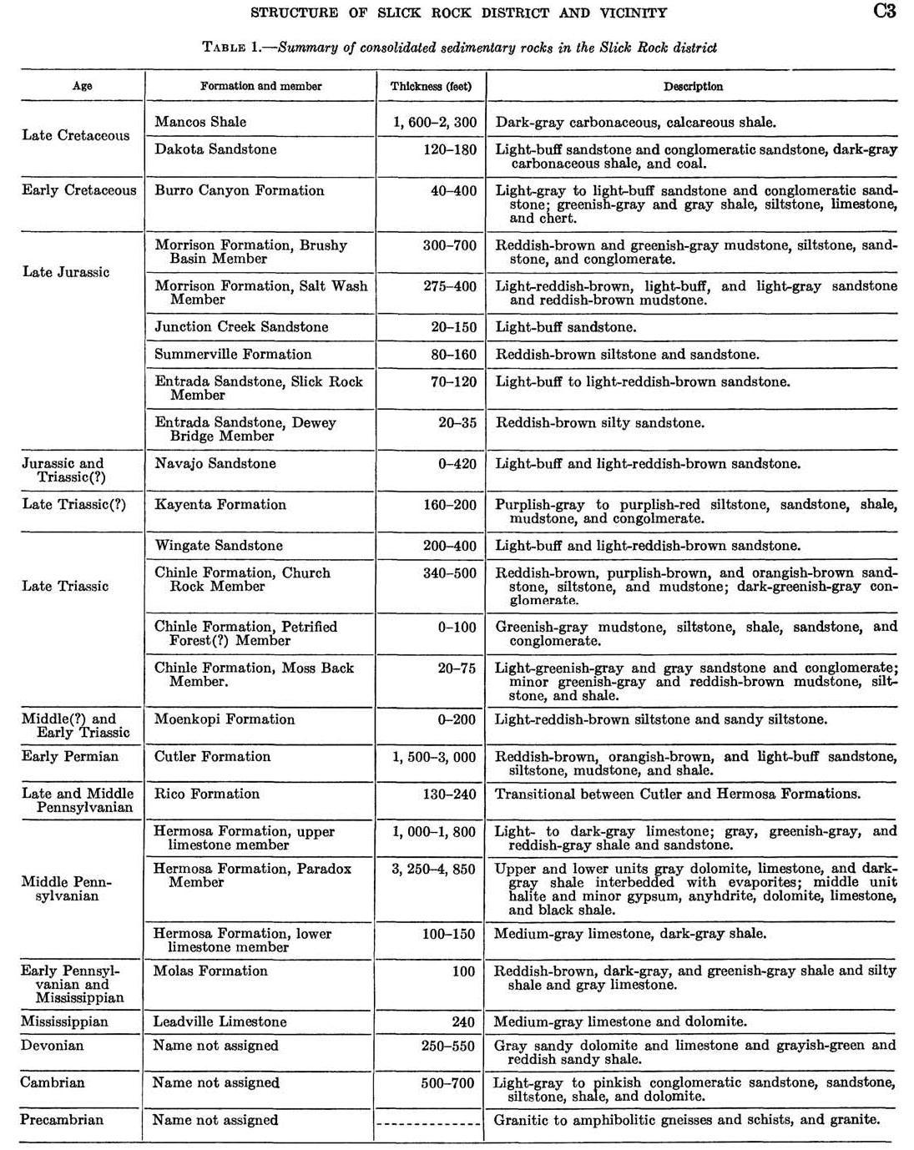

Figure 7.1 - Uravan Mineral Belt (adopted from Chenoweth, 1981)
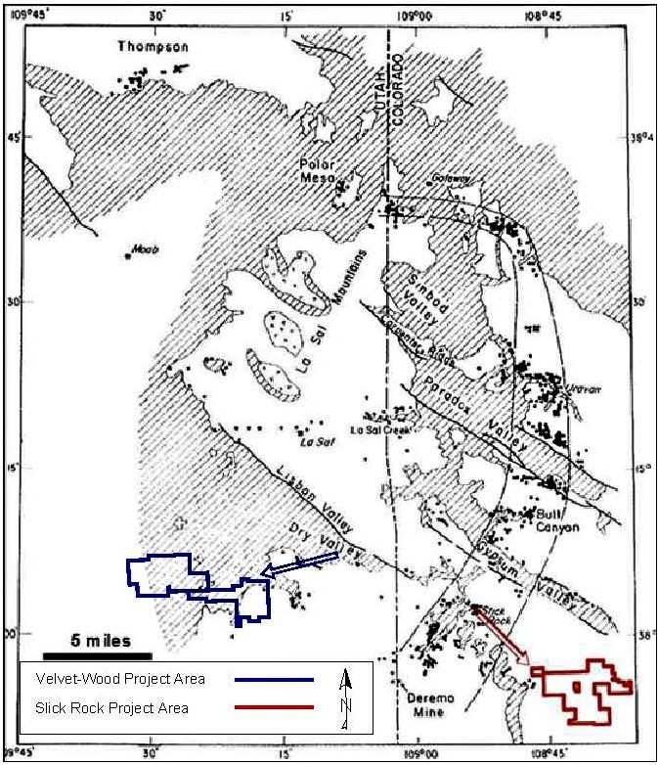

7.2 Velvet-Wood Project Local Geology
The dominant feature in the Velvet-Wood area is the Lisbon Valley Anticline. The Lisbon Valley Anticline is a northwest/southeast feature about 20 miles long that was formed when salt in the Paradox Formation was mobilized. The up-warping and subsequent erosion of the anticline has exposed Pennsylvanian to Cretaceous age rocks along the length of the anticline. Consolidated rocks that crop out in the Lisbon Valley area range in age from Late Pennsylvanian to early Pleistocene. The oldest, the Pennsylvanian Honaker Trail Formation, is exposed in the interior of the anticline with successively younger rocks exposed in the faces of three mesas along the flanks of the anticline. In the Velvet-Wood area the mesa recedes southward stepwise away from the center of the anticline and is known as Three Step Hill. The surficial geology of Velvet-Wood is shown on Figure 7.2 and the Regional Cross Section in Figure 7.3.
Figure 7.2 - Velvet-Wood Project Local Geologic Map (from Doelling, 2004)
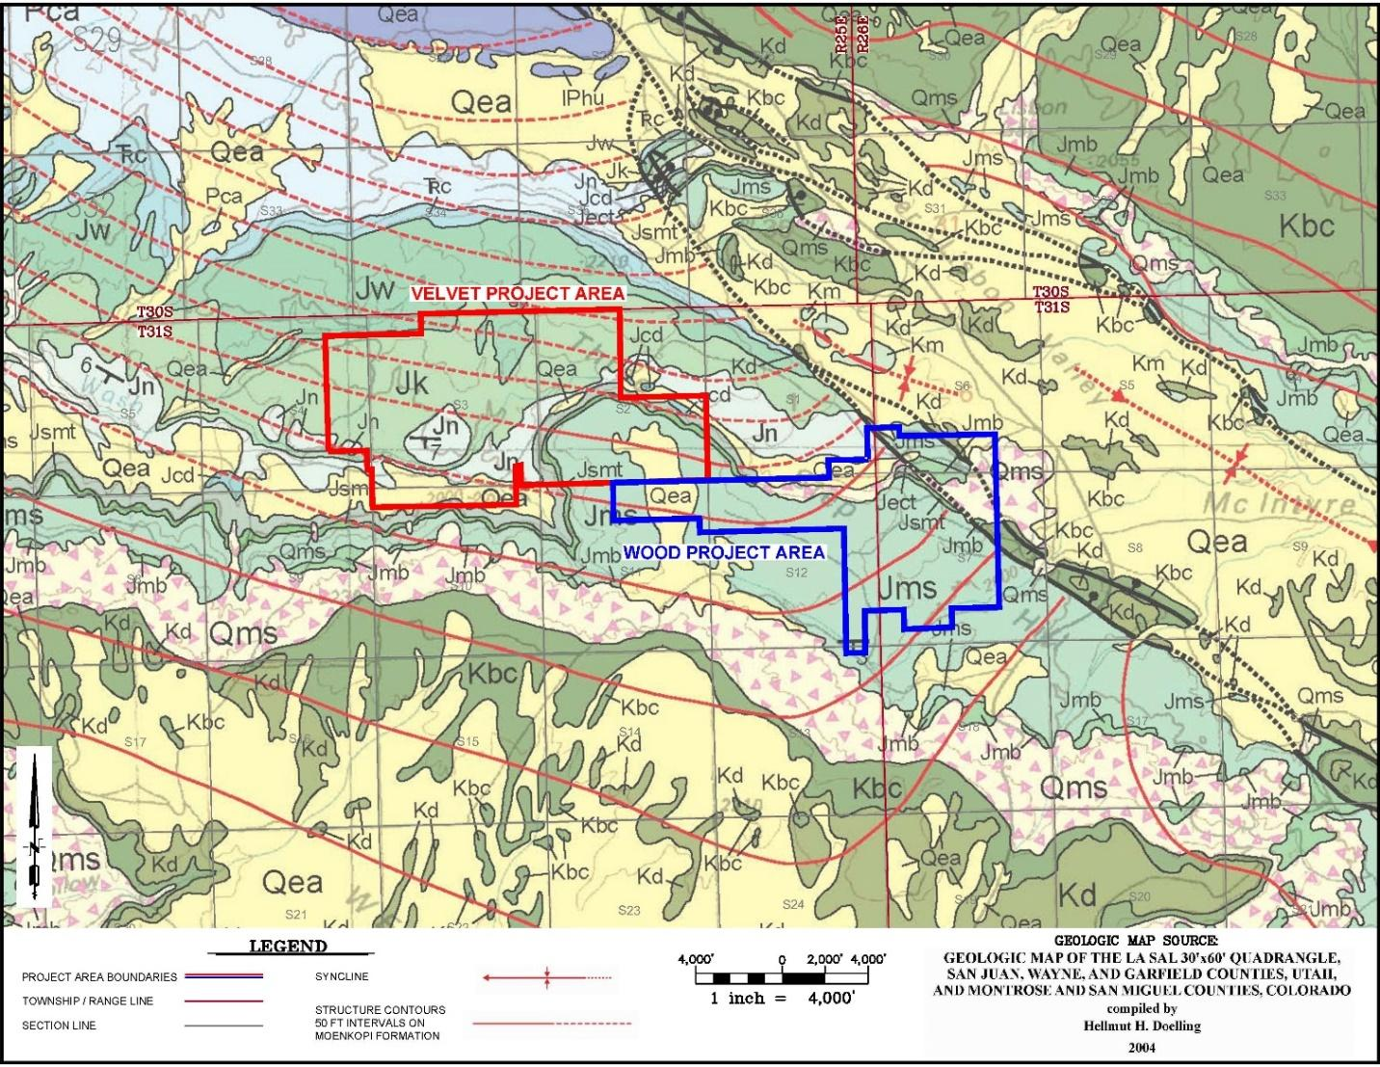
Figure 7.3 - Velvet-Wood Project Regional Cross Section (Doelling, 2004)
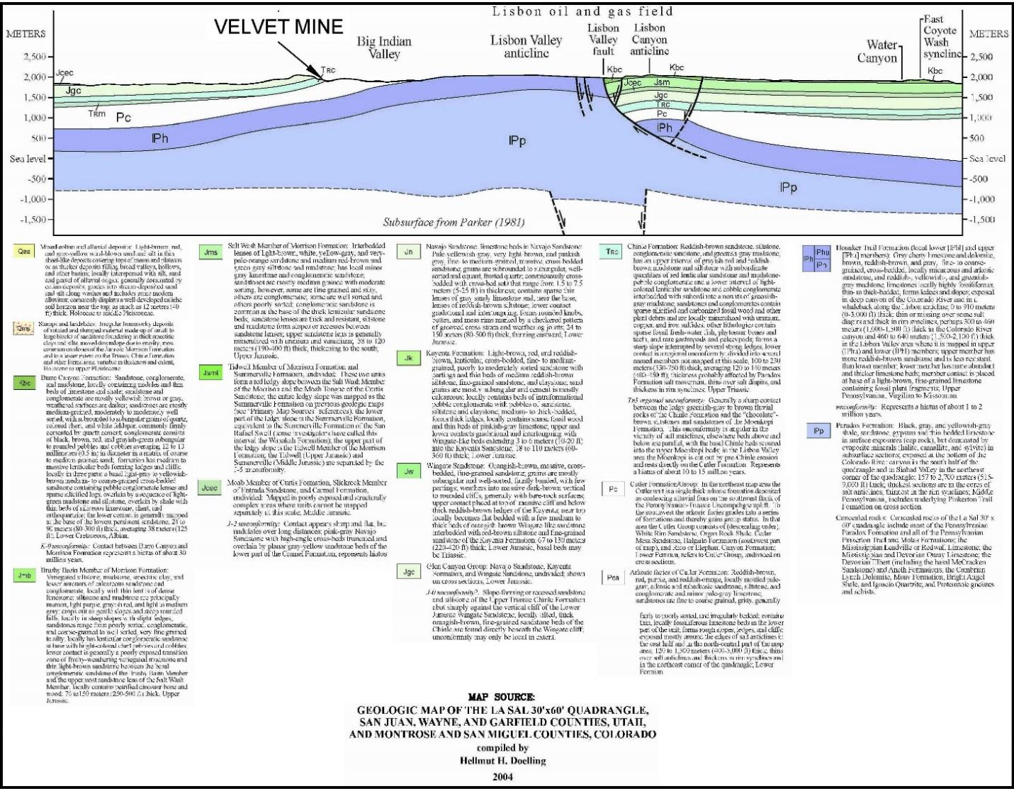
Three Step Hill is composed of three mesas, each progressively higher than the last. The Velvet-Wood Deposit is under the lowest mesa and on the margin of the second. The top of the mesa is a dip slope primarily on the top of the Wingate Sandstone. Low mesas of Kayenta Formation rocks are preserved near the southern base of the dip slope. The dip slope of the middle mesa is composed of resistant sandstone units of the Salt Wash Member of the Morrison Formation. The Brushy Basin Member has been stripped off the plateau but is exposed near the base of the slope of the third mesa. The highest mesa is capped by the Burro Canyon Formation. Some remnants of Dakota Sandstone are exposed on the upper plateau. The dips of the rocks are progressively shallower toward the south. The dips on the lower plateau are about 6 to 8 degrees and dips on the upper plateau are about 3 to 5 degrees.
Locally, uranium mineralization is found in the Permian Cutler Formation. The Cutler formation in Lisbon Valley is composed predominantly of fluvial arkosic sandstones, siltstones, shales, and mudstones that were deposited by meandering streams that flowed across a flood plain and tidal flat. This flood plain was occasionally transgressed by a shallow sea from the west, resulting in the deposition of several thin limestones and marine sandstones. Wind transported sand along the shoreline of the shallow sea, forming dunes (Campbell and Mallory, 1979). The marine and eolian sandstones are usually finer grained, better sorted, and cleaner than the fluvial arkosic sandstones. The fluvial sandstones are medium to very coarse grained and have abundant feldspar and biotite. The sandstone units are usually red-brown to purple red in color. Some of the sandstones have been bleached tan to gray-white. The top of the Cutler is truncated by a regional unconformity that has removed in excess of two hundred feet of the formation in the northern part of Lisbon Valley.
The unconformity at the top of the Cutler has truncated the southward dipping Cutler beds, the mineralized sandstone bed at the Velvet-Wood Deposit is stratigraphically a few hundred feet above that at the Big Buck Mine in the northern end of Lisbon Valley. The purple-red fluvial sandstones occur in large lenticular bodies that are hundreds of meters long and range in thickness from less than 3 to over 75 feet. Laterally these lenses thin and grade into the shale, mudstone, and siltstone sequences (Campbell and Mallory, 1979).
The fluvial sandstones are composed of medium to coarse-grained quartz, feldspar, and rock fragments in sub equal amounts. These arkosic sandstone units’ source of sediment was the Uncompahgre highland northeast of the Velvet-Wood area on the Utah/Colorado border. The cementing agent in the Cutler fluvial sandstones is either calcite or secondary overgrowth on the quartz grains. All of the known mineralized fluvial sandstone units were bleached light tan-pink or gray-white (Campbell and Mallory, 1979).
The upper portion of the Cutler Formation, which is the primary host of known uranium mineralization in the Velvet-Wood Area, is composed of intervals of siltstone interbedded with thin-bedded, fine-grained sandstone. In places there are thicker, more resistant sandstone beds up to 47 feet thick. The thickness and frequency of sandstone beds increases downward, and siltstone is less common. Thick mudstone intervals separate the sandstone beds. A few limestone and conglomerate beds occur in the bottom third of the formation. The rocks are mostly greenish-gray, reddish-brown, or reddish-orange. The limestone beds are usually olive-gray (Campbell and Mallory, 1979).
Faulting and folding are the major structural features of the Velvet-Wood area. There are two major faults in the Velvet-Wood area. The faults are northeastward dipping normal faults with displacement ranging from a few feet to as much as 700 feet. The rock units between the two faults are folded downward to the northeast. The sandstones in the Velvet-Wood area exhibit jointing parallel to the Lisbon Valley anticline and are thought to be tensional joints. The host rocks of the Velvet-Wood Area are truncated by the faulting on the southwest side of the Lisbon Valley graben. The mineralization of the Velvet-Wood Deposit appears to be fault bounded on the northeast side of the deposit. (Gordon, et al, 1981).

7.2 Slick Rock Project Local Geology
The Slick Rock district lies in the Paradox Basin at the southern edge of the salt anticline region also called the Paradox Fold and Fault Belt (Kelley, 1958). The district, which covers approximately 570 square miles of the Colorado Plateau, is underlain by about 13,000 feet of sedimentary strata which lies on metamorphic and igneous rocks of a Precambrian basement. The sedimentary formations range in age from Cambrian to Late Cretaceous (Shawe, 1970). See Figures 7.4a and 7.4b for Slick Rock Project Local Geology Map.
Figure 7.4a - Geologic Map of Slick Rock Project Area (from USGS/Carter 1955)
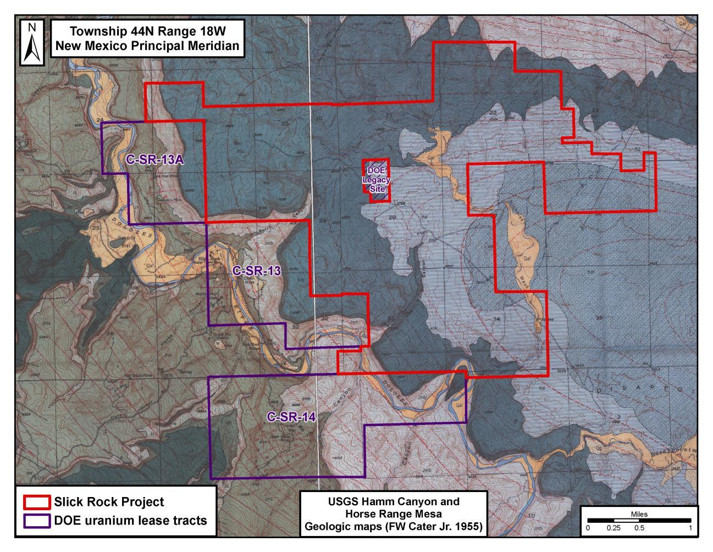
Figure 7.4b - Geologic Map of Slick Rock Project Area Legend (from USGS/Carter 1955)

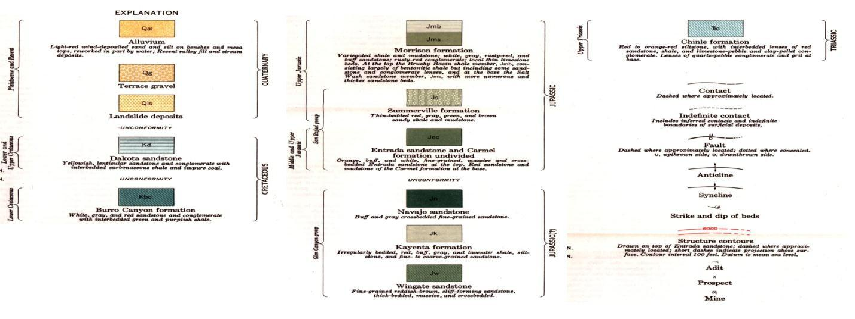
The Slick Rock project is located in the proximal Disappointment Valley syncline. The syncline plunges gently to the southeast and lies between the collapsed Gypsum Valley anticline to the northeast and the Dolores anticline to the southwest. Sedimentary rocks that outcrop in the Slick Rock district range from the Permian Cutler Formation up to the late Cretaceous Mancos Formation with a maximum thickness of approximately 4,700 feet (Shawe, 2011). The Jurassic Morrison Formation is the host of uranium/vanadium deposits in the Slick Rock district. It is widely recognized as an aggrading, terrigeneous clastic, fan-shaped fluvial sequence of sediments. While the precise location of the sediment source is unknown due to erosion, most authors agree that the sediment source area for the fan is the modern-day south-central Utah and north-central Arizona area (Page et al., 1956). The proximal fan is dominated by a high percentage of coarse clastics in braided stream sediments. The energy of the depositional environment decreases distally, as does the grain size of the sediments. The Slick Rock district occupies the medial fan facies. From the apex of the fan, the stream flow was in a northern, northeastern, and eastern direction. In the Slick Rock district, the direction of stream flow was generally to the northeast while local paleo topography controlled the flow direction.
The salt anticlines were the positive topographic highs during Jurassic time that diverted Morrison distributary systems to courses along their flanks. This allowed for thick accumulations of high sandstone/mudstone ratio sediments in valleys that flanked the elongated salt domes of Jurassic time. High sandstone/mudstone ratios increase permeability (the ability of sediments to transmit fluids) and porosity (available void space). Such conditions are favorable for increased fluid flow and may largely control ore formation. The thick accumulation of sediments in major channels occurred along the southern margin of the Gypsum Valley anticline in the Slick Rock district and across Anfield’s project area (Tyler and Ethridge, 1983).
Major folds in the Slick Rock district are broad, open, and trend about north 55 degrees west, and are parallel to the collapsed Gypsum Valley salt anticline which bounds the northeast edge of the district. The Dolores anticline lies about ten miles southwest of the Gypsum Valley anticline. The Disappointment syncline lies between the two anticlines (Williams, 1964). See Figure 7.5, Slick Rock Structural Geology Map.
Within the Slick Rock project area, the Morrison is divided into two Members: the upper Brushy Basin Member and the lower Salt Wash Member. The Salt Wash Member is composed of fluvial sandstone and mudstone averaging about 350 feet thick, and is further divided into three parts: the top and bottom units that are composed of fairly continuous layers of sandstone interbedded with thin layers of mudstone, and a middle unit that is primarily mudstone but contains scattered discontinuous lenses of sandstone (Rogers and Shawe, 1962 MF-241).
The Slick Rock district lays in an area where only the Salt Wash and Brushy Basin Members of the Morrison Formation are present. The Morrison Formation attains its maximum thickness in these members and stream-type deposits (lenticular cross-bedded sandstones) have their greatest aggregate thickness and maximum lateral continuity (Shawe, 2011).

Figure 7.5 - Slick Rock Structural Geology Map (from Williams, 1964)
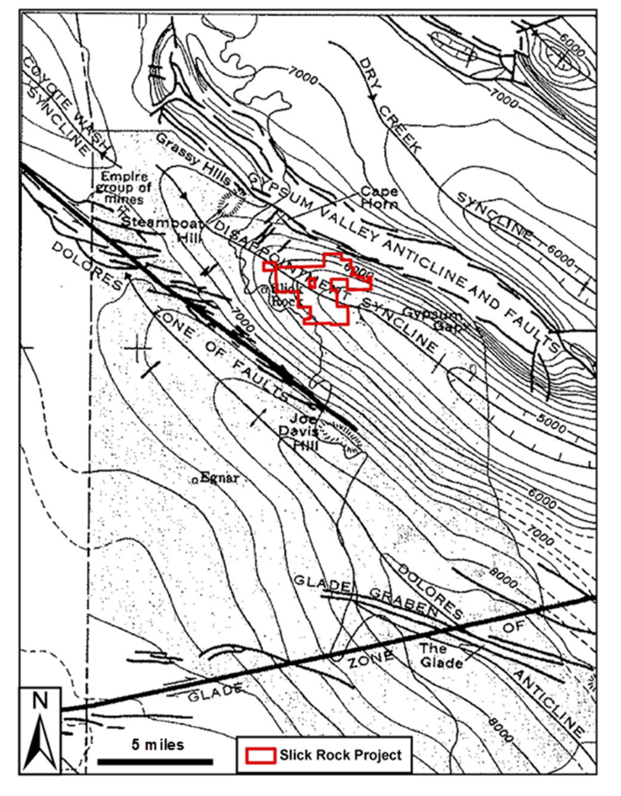
As discussed in Section 6, History, the USGS on behalf of the Raw Materials Division of the Atomic Energy Commission, conducted extensive exploration throughout the Uravan mineral belt. As early as 1952, the USGS had determined that the following four geologic characteristics were indicative of favorable grounds for a uranium deposit:
- Most mineralized deposits are in or near thicker, central parts of sandstone lenses and, in general, the thickness of the sandstone decreases moving away from the mineralized deposits. Sandstone less than 40 feet thick is generally not favorable for large ore bodies.
- Sandstone in the vicinity of the mineralized deposit is colored light brown, but moving away from the mineralized deposit an increasing proportion of sandstone has a reddish color, which is indicative of unfavorable ground.
- The mudstone in the mineralized sandstone near and immediately below the deposit changes from a red to gray color. The amount of altered mudstone decreases further outward from the deposit.
- Sandstone in the immediate vicinity of the deposit contains more carbonized plant fossils than similar beds further away from the mineralized zone. This suggests that mineralization is localized in the vicinity of abundant carbonaceous material (Weir, 1952).
Results from USGS's 1948-1956 drilling indicate that within Anfield’s Slick Rock project area the Salt Wash is greater than 40 feet thick, contains abundant carbonaceous material, is tan to gray in color, and is in contact with a reduced mudstone over a significant portion of the project area.

Section 8: Deposit Types

8.1 Velvet-Wood Deposit Type
Uranium mineralization in the Velvet and Wood areas is found in sandstone units within the Cutler Formation. The sandstones are fluvial arkose that has been bleached. The mineral deposits are irregular tabular bodies (Denis, 1982) located at the base, at the top, or close to pinch-outs of the sandstone bodies (Campbell and Mallory, 1979). The major producing zone in the Cutler occurs near the unconformity between the Cutler and the overlying Chinle Formation. The mineralization may extend a short distance into the sandstone of the Moss Back above. The uranium-bearing sandstones are petrologically very similar to other Cutler fluvial sandstones but contain less calcite and more clay and are slightly coarser grained (Campbell and Mallory, 1979). Uraninite is the principal uranium mineral encountered in the reduced zones of the Velvet Area. In areas where the mineralization lies above groundwater levels, oxidized uranium minerals such as carnotite and tyuyamunite may occur. Uranium mineralization within the Colorado Plateau of Southwestern Colorado and Southeastern Utah have been described as tabular-blanket type deposits that are sub-parallel to bedding planes and/or features such as unconformities. Mineralization is often confined to paleochannels and controlled by lithology, permeability, porosity, and the presence of a chemical reductant, often carbonaceous material (Hasan, 1986). A similar depositional morphology is observed at the Wood Mine.
Uranium mineral resources within and in the vicinity of the project are found in the upper Permian Cutler formation. Many of the other mines in the district were located in the basal Moss Back member of the Triassic Age Chinle Formation overlying the Cutler Formation. As shown on Figure 8.1, Velvet-Wood Project Stratigraphic Column, there is an erosional unconformity between the Permian and Triassic aged beds where the Triassic Moenkopi formation was eroded away before the placement of the Moss Back Member of the Chinle Formation. Observations from the 2007 and 2008 coring program on the Velvet project has developed the model that mineralization in both formations is related to the unconformity, although the location of mineralization with respect to the contact varies from location to location within the district. Most of the mineral resources in the Cutler occur within six feet of the unconformity.

Figure 8.1 - Velvet-Wood Project Stratigraphic Column (Chenowith, 1990)
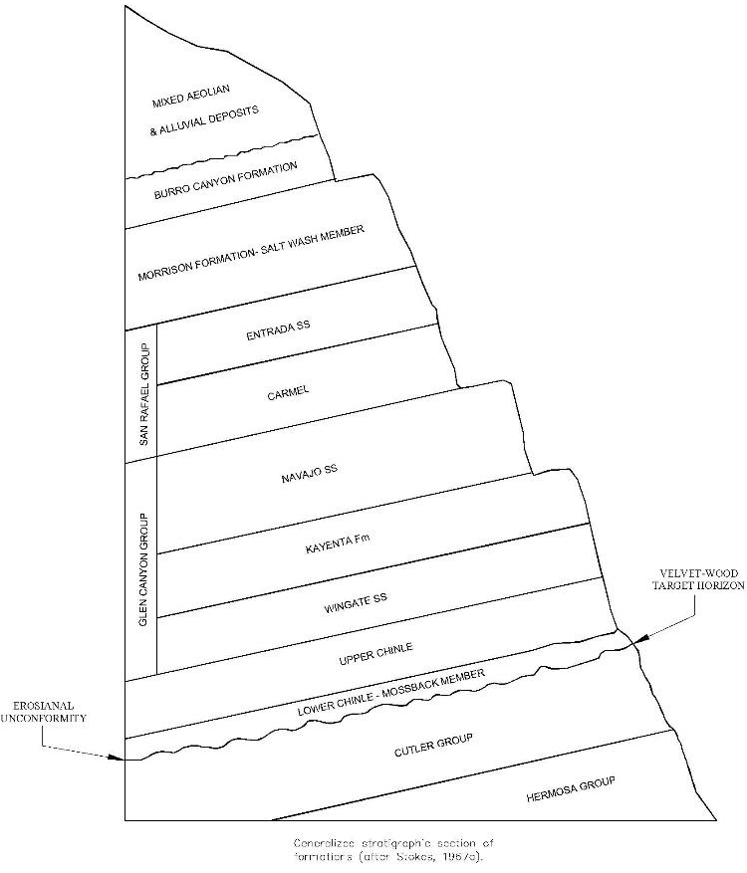
Much of the historic mining in the vicinity such as the Bardon, Divide, School Section, Pats, and Service Berry mines are pre-1960 except for the Velvet Mine (1979-1984). With the exception of the Velvet and Bardon mines, most of these are in the Chinle formation and were mined prior to 1941. The discovery of mineralization in the Cutler formation was late, therefore the Cutler is largely unexplored (Chenoweth, 1990). Most of the earlier drilling stopped at the base of the Chinle. Further to the east, the discovery of the Wood Deposit was reported by Uranerz in 1987 in T31S, R26E, Section 7 (Chenoweth, 1990). The Bardon, Velvet and Wood mines are oriented along a common trend beginning in the northwest at the Bardon Mine and proceeding to the southeast through the Velvet Mine to the Wood Mine along a trend of more than 6 miles. Limited exploration has been conducted between the Velvet Mine and Wood area, and the Bardon Mine and the Velvet Mine, but these areas remain largely unexplored. The reader is cautioned that additional drilling may or may not result in discovery of additional mineral resources on the property.

8.2 Slick Rock Deposit Type
There has been much discussion and debate regarding ore forming mechanisms in the Slick Rock area, but there is good agreement on several contributing factors:
The Brushy Basin and Salt Wash members contain significant concentrations of detrital volcanic debris which is strongly suspected as the source of uranium and vanadium.
Compaction and de-watering during burial of these sediments allowed for the transport mechanism along preferential pathways dictated by permeability and porosity within transmissive sand units of the Morrison Formation.
The uranium and vanadium in solution within a transmissive sand unit encountered a reduced environment locally caused by abundant plant remains and evidenced by reduced green mudstone found within the Salt Wash sandstones. This environment favored precipitation of uranium along a solution interface between the uranium in an oxidized alkaline solution and a strongly reduced acidic environment.
The physical expressions of the deposits formed at the solution interface have a variety of shapes and volumes. In the following, Shawe provides an excellent summary of the deposit morphology in the Slick Rock district:
Two general forms of ore bodies are common in the Morrison Formation in the district, one tabular and the other so-called “roll”. Some deposits consist mainly of tabular ore bodies and others are dominantly of roll bodies, although both types display elements of the other, and in many places tabular bodies are continuous with roll bodies. Some deposits have both types significantly developed. The two types were deposited by the same general process and at the same time; differences in their forms were dictated by local differences in the lithology of the host sandstone units that controlled fluid movement (Shawe, 2011).
In the Slick Rock district, uranium/vanadium deposits of the Morrison are mainly tabular to lenticular and elongate parallel to sedimentary trends. Tabular trends are localized in massive sandstones where clay and mudstone are interstitial, in scattered and streaked gall and pebble accumulations, and are found in discontinuous lenses. Conversely, roll deposits are narrow, elongate, and curve sharply across bedding and appear to be confined to sandstone where clay and mudstone are well indurated within interconnected layers. Mineralization in either case, tabular or roll deposits, averages about 0.25% U₃O₈ and 1.5% V₂O₅ within the mineralized sandstone. The mineralized bodies have an average thickness of 2 to 4 feet and range in size from a few feet wide to several hundred feet wide (Fischer and Hilbert, 1952). These deposits can contain a few tons of ore to several thousand tons in the larger ore bodies.
Details of the forms of roll ore bodies related to lithologic differences and mineral distribution within rolls (calcium-carbonate, titanium oxides, barite, and iron oxides) provide strong evidence that the deposition of the mineralized bodies occurred at an interface between two chemically differing solutions (one that is oxidized and one that is reduced). The interface interpretation was first proposed by Fischer in 1942. Continuity of the roll ore bodies with tabular bodies indicate that the tabular bodies also formed at a solution interface. It is important to note that the term “roll” was coined by local miners to describe the geometry of ore bodies that cut across sedimentary bedding and does not imply similarity to the geochemical process involved in forming the “roll” deposits of Wyoming and South Texas uranium provinces, as illustrated in Figures 8.2a and 8.2b, (Shawe, 2011).

Figure 8.2a - Uranium/Vanadium Deposits of the Slick Rock District, Colorado
Perspective Geologic Cross Section of Roll Ore Bodies (Shawe, 2011, paper 576-f)
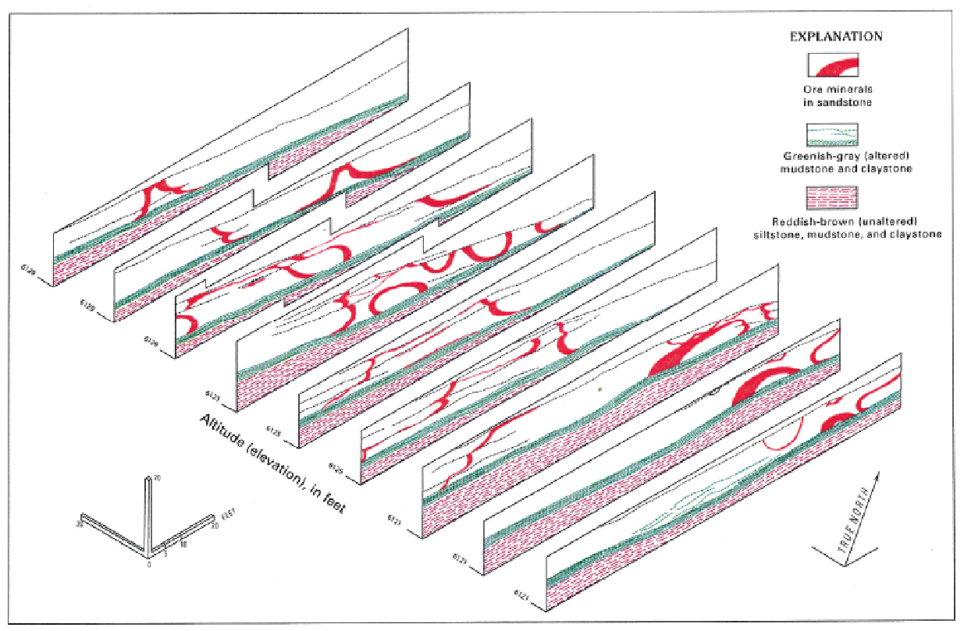
Figure 8.2b - Uranium/Vanadium Deposits of the Slick Rock District, Colorado
Perspective Geologic Cross Section of Tabular Ore Bodies (Shawe, 2011, paper 576-f)
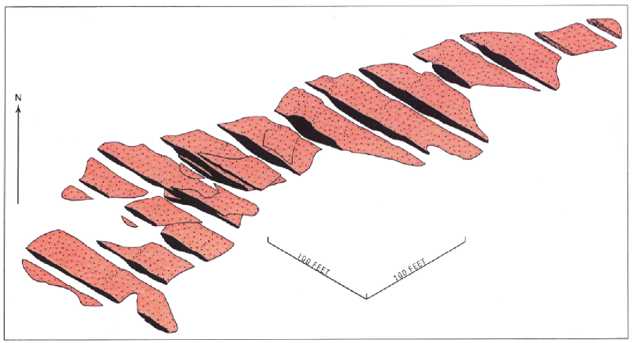
The uranium- and vanadium-bearing minerals occur as fine-grained coatings in detrital grains; they fill pore spaces between the sand grains and replace carbonaceous material and some detrital grains (Weeks et al., 1956). The primary uranium minerals are uraninite (UO₂) with minor amounts of coffinite (USiO₄OH). Montroseite (VOOH) is the primary vanadium mineral, along with vanadium clays and hydromica. Metal sulfides occur in trace amounts. Secondary minerals: calcium uranyl vanadate (Tyuyamunite) (Ca(UO₂)₂(VO₄)₂ . (5-8)H₂O) and potassium uranyl vanadate (Carnotite) (K₂(UO₂)₂(VO₄)₂ . 1-3H₂O) occur in shallow oxidized areas and on outcrop. Figure 8.3 shows a typical specimen of oxidized uranium/vanadium minerals collected underground in the vicinity of the Burro No. 3 shaft and the scintillometer.
Figure 8.3 – Slick Rock Sample and Scintillometer
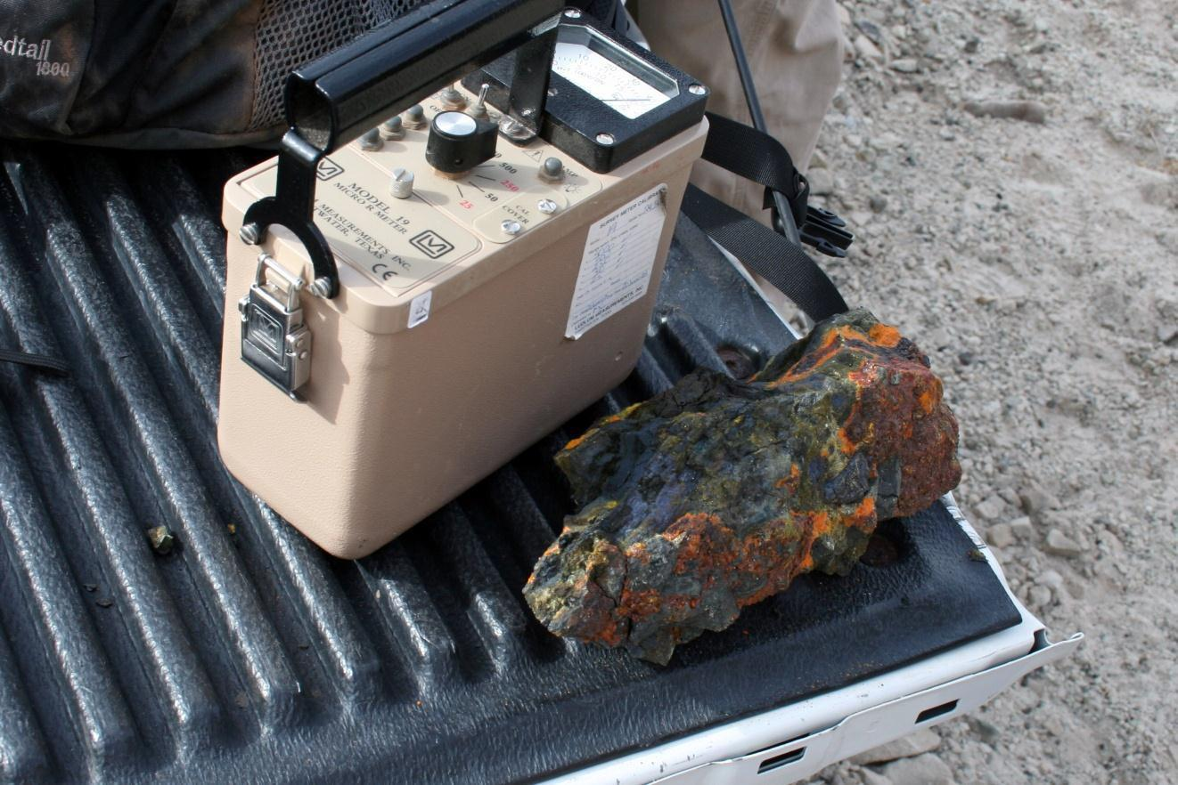

Section 9: Exploration
Anfield has not conducted exploration within or near either the Velvet-Wood or Slick Rock mine areas.
In the late 1940s and through the1950s, extensive exploration was conducted by the US Atomic Energy Commission (AEC) and private parties throughout the region during the Manhattan Project. These programs consisted of geologic mapping, ground and aerial radiometric surveys, trenching, and rock and sediment sampling. Subsequently exploration has been primarily limited to drilling.

Section 10: Drilling

10.1 Drill Summary
Anfield has not conducted drilling on either the Velvet-Wood or Slick Rock projects. A summary of the drill data acquired by Anfield from previous operators follows.

10.2.1 Velvet-Wood Drilling
Atlas and MRC conducted extensive rotary and limited core drilling on the Velvet Mine area that was included in the acquisition of the property, including the delineation of 4 mineralized areas with drilling on a rough grid approximating 100 foot centers.
The available drill data for the Velvet Mine project area includes radiometric data from some 173 drill holes completed on the property. From 1985 through 1991, Uranerz completed a total of 120 known historic vertical rotary drill holes in the Wood Mine project area. There are geophysical logs available for 96 of those historic drill holes. Of the 96 logs, 95 of the historic geophysical logs typically consist of natural gamma, resistivity, spontaneous potential (SP), half foot radiometric grade of uranium measured in weight percent U₃O₈, and vertical deviation data which were matched with a northing and easting collar location and collar elevation from available drill hole maps. All geophysical logging was performed by Century Geophysical Corporation for Uranerz. Industry standard practice for Century Geophysical logging trucks included calibration of the logging trucks routinely at Department of Energy facilities.
Drilling averaged a depth of 1,538 feet and ranged from 1,240 feet to 1,870 feet. All of the holes were surveyed for down-hole deviation, and deviation data was available from the geophysical logs. Drift at the mineralization horizon ranged from 5 feet to over 258 feet and averaged 63 feet to the northeast, or up dip. The dip of the host formation is approximately 8 degrees to the southeast. Drilling was conducted vertically although virtually all drill holes drifted up dip. The average vertical declination was approximately 2.3 degrees from vertical. Because this declination opposed the dip of the formation, the effect of dip on true thickness is diminished. Considering the effect of the actual drill hole declination from vertical, the correction to true thickness would be less. This means that a 10-foot thickness interpreted from the geophysical log would actually be 9.99 feet. At this level, the data correction would be less than the accuracy of the original data, which is interpreted down to one foot. As a result, no correction is necessary from the log thickness to true thickness.
Additional exploration drilling was conducted by Uranium One in 2008, generally focused between the areas of known mineralization at Velvet and Wood. The drilling showed low grade mineralization but did not encounter significant mineralization. In total, Uranium One completed 43 drill holes at Velvet and 14 drill holes at Wood. Locations of all known drill holes are shown on Figure 10.1. Drilling results for the Velvet-Wood project are summarized in Tables 10.1 through 10.3 which follow. Note values are expressed as Grade Thickness (GT), the product of average grade (%eU₃O₈) x thickness (feet).

Table 10.1 - Historic Drill Results Velvet Area*
Barren | Trace  < 0.1 GT | Mineralized  0.1–0.25 GT | Mineralized  0.25-0.5 GT | Mineralized  > 0.5 GT | TOTAL
6 | 30 | 29 | 24 | 84 | 173
3.5 % | 17.3 % | 16.8 % | 13.9 % | 48.6 %

Table 10.2 - Historic Drill Results Wood Area*
Incomplete | Barren | Trace  < 0.1 GT | Mineralized  0.1–0.25 GT |  | Mineralized  0.25-0.5 GT | Mineralized  > 0.5 GT | TOTAL
1 | 20 | 40 | 7 | 6 |  | 21 | 95
1.1 % | 21.1 % | 42.1 % | 7.4 % | 6.3 % |  | 22.1 %
*The historic data available for Velvet was limited to data from the previous MRC mineral holdings. The historic data available for Wood was from the previous Uranerz mineral holdings.

Table 10.3 - 2007/2008 Drill Results Velvet-Wood
Incomplete | Barren | Trace  < 0.1 GT | Mineralized  0.1–0.25 GT | Mineralized  0.25-0.5 GT |  | Mineralized  > 0.5 GT | TOTAL
3 | 15 | 20 | 6 | 7 | 6 |  | 57
5% | 26% | 35% | 11% | 12% | 11%

Figure 10.1 - Velvet-Wood Drill Hole Map
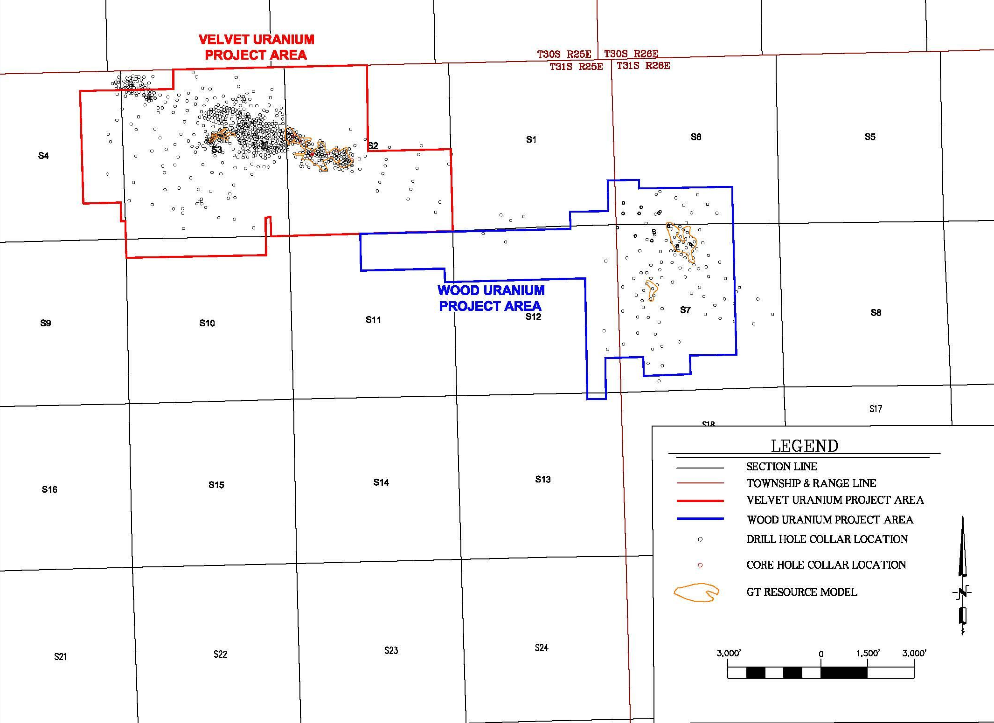

10.2.2 Slick Rock
Anfield has not conducted any exploration drilling on the Slick Rock project. Anfield has obtained radiometric and chemical assays and from U.S. Atomic Energy Commission's exploration program OFR70-348 for vanadium and uranium values, respectively, from those holes drilled by the USGS on behalf of the Raw Materials Division of the AEC. Logs for boreholes drilled by USEC and Energy Fuels were obtained by claim acquisition, and the uranium intercept values from the logs for boreholes drilled by Homeland Uranium were available in the public domain.
A total of 312 holes are known to be contained within or proximal to the Slick Rock project area. Of that total, 27 of these holes had locations but no other data leaving 285 drill holes upon which to build a database. Of the 285 holes in the database used for resource estimation, 207 were drilled by Union Carbide, 53 by the USGS, 17 by USEC and 4 each by Energy Fuels and Homeland Uranium. Within the 285 drill holes data was available on 346 discrete intercepts distributed between 3 stratigraphically distinct zones.
Mineralization at Slick Rock occurs within three stratigraphic horizons of the Jurassic Morison Formation. Three-Dimensional Plotting and correlation of the Slick Rock intercept demonstrated three vertically distinct mineralized zones running along dipping bedding. The A zone is stratigraphically the youngest and highest in the section, followed by the B zone and then the deepest C zone. A summary of drill results follows in Table 10.4. Drill hole locations are shown on Figure 10.2.
Table 10.4 - Slick Rock Drill Hole Intercepts by Zone
 | Intercepts in database | Composited Intercepts | Composited Intercepts above 0.02 % eU₃O₈
Zone A | 109 | 46 | 13
Zone B | 214 | 129 | 67
Zone C | 23 | 6 | 3

Figure 10.2 - Slick Rock Drill Hole Map
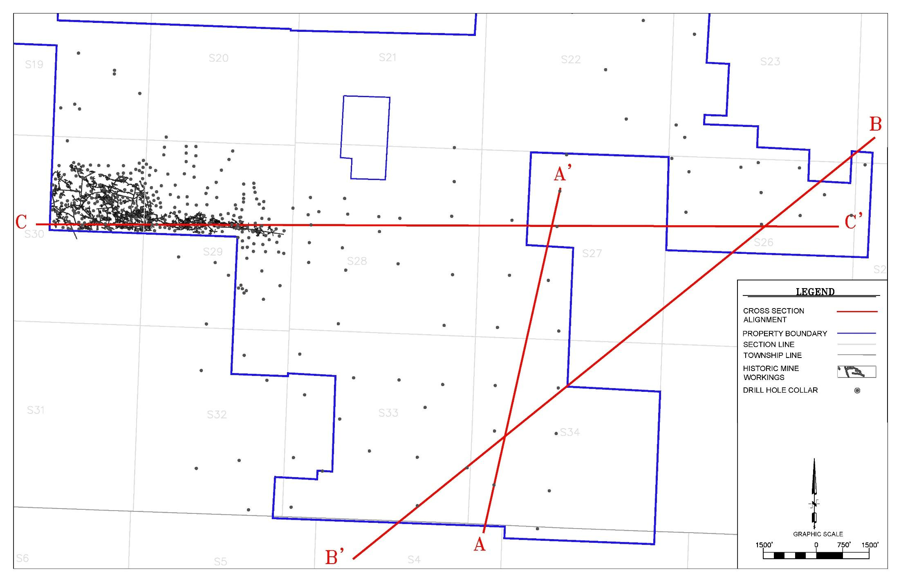

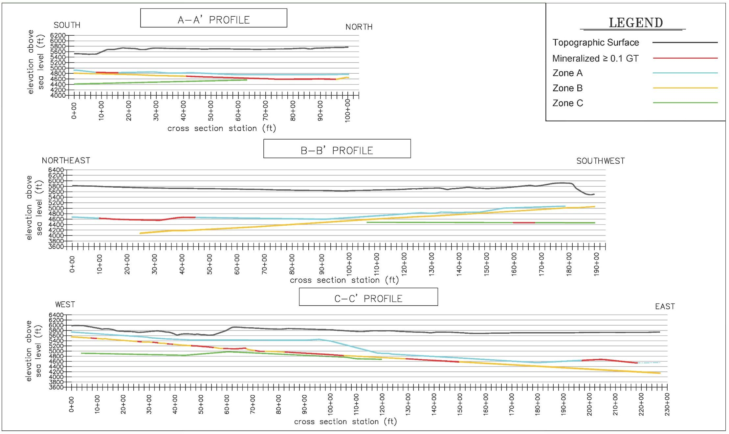
Figure 10.3 - Slick Rock Cross Sections

Section 11: Sample Preparation, Analyses, and Security

11.1 Velvet-Wood Sampling
The Velvet-Wood Mine Uranium Project was initially drilled during the 1970s and 1980s with the principal exploratory work and drilling completed by Gulf and Uranerz for the Velvet and Wood properties, respectively. As previously discussed in Section 14, the data is considered accurate and reliable for the purposes of completing a mineral resource estimate for the property.
Core drilling completed during the 2007/2008 drilling program was directly supervised by BRS and Uranium One personnel including Doug Beahm and personnel under his direct supervision. On site personnel completed lithologic logging of rotary and core samples. Upon completion of drilling, geophysical logs of the drill holes were completed by a commercial provider of such services, Century Geophysical. The loggers were contractually required to provide Uranium One with calibration data and the k-factor for their probes and completed onsite calibration for each hole.
With respect to QA/QC for equivalent uranium measurements (eU₃O₈) by downhole geophysical logging, the Department of Energy (DOE) maintains standard calibration pits located in Grand Junction, Colorado for use by the US uranium industry for instrument calibration. For Velvet and Wood, the original log files contain a record of the geophysical probes which show the instruments were calibrated at the DOE standard calibration pits located in Grand Junction, Colorado prior to the drilling program. For example, the geophysical logging unit which measured eU₃O₈ for core holes DW14T-08 and SLV-8883T-08, completed on 10/02/2008 and 9/25/2008, respectively were calibrated at the Grand Junction DOE facility on 9/22/2008.
Drill core was placed in protective plastic sleeves at the drill site and packaged into core boxes. Mineralized core was subsequently split for analysis and metallurgical testing with half of the core retained. The core splits were delivered to the testing laboratory and testing facility, Hazen Research (Hazen), by the author, Beahm, and a chain of custody established. In addition, select core samples were chosen for geotechnical testing. Chemical assays were completed by the following methods:
- Uranium by fluorometric assay.
- Vanadium, molybdenum, arsenic, iron, magnesium, aluminum, calcium, thorium, zinc, copper, nickel, cobalt, and manganese by semi-quantitative x-ray fluorescence (XRF).
- Uranium equivalent (eU₃O₈) by gamma spectroscopy.
Hazen is located at 4601 Indiana Street, Golden, Colorado, USA 80403. Hazen has provided analytical services for the uranium mining and processing industries since the early 1960s. An outgrowth of this activity has been the Radiochemistry Laboratory, which specializes in the determination of the long half-life radionuclides of the uranium and thorium decay series and radionuclides produced from nuclear power generation. These isotopes emit alpha, beta, and gamma radiation. Hazen holds a variety of state and federal certifications to perform radiochemical testing on drinking water from domestic and foreign sources, including NELAC Certification by the State of New York. Typical parameters include gross alpha/beta, gross gamma, radium-226, radium-228, radon in water, thorium, tritium, strontium, cesium, and uranium. In addition, Hazen Analytical Laboratory holds certifications from various state regulatory agencies and from the USEPA.
It is the authors’ opinion that the sample preparation, security, and analytical procedures were in keeping with industry practice and are adequate for the purposes of this report.

11.2 Slick Rock Sampling
Anfield has not conducted a drilling and/or sampling program on the Slick Rock project. The only chemical assay values are historical and were generated by the AEC laboratories. Later operators (USEC, UCNC, Homeland Uranium, Energy Fuels, and UEC) relied on radiometric values and did not perform chemical assays.
Samples were prepared by the USGS on behalf of the Raw Materials Division of the Atomic Energy Commission (AEC). USGS geologists conducted diamond drilling and radiometrically logged the holes, described the lithology, and scanned the cores for radiometric anomalies using a Geiger counter. Within Anfield’s Slick Rock project area, 51 of the 52 core samples were retrieved with greater than an 80% recovery rate. Only borehole DV-88 was less than 80% at a 65% recovery rate (OFR70-348).
Sample intervals with radiometric anomalies greater than 0.045% eU₃O₈ were shipped to the AEC labs in Washington, D.C., Denver, CO, or Grand Junction, CO for chemical determination of uranium and vanadium content. The precise chain of custody of these samples is unknown. The AEC laboratories determined uranium values using fluorometric, colorimetric, volumetric, polargraphic, coulometric, radioactivation, X-ray spectrometric, and nuclear photographic plate techniques. The choice of method is determined by many factors such as the concentration of uranium in the sample, its chemical complexity, the accuracy sought, the speed required, and the availability of the instrumentation (Grimaldi, 1955). AEC laboratories determined vanadium content via wet chemical digestion and volumetric determination by using a prescribed method developed by Claude W. Sill, U.S. Bureau of Mines, Salt Lake City, Utah and compiled and edited by R. W. Langridge in AEC publication, RMO-3001. The certifications held by the AEC laboratories are unknown.
The samples were collected and processed according to strict protocols developed by the AEC and other U.S. government agencies. The results are consistent with later industry analyses. The authors believe the determinations of grade are sufficiently accurate and precise to support the estimation of mineral resources.

Section 12: Data Verification

12.1 Velvet-Wood Data Verification
The primary assay data for the Velvet-Wood Project is downhole geophysical log data. A comparison of downhole radiometric geophysical data to chemical core assays was also completed to evaluate radiometric equilibrium conditions.
Ten of the 96 Wood Project logs were chosen at random and reviewed for data entry errors. In one instance half foot uranium grade data from a printout was compared to half foot grade data that was scaled from a histogram. The two data sets varied by less than 0.002 %eU₃O₈. This amount of variance is insignificant. No grade data entry errors were found. Five drift data entry errors were corrected. Due to the preliminary amount of drift data entry errors, all drift data entries were checked and corrected if necessary. One hundred percent of the log data entry was reviewed after entry and corrected where necessary. Multiple maps were rectified, and point locations and rectifications were checked for consistency and any data entry errors.
Historic drill data for each drill hole consisting of radiometric data was posted on drill maps including collar elevation, elevation to the bottom of the mineralized intercept, thickness of mineralization, grade of mineralization, and elevation of the bottom of the hole. Data entry was checked and confirmed. Drill hole locations were digitized from the drill maps to create a coordinate listing and then plotted. The resultant drill maps were then checked and confirmed by overlaying with the original maps.
2008 drill data included collar elevation, collar location, grade and elevation of mineralized intercepts, and elevation of bottom of hole. New drill hole locations were taken from field surveys using modern survey grade GPS equipment. All historic coordinates were converted to match the Utah State Plane NAD83 coordinate system. This conversion included the re-surveying of a limited number of historic survey monuments and rectification of the historic coordinate system to the Utah State Plane NAD83 coordinate system. With this rectification, historic drill holes could be located in the field with an estimated error of approximately 15 feet. Further field surveys should be completed to increase the accuracy of historic drill hole coordinates.
A comparison was completed of historic drill hole Sum GT data with 2008 Uranium One drill hole Sum GT data for three holes completed which were intended to twin holes SLV-8806, SLV-8803, and DW-14. The closest of the 2008 core holes to historic data was SLV-8806T-08 which is approximately 23 feet to the southeast of SLV-8806 at mineralization. SLV-8806T-08 had an 8.28 GT as compared to SLV-8806 with a 6.12 GT. Drill hole SLV-8803T-08 deviated approximately 25 feet to the west from SLV-8803 at mineralization. SLV-8803T-08 had a 2.08 GT as compared to SLV-8803 which had a 9.36 GT. No deviation data is available for the historic drill hole DW-14 so the distance to the intended twin drill hole is not known at depth. The 2008 drill hole DW-14T-08 did not intercept mineralization above cutoff grade as compared to DW-14 with a 1.65 GT.
Although the GT values of holes SLV-8803T-08 and DW-14T-08 are less than the intended twin holes, the drill holes show mineralization at the same elevation, in the same host rock, and with approximately the same mineralized thicknesses. The drill holes therefore confirm the continuity of the host formation but indicate that variations in grade should be expected, as seen historically at Atlas’ nearby Velvet Mine.

12.2 Slick Rock Data Verification
Anfield has not conducted any drilling activities at the Slick Rock project to verify data generated by the USGS or subsequent operators. Anfield has obtained radiometric and chemical assays and from U.S. Atomic Energy Commission's exploration program OFR70-348 for vanadium and uranium values, respectively, from those holes drilled by the USGS on behalf of the Raw Materials Division of the AEC. Logs for boreholes drilled by USEC and Energy Fuels were obtained by claim acquisition, and the uranium intercept values from the logs for boreholes drilled by Homeland Uranium were available in the public domain.
Previous owner, UEC, validated historic drill sites by locating and measuring drill hole locations in the project area using a Trimble GeoXH mapping-grade GPS unit. The authors reconfirmed multiple site locations during their site visit on April 12, 2023. The drill hole database was compared with measured geo-spatial coordinates from the previous field work where physical locations of all available drill holes were found to be consistent with their locations stated in the database.
The authors audited the OFR70-348 data from copies of the original documents and re-extracted the intercept data for comparison to the existing database acquired by Anfield in acquisition from UEC. Where data in the database was missing compared to the original Geologic and Assay Logs from the USGS that data was taken into the database. Few present inconsistencies in the UEC database were explainable by data entry error and corrected to match the original document data.
The veracity of the OFR70-348 documents was confirmed to the authors by location of multiple duplicate originals from a separate USGS file collection. The separate USGS documents were found to be identical between the USGS data set and the one provided by Anfield for 5 holes that occurred in both data sets. The 5 identical holes are: DV-5A, DV-39, DV-40, DV-41, DV-42.
A total of 312 holes are known to be contained within or proximal to the Slick Rock project area. Of that total, 27 of these holes had locations but no other data leaving 285 drill holes upon which to build a database. Of the 285 holes in the database used for resource estimation, 207 were drilled by Union Carbide, 53 by the USGS, 17 by USEC and 4 each by Energy Fuels and Homeland Uranium. Within the 285 drill holes data was available on 346 discrete intercepts distributed between 3 stratigraphically distinct zones.
Given the consistency of the results from government and private industry drilling, the ability to recover historic information in original form, the ability to locate the drill collars in the field, and the agreement of drill results with nearby mine production, the authors believe the sample data are sufficiently accurate and precise to generate an inferred mineral resource estimate as described in Section 14.

12.3 Density

12.3.1 Velvet-Wood Density
Atlas mining production reported a unit weight of 14.5 cubic feet per ton. Eight samples taken from Velvet core holes for geotechnical purposes were analyzed for density among other properties. The densities of the eight samples ranged from 123.1 to 163 pounds per cubic foot and averaged 136.1 pounds per cubic foot. This converts to an average density of 14.7 cubic feet per ton as compared to the historic value of 14.5 cubic feet per ton. In this report, for the purposes of mineral resource calculations, a density factor of 14.5 cubic feet per ton is recommended.

12.3.2 Slick Rock Density
The 1954 and 1956 USGS reports on “Accuracy of Uranium and Vanadium Estimates” assume a bulk tonnage factor in the Colorado Plateau to be 14 cubic feet per ton. The historic density expressed as a tonnage factor from Burro mine records is 15 cubic feet per ton. As the 15 cubic feet per ton is more conservative in its effect on the overall resource tonnage and pound of product and is proximal to the Slick Rock Resources, it is the most reasonable estimate of density in the opinion of the authors. Future verification drilling should incorporate a core drilling program to confirm the density factor for future resource estimation.

12.4 Downhole Deviation
Virtually all the drilling performed in both resource project areas was drilled vertically. Downhole deviation data of drill holes was primarily available for the Velvet mine portion of the Velvet-Wood project and partially available for the Wood portion. In the case of Velvet, where deviation data was available and verifiable the data was accommodated into drill hole databasing to adjust the location of the GT and T intercepts accordingly. In the cases of the Wood portion of the Velvet-Wood project and the Slick Rock project, all drilling was modeled as vertical.

12.5 Radiometric Equilibrium General Information
The dominant data available for evaluation of mineral resources of both the Velvet-Wood and Slick Rock projects was radiometric equivalent uranium data. This data consisted of radiometric geophysical logging data of each drill hole from which the uranium content was calculated using standard industry methods and calibration. Such calculations of equivalent uranium content from geophysical log data assume that the uranium is in radiometric equilibrium with its daughter products.
Radioactive isotopes decay until they reach a stable non-radioactive state. The radioactive decay products are of two general categories: the first being the sub-atomic energy generating product (i.e., alpha, beta, gamma, and neutron radiation) and the second being the atomic isotope. Decay product isotopes are referred to as daughters and occur down what is known as a decay chain. When all the decay products are maintained in close association with the primary uranium isotope U-238 for the order of a million years or more, the decay chain will reach equilibrium with the parent isotope; meaning that the daughter isotopes will be in a state of decay in the same quantity as they are being created (McKay, 2007).
An otherwise equilibrated decay system may be put into a state of disequilibrium when one or more decay products are mobilized and removed from the system because of differences in solubility between uranium and its daughter isotopes. In addition, both the primary isotope of uranium U-238 and its daughters emit different forms of radiation as they decay. The primary field instruments for the indirect measurement of uranium, either surface or down-hole probes, measure gamma radiation. Within the uranium decay chain, the gamma emitting elements are primarily Radium226, Bismuth214, and Uranium238. Of these Radium226 is the dominant source of gamma radiation.
Disequilibrium is considered positive when there is higher proportion of uranium present compared to daughters and negative where daughters are accumulated, and uranium is depleted. The disequilibrium factor (DEF) is determined by comparing radiometric equivalent uranium grade eU₃O₈ to chemical uranium grade. Radiometric equilibrium is represented by DEF of 1, positive radiometric equilibrium by a factor greater than 1, and negative radiometric equilibrium by a factor of less than 1. Negative disequilibrium occurs when uranium is separated from its daughters, specifically Radium. This occurs when the uranium mineralization is oxidized, liberating the uranium but leaving the radium in place.
Velvet-Wood project data from historical core drilling and the 2007/2008 coring program contains 41 individual core samples from 6 core holes. Comparing the core assay U₃O₈ GT values of each of the intervals to their corresponding radiometric equivalent eU₃O₈ GT values provides a DEF range of 0.81 to 1.59 with an average DEF of 1.33. Although the available data indicates a positive DEF, the authors recommend the use of a DEF factor of 1 for Velvet-Wood based of the limited number of data points and the fact that the core holes offset holes with relatively high thicknesses and grades rather than a representative sampling of the deposit.
There is very limited data available to the author from the USGS pertaining to radiometric equilibrium for the Slick Rock project. It is the author’s experience that the Colorado Plateau uranium deposits typically are neutral to slightly positive in their DEF. As such, a DEF of 1 is assumed for the Slick Rock resource estimate. Future verification drilling should incorporate core drilling samples to confirm the disequilibrium factor for future resource estimation.

Section 13: Mineral Processing and Metallurgical Testing
During the period 1953-1980, there were as many as 24 uranium and uranium/vanadium mills operating in the Colorado Plateau region of Arizona, Utah, Colorado, and New Mexico. The “gold standard” reference for the industry through 1970 was Merritt, 1971. If the vanadium content of the mill feed was sufficiently high, the mill usually had a vanadium byproduct circuit. A notable example was the Navajo mill at Shiprock, NM, built by Kerr-McGee Oil Industries Inc., later acquired by Vanadium Corporation of America and its successor, Foote Mineral Company. For operations without vanadium circuits, a vanadium penalty was sometimes assessed for toll and custom shippers.
The general processing technique employed by most mills was crushing and coarse grinding in rod mills, followed by agitated tank leaching in aqueous sulfuric acid at pH 1.5-2.0 with an oxidant like manganese dioxide or sodium chlorate, solution purification, and precipitation of a uranium oxide product. Early mills recovered uranium from the leached slurry with ion exchange resin beads suspended in mesh baskets, but commercialization of polyacrylamide flocculants allowed later plants to effect separation of the pregnant leach solution from the leached residue by counter-current decantation (“CCD”) in a string of thickeners. By 1970, nearly all plants treated the clarified pregnant leach solution (“PLS”) in solvent extraction (“SX”) circuits using tertiary amine extractants dissolved in a diluent that was usually a high-flash point kerosene.
Some mineralized material contained sufficient calcite to render acid leaching uneconomical, and leaching was conducted at elevated temperature and pressure in agitated autoclaves with sodium carbonate and bicarbonate in an aqueous solution. In this case, carbonate ion complexed the dissolved uranium and bicarbonate ion-controlled hydroxyl ion which otherwise would have prematurely precipitated the uranium as a hydroxide. A few mills, notably Anaconda’s operation at Bluewater, NM, treated ores on a toll basis and had both acid and alkaline circuits.
The plants with vanadium recovery circuits leached at a higher free acid concentration corresponding to pH 0.5-1.5 and recovered vanadium from the uranium SX waste solution (“raffinate”) in another SX circuit with a different extractant, typically an aliphatic phosphoric acid, or with a different concentration in the organic phase of the same extractant.
Overall recoveries of uranium were typically in the range of 93 to 97 percent and vanadium recoveries were 70 to 80 percent, depending on mineralogy and the extent to which soluble losses could be minimized during solid/liquid separation. It is very likely that the Shootaring Canyon mill will be able to achieve at least 96 percent U₃O₈ recovery, especially given the unusually high average feed grades of 0.24 to 0.29% U₃O₈ and the high free acid concentration during leaching. The vanadium plant will have the advantage of state-of-art instrumentation and process control and may readily achieve 80% V₂O₅ recovery.

13.1 Velvet-Wood Metallurgical Studies
Metallurgical studies have been completed on mineralized material from the Velvet deposit that was recovered from core drilling completed in 2007 and 2008 at the Velvet Mine. Metallurgical testing completed to date demonstrates that the mineralized material is amenable to acid leaching with conventional mineral processing methods.
Leaching experiments for 18 Velvet core samples were completed; however, three of the extractions were low due to laboratory errors and difficulties in pH control, as discussed in the summary report (Hazen Research, Inc., 2008). The average of the 15 experiments that were conducted under near-optimum conditions was 96.1 percent uranium extraction. However, the average grade of mineralized samples used in the leaching experiments was only 0.100% U₃O₈, while the run-of-mine diluted average grade is expected to be 0.265% U₃O₈ and the average grade mined from Atlas Mineral’s Velvet Mine was 0.46% U₃O₈. Therefore, the samples used in the leach experiments were substantially lower in uranium grade than the estimated grade of the Velvet and Wood mineralization. It is therefore possible that vanadium content and uranium extractions obtained in the tests were also lower than may be obtained with the estimated higher grades for mined material.
Acid consumption for baseline experiments averaged 118 lb/ton. Carbonate content in the mineralized material has a direct relationship to acid consumption during leaching and may influence uranium extractions either by causing excessive gypsum precipitation or by making pH control difficult. Sodium chlorate (NaClO₃) proved to be an effective oxidant. Molybdenum content for all of the core samples that were assayed averaged 99 ppm and molybdenum content in the pregnant leach solution averaged 0.17 grams per liter. Vanadium assay results from Uranium One’s 2007/2008 exploration program showed an overall average of 2.13 to 1 vanadium to uranium ratio, while the historic ratio was 1.39 to 1. On average, vanadium concentrations will be less than 1.00% V₂O₅, whether based on the historic vanadium to uranium ratio, or the ratio from 2008 assays.
No metallurgical testing has been completed on the Wood property. However, given the close proximity to Velvet and the fact that the mineralization lies within the same geologic unit as Velvet, similar metallurgical test results are expected. The mineralized core recovered from Wood in 2008 had similar mineralogy to that found in mineralized core recovered from Velvet in 2007, based on geologists’ direct observation of core and drill samples from both projects.
As alternatives to conventional milling, heap and vat leaching were briefly considered. However, this report is confined to agitated leaching, and there are several reasons for this decision:
- Vat leaching economics depend on rapid leaching kinetics that can be obtained in a 4- to 7-day leaching cycle, thereby minimizing the number of vats required. In order to ensure rapid solution percolation, the vat feed must be crushed to minus 0.25 to 0.5 inches, de-slimed, and the slimes separately leached in agitated tanks. Since fine particles dictate the thickener area requirement for a CCD circuit, vat leaching would require essentially the same size CCD system that conventional milling requires, negating most of the cost advantage usually attributable to vats;
- Heap leaching was applied successfully to several uranium ores during the 1960s and 1970s, but it has not been attempted when co-product vanadium is planned. Satisfactory vanadium extraction requires a higher free acid concentration, causing more severe attack of the gangue minerals and heightening the potential for secondary slimes to impair heap permeability;
- Neither vats nor heaps could reasonably be expected to achieve uranium extractions that can be obtained with milling.
Owing to the need to leach at an elevated free acid concentration to dissolve and complex vanadium, an acid consumption of 112 pounds of 98% H₂SO₄ per ton of leach feed was assumed.
The author of this section, Terry McNulty, is familiar with and has reviewed the available metallurgical testing and concludes that practices which have been employed are in keeping with industry standards, and the data available for completion of a PEA for the Project is reliable.

13.2 Slick Rock Metallurgical Studies
Anfield has not conducted any metallurgical tests for mineral processing at Slick Rock. Production from this property was processed by UCNC with acceptable recoveries by conventional milling methods for nearly 26 years. Uranium recoveries at the processing mill in Uravan, Colorado, were estimated to be 97 to 98%, and vanadium recoveries at the Rifle, Colorado, processing mill were estimated to be 85% according to personal communication with Curt Sealy, formerly with UCNC and UEC as VP-Strategic Development (Beahm, et al., 2014).

13.3 Recommended Metallurgical Recoveries
Owing to the need to leach at an elevated free acid concentration to dissolve and complex vanadium, an acid consumption of 112 pounds of 98% H₂SO₄ per ton of leach feed was assumed for the purposes of this PEA. Under these leaching conditions, the authors recommend metallurgical recoveries of at least 94% for uranium and 75% for vanadium as a conservative base case. However, it is very likely that the Shootaring Canyon Mill will be able to achieve at least 96 percent U₃O₈ recovery, especially given the high average feed grades of 0.24 to 0.29 % U₃O₈ and the high free acid concentration during leaching. The vanadium plant will have the advantage of state-of-art instrumentation and process control and may readily achieve 80% V₂O₅ recovery.
As a point of comparison, Energy Fuels, operator of the White Mesa, Utah, mill, predicted metallurgical recoveries for uranium and vanadium of 96% and 75%, respectively, from their La Sal, Utah project (Mathisen, 2022). The La Sal project is located less than 20 air miles from Velvet-Wood, is a similar sandstone-hosted uranium/vanadium deposit, and has similar uranium and vanadium grades.

Section 14: Mineral Resource Estimates

14.1 Mineral Resource Estimation
This report summarizes mineral resource for the Velvet-Wood and Slick Rock mines with mineral processing at a common facility, the Shootaring Canyon Mill. The total estimated uranium mineral resources are summarized in Table 14.1. The associated vanadium mineral resources which will be mined as a co-product are summarized in Table 14.2.
Table 14.1 - Velvet-Wood & Slick Rock Uranium Mineral Resource Summary*
Area/Classification | GT Cutoff | Pounds eU₃O₈ | Tons | Avg Grade %eU₃O₈
TOTAL MEASURED AND INDICATED MINERAL RESOURCE URANIUM | 0.25 – 0.50 | 4,627,000 | 811,000 | 0.29
TOTAL INFERRED  MINERAL RESOURCE URANIUM | 0.25 – 0.40 | 8,410,000 | 1,836,000 | 0.24
*Numbers rounded
Table 14.2 - Velvet-Wood & Slick Rock Vanadium Mineral Resource Summary*
Area/Classification | GT cutoff  (Based on Uranium) | V:U  Ratio | Pounds V₂O₅ | Tons | Avg Grade %V₂O₅
TOTAL INFERRED  MINERAL RESOURCE VANADIUM | 0.25-0.50 | 4.2 | 54,399,000 | 2,647,000 | 1.03
*Numbers rounded
While mineral resources are not mineral reserves and do not have demonstrated economic viability, reasonable prospects for future economic extraction were applied to the mineral resource estimates herein through consideration of grade and GT cutoffs as well as mineralization proximity to existing and proposed, conceptual mining. As such, economic considerations were exercised by screening out areas which were below these cutoffs or of isolated mineralization and thus would not support the cost of conventional mining under current and reasonably foreseeable conditions.

14.1.1 Definitions
A Mineral Resource is defined as a concentration of occurrence of natural, solid, inorganic, or fossilized organic material in or on the Earth’s crust in such form and quantity and of such a grade or quality that it has reasonable prospects for economic extraction. The location, quantity, grade, geological characteristics, and continuity of a mineral resource are known, estimated, or interpreted from specific geologic evidence and knowledge (CIM, 2014). Mineral resource estimates are classified as Measured, Indicated, or Inferred based on the level of understanding and definition of the mineral resource.

14.1.2 General Methodology
The GT contour method is used as common practice for Mineral Reserve and Mineral Resource estimates for similar sandstone-hosted uranium projects (“Estimation of Mineral Resources and Mineral Reserves”, adopted by CIM November 23, 2003, p. 51.) It is the opinion of the author that the GT contour method, when properly constrained by geologic interpretation, provides an accurate estimation of contained pounds of uranium.
The GT contouring method is the primary method of resource estimation employed for both the Velvet-Wood and Slickrock projects in this report. The GT contour methodology was applied to all areas of mineralization outside of the Velvet Mine workings. Within the mined areas of Velvet, mineral resources were estimated based on measurements of individual blocks of remaining mineralization and assignment of average grade and thickness from face and long-hole data. Individual resource blocks for these estimates are shown on Figure 14.1.
There are minor differences in the application of the GT contouring method between the Slick Rock and the Velvet-Wood projects dictated by legacy database infrastructure and specific modelling interpretations between projects, but the overall approach to the GT contouring and the fundamental calculation of resources for each project remains the same.
For both Velvet-Wood and Slick Rock, all individual drill hole intercept data meeting or exceeding the minimum reported grades (0.05% eU₃O₈ Velvet-Wood and 0.02% eU₃O₈ for Slick Rock) were first calculated, individually multiplying the thickness in feet by a average eU₃O₈ % grade resulting in a sum GT value in feet x % eU₃O₈ for each intercept. Intercept GT values were summed within each drill hole when the intercepts represented correlated three-dimensional continuous geologic zones such as the unconformity between the Moss Back and Cutler Members at Velvet-Wood.
The summed GT intervals were composited with interstitial waste values, and in the case of Velvet-Wood then diluted to a summed minimum thickness of 4 feet to accommodate split shot ore-waste mining. If the thickness exceeded 4 feet, no dilution was added to the Velvet-Wood dataset. No minimum thickness was applied to the Slick Rock intercept data, rather the Slick Rock data was composited to the total thickness within each zone and a 0.4 GT cutoff applied to the resource estimate which constrains the resource to an average thickness of 3.8 feet, or nominally 4 feet.
Summed GT and thickness for the summed mineralized intercepts of each zone were then contoured using standard ACAD Civil-3D algorithms creating a three-dimensional surface for GT and thickness in each zone. These surfaces were then bounded based upon the geological interpretation of each deposit. Verification of the contour models was performed by inspection against all the available data prior to calculating the resource estimate. From the contoured GT ranges, the contained pounds of uranium were calculated volumetrically. The generation of these contour model volumes was done for both projects in ACAD Civil-3D but in different versions using slightly different techniques. In the case of Velvet-Wood the resource calculation was performed on a banded area times thickness basis, while Slick Rock was calculated using the Civil-3D surface volumetrics toolset. Velvet-Wood was validated using the volumetrics tool set and found to be within 1 to 3% of the banded area times thickness method. This is a reasonably small amount of variance between calculation methodologies, and cross validates the results of the same contour model calculated using both methods.
Validation of each of the sum GT and sum thickness contour models is performed via inspection of the model contours to all available data prior to resource calculation. All interpolation within the maximum radius of influence is performed via the inverse distance square method from available data when manually constructing contours. Interpolation between manual contours and points is performed by the Civil 3D standard algorithm parameters. It is the opinion of the authors that the resource models are reasonably valid within the mineral resource classification assigned to each area of each project.

14.3 Project GT Resource Modeling - Key Assumptions and Criteria
Data cutoffs and modeling assumptions are critical components of any resource modeling method. Modelling parameters are dictated by several factors including density of drilling data, deposit characteristics and interpreted geologic model. In the case of both the Velvet-Wood and Slick Rock projects, they are both stratigraphically controlled, sand-stone hosted uranium/vanadium deposits of the Colorado Plateau style, as discussed in Section 7 above. This deposit style has been modelled well in the authors experience by the GT contouring method and has yielded results which have proven accurate enough to guide mining operations for many decades.
The Modeling Assumptions and Data Cutoffs applied to each model are stated below in Table 14.3 Below:
Table 14.3 - Modeling Assumption Parameters by GT Contour Model
Modeling Assumption Parameter | GT Contour Resource Model
 | Velvet Mine | Wood Mine | Slick Rock Mine
Minimum reported grade (% eU₃O₈) | 0.05 | 0.05 | 0.02
Nominal Thickness (ft) | 4 | 4 | 4
Maximum Radius of Influence (ft) | 100 | 100 | 400
Radiometric Equilibrium Factor (DEF) | 1 | 1 | 1
Bulk Tonnage Factor (cft/st) | 14.5 | 14.5 | 15
Minimum Sum GT Resource Model Cutoff | 0.25 - 0.50* | 0.25 | 0.40

Minimum grade and thickness criteria are used to define mineralized intercepts for resource modeling purposes. These are applied to each individual mineralized intercept and then to the sum GT of intercept composites are applied to the data prior to contour modeling. Data not meeting these minimum requirements are removed from the modeling data set and have no influence on the contour model other than establishing its boundaries.
As discussed previously, a minimum thickness dictated by mining approach is typically applied at the data preparation level and thus some mining dilution can be accounted for as was done for Velvet-Wood at the minimum mining thickness of 4 feet. In the case of Slick Rock, the average thickness was 3.8 feet, or essentially equal to the minimum mining thickness, so the minimum thickness was not applied.
Maximum radius of influence is influenced by the drilling density and the continuity of the deposit model. The tighter drilling spacing of the Velvet and Wood data allows for a smaller maximum radius of influence and a more certain resource classification. The larger drill spacing available at Slick Rock provides decreased certainty and a lower resource classification in the Inferred category.
The bulk tonnage factors and DEF discussed in Section 12 of this report were used in the calculation of the resource quantities from the sum GT and sum thickness contour model volumes.
The minimum sum GT contour resource model cutoff is the primary cutoff criteria applied to the contour model volume as the initial screening of those portions of the model quantities not meeting the criteria for reasonable economic extraction. In addition, individual model areas outside the conceptual mine limits not meeting a minimum of 10,000 lbs of eU₃O₈ resource were dropped from the resource totals as not meeting a minimum expectation of reasonable economic extraction.

14.4 Reasonable Prospects for Economic Extraction and Cutoff Criteria
Based on conceptual mine limits as discussed in Section 16 and the average grade, thickness and GT criterion applied to the estimate, it is the authors’ opinion that the mineral resources estimated for the project which include the Velvet-Wood and Slick Rock mines can be reasonably and economically recoverable through underground mining methods including haulage from the mine sites to the Shootaring Canyon Mill for conventional mineral processing and product recovery. Both mines need to operate simultaneously in order to meet the mill tonnage capacity and/or an alternate feed would be needed.
The project economics as defined in the PEA and presented in Section 21 and 22 has a positive NPV and a reasonable internal rate of return based on commodity prices of $70 per pound for uranium oxide and $12 per pound for vanadium pentoxide as discussed in Section 19.
As previously discussed, a minimum mining thickness of 4 feet was applied to the Velvet-Wood and Slick Rock mines. The minimum GT applied to the mineral resource estimate varied from 0.25 to 0.50 at Velvet-Wood and was 0.40 at Slick Rock. The minimum GT cutoff criteria defines the lowest volume and quality (thickness and grade) of mineralized material which would break even with respect to marginal operating costs. In practice, the mine would operate at a higher or primary cutoff until the capital for the mine and mill was recovered. Where it is necessary to excavate mineralized material below this primary cutoff and above the minimum cutoff, this material would be stockpiled and the cost of excavation and handling this material born by the primary mined material. Thus, this marginal mineralized material could later be recovered if it meets haulage and milling costs. Note if the marginal mineralized material were treated as mine waste, the same general cost excavate and handle this would be incurred with no possible future benefit.
The lowest cutoff criteria was therefore a 4 foot minimum thickness at a 0.25 %ft GT, equating to an average grade of 0.065 %eU₃O₈. The lowest Vanadium to Uranium (V:U) ratio is at Velvet and is 1.4:1 resulting in an average grade of 0.091 %V₂O₅.
- At 0.065 %eU₃O₈ contained pounds equal 1.3 lbs U₃O₈ per ton
- At 92% recovery this equals 1.2 lbs U₃O₈ recovered per ton
- At $70/lb sales price, the gross value of one ton of material at 0.065 %eU₃O₈ is approximately $84 per ton.
- At 0.09 %V₂O₅ contained pounds equates to 1.8 lbs %V₂O₅ per ton
- At 75% recovery this equates to 1.4 lbs V₂O₅ recovered per ton
- At $12/lb sales price, the gross value of one ton of material at 0.09 %V₂O₅ is approximately $17 per ton
- Overall, the value per ton at the minimum cutoff and at the lowest V:U ratio is thus $101/ton.
- The PEA estimates a haulage cost of $21/ton and a milling cost of $70/ton or a total of $91/ton.
- Assuming the mining costs are written off against the primary mined material, the minimum cutoff criteria would thus represent a breakeven cost.
The author concludes that application of both the minimum grade and minimum GT cutoffs represent a breakeven point with respect to mineral value and cost of production.
For this PEA, the mine limits and cutoff criteria, including the conceptual mine limits, were applied to the mineral resource estimate to segregate mineral resources having reasonable prospects for eventual economic extraction from within the overall envelope of mineralization. This resulted in a reduction of the estimated mineral resource as shown on Figures 14.1 through 14.6 at an average grade approximately five times the minimum cutoff grade. It is recommended that mine plans and costs be updated in a future preliminary economic assessment or pre-feasibility study.

14.5 Measured Mineral Resources, New Velvet Mine
Measured mineral resources are limited to the New Velvet area in Section 2, Township 31 South, Range 25 East (Figure 14.3). The current estimate follows with the recommended cutoff, 0.25 GT, highlighted:
Table 14.4 – New Velvet Measured Mineral Resources*
GT minimum | Pounds eU3O8 | Tons | Average Grade %eU₃O₈ | Average Thickness (feet)
0.25 | 1,966,000 | 362,600 | 0.27 | 6.7
0.50 | 1,836,000 | 282,700 | 0.32 | 6.9
1.00 | 1,571,000 | 187,000 | 0.42 | 7.1
*Numbers rounded

14.6 Indicated Mineral Resources, Old Velvet Mine
The Old Velvet Mine Area is located in Section 3, Township 31 South, Range 25 East as shown on Figure 14.1. The mineral resource estimate addresses an undeveloped area (Area III) of the Old Velvet Mine and Areas I, II, IV, and East Side of the mine that were developed but left unmined. Areas I, II, IV, and East Side were closely delineated with underground face and longhole sampling as reported by Price, 1987. Area III was delineated by surface drill holes on approximate 100-foot centers.
Old Velvet Mine Area III - Resource Calculation Methods
Resource calculations were completed using the GT Contour method previously discussed. Although a mineral resource classification as Measured may be appropriate as discussed above for the New Velvet Mineral resources in Section 2, a classification of Indicated Mineral Resources is recommended for Old Velvet Mine Area III as the data has yet to be verified by surface drilling and is currently inaccessible for underground sampling. The current mineral resource estimate for Old Velvet Mine Area III follows:
Table 14.5 – Old Velvet Mine Area III Indicated Mineral Resources*
GT minimum | Pounds eU₃O₈ | Tons | Average Grade  %eU₃O₈ | Average Thickness (feet)
Undiluted
0.50 | 39,000 | 5,100 | 0.38 | 2.2
Diluted**
0.50 | 39,000 | 9,200 | 0.21 | 4.0
*Numbers rounded **used in summary Table 14.7 not additive to total
Old Velvet Mine Areas I, II, IV, and East Side - Resource Calculation Methods
The following are the current estimates of mineral resources for Old Velvet Mine Areas I, II, IV, and East Side (refer to Figure 14.1). These unmined areas were designated as Areas I, II, IV, and East Side and were sampled underground using a combination of face and longhole drill samples. The data was posted on underground mine maps (Price, 1987) which were used as the basis for Figure 14.1. The authors have audited the Price, 1987 data and have used the data as the basis of the current resource estimate. In the course of this estimate the following checks and calculations were made:
- The data was reviewed to assure that the posted data matched the data utilized in the calculations.
- The area of influence assigned to the data was reviewed and confirmed, specifically;
  - Rib and face samples were projected 10 feet into the rib face or through the pillar if other sides of the pillar were accessible and the projection was justified by the data.
  - Long-hole samples were projected 10 feet on each side of the long-hole fans.
- Density was reviewed. A density of 13 cubic feet per ton was used as compared to the 14.5 cubic feet per ton recommended in this report. This would have the effect of overstating the tonnage by 10% if the 14.5 cubic feet per ton were correct. However, the GT cutoff employed in the estimate was 0.6 as compared to the 0.5 to 0.25 range recommended in this report, which would offset this difference.
- Average thickness and grade were compared to all other sources of data including surface drill data.
- Mineralized areas delineated on the mine maps were digitized into AutoCAD and the total area, tonnage, and pounds were calculated and compared to the 1987 Price estimate.
The current mineral resource estimate using the methodologies described above for the Old Velvet Mine Areas I, II, IV, and East Side follows:
Table 14.6 - Old Velvet Areas I, II, IV, and East Side Indicated Mineral Resources*
GT minimum | Pounds eU₃O₈ | Tons | Average Grade  %eU₃O₈ | Average Thickness (feet)
Undiluted**
0.50 | 509,000 | 62,000 | 0.41 | 5.02
*Numbers rounded **used in summary, Table 14.7 not additive to total
Although a mineral resource classification of Measured for Old Velvet Areas I, II, IV, and East Side by CIM definitions may be appropriate based on the level of detail reflected in the data and the estimation, a classification of Indicated Mineral Resources is recommended for Old Velvet Areas I, II, IV, and East Side as the data has yet to be verified by field data. The area is currently inaccessible as the mine is flooded, and verification drilling from the surface would be impractical as surface drilling would likely not be able to maintain circulation in the vicinity of the mine openings.
Table 14.7 - Total Indicated Mineral Resources Old Velvet Mine Area**
GT minimum | Pounds eU₃O₈ | Tons | Average Grade  %eU₃O₈
0.50 | 548,000 | 71,200 | 0.38
*Numbers rounded ** Sum of Areas I, II, III, and IV

14.7 Indicated Mineral Resources, Wood Mine
The current indicated mineral resource estimate for the Wood project area, utilizing the GT contour method is shown on Figure 14.2, Wood Project Resource GT Map. A GT cutoff of 0.25 is recommended for reporting purposes in this report and is highlighted in the following table.
Table 14.8 - Total Indicated Mineral Resources Wood Mine
GT minimum | Pounds eU₃O₈ | Tons | Average Grade  %eU₃O₈
0.25 | 2,113,000 | 377,000 | 0.28
0.50 | 1,940,000 | 275,200 | 0.35
1.00 | 1,581,000 | 155,500 | 0.51
*Numbers rounded

14.8 Inferred Mineral Resources, Velvet-Wood
Inferred mineral resources were estimated for limited areas in both the Velvet and Wood areas where a reasonable prospect of mineralization could be based on geologic data from drilling but where drill spacing exceeded 100 feet. The areas where inferred mineral resources are projected for the Velvet and Wood Areas are shown on Figures 14.3 and 14.2, respectively.
Table 14.9 - Total Inferred Mineral Resources Velvet-Wood Areas
Resource Area | GT Cutoff | Pounds eU₃O₈ | Tons | Average Grade  %eU₃O₈
Wood | 0.25 | 34,500 | 11,000 | 0.16
Velvet | 0.25 | 517,500 | 76,000 | 0.34
TOTAL |  | 552,000 | 87,000 | 0.32
*Numbers rounded

14.9 Inferred Mineral Resources, Slick Rock
Inferred mineral resources for the Slick Rock area were evaluated based on reasonable prospects for future economic extraction through consideration of grade and GT cutoffs as well as mineralization proximity to existing and proposed conceptual mining. As such economic considerations were exercised by screening out areas of which were below these cutoffs or of isolated mineralization and thus would not support the cost of conventional mining under current and reasonably foreseeable conditions. All areas of resource falling below the screening criteria for reasonable economic prospects are shown in Figures 14.4, 14.5 and 14.6 as gray hatching and labeled.
A sensitivity analysis was performed on the mineral resource models for each zone as shown on Table 14.10. The authors recommend the 0.40 GT cutoff for the Slick Rock mine. With further definition of the mineral resource via drilling and additional mine design and cost evaluation, it is the authors’ opinion that the minimum GT cutoff may be lowered.
Table 14.10 - Slick Rock Inferred Resource Sensitivity Analysis
Mineral Resource Estimates  (0.02% Grade Cutoff) | Tons (millions) | Average Sum Thickness (ft) | Average Grade (%eU₃O₈) | Pounds eU₃O₈ (millions)
Zone A (Upper)
0.10 GT cutoff | 1.3 | 3.6 | 0.17 | 4.1
0.25 GT cutoff | 0.8 | 4.0 | 0.22 | 3.7
0.40 GT cutoff | 0.7 | 4.1 | 0.26 | 3.4
Zone B (Middle)
0.10 GT cutoff | 3.2 | 3.4 | 0.11 | 7.0
0.25 GT cutoff | 2.2 | 4.4 | 0.13 | 5.6
0.40 GT cutoff | 1.0 | 3.6 | 0.21 | 4.3
Zone C (Lower)
0.10 GT cutoff | 0.1 | 2.4 | 0.10 | 0.3
0.25 GT cutoff | 0.1 | 5.3 | 0.10 | 0.2
0.40 GT cutoff | 0.1 | 5.7 | 0.11 | 0.1
ALL ZONES GRAND TOTALS
0.10 GT cutoff | 4.6 | 3.4 | 0.13 | 11.4
0.25 GT cutoff | 3.1 | 4.3 | .15 | 9.5
0.40 GT cutoff | 1.8 | 3.8 | .23 | 7.9
Note:
1. Mineral Resources are not mineral reserves and do not have demonstrated economic viability.
2. Numbers are rounded

Table 14.11 summarizes the inferred mineral resources at the recommended GT cutoff.
Resource Zone | GT Cutoff | Pounds eU₃O₈ | Tons | Average Grade  %eU₃O₈
Zone A (Upper) | 0.40 | 3,403,000 | 659,000 | 0.26
Zone B (Middle) | 0.40 | 4,316,000 | 1,026,000 | 0.21
Zone C (Lower) | 0.40 | 139,000 | 64,000 | 0.11
TOTAL |  | 7,858,000 | 1,749,000 | 0.23
Table 14.11 - Total Inferred Mineral Resources Slick Rock Area

14.10 Uranium Mineral Resource Summary
Mineral resources for the Velvet-Wood and Slick Rock Uranium Projects are summarized in the following table and include the sum of measured and indicated mineral resources and the inferred mineral resources.

Table 14.12 - Velvet-Wood & Slick Rock Uranium Mineral Resource Summary*
Area/Classification | GT cutoff | Pounds eU₃O₈ | Tons | Average Grade %eU₃O₈
Velvet Measured Mineral Resource | 0.25 | 1,966,000 | 362,600 | 0.27
Velvet Indicated Mineral Resource | 0.50 | 548,000 | 71,200 | 0.38
Wood Indicated Mineral Resource | 0.25 | 2,113,000 | 377,000 | 0.28
TOTAL MEASURED AND INDICATED MINERAL RESOURCE |  | 4,627,000 | 810,800 | 0.29
Velvet Inferred | 0.25 | 517,500 | 76,000 | 0.34
Wood Inferred | 0.25 | 34,500 | 11,000 | 0.16
Slick Rock Zone A Inferred | 0.40 | 3,403,000 | 659,000 | 0.26
Slick Rock Zone B Inferred | 0.40 | 4,316,000 | 1,026,000 | 0.21
Slick Rock Zone C Inferred | 0.40 | 139,000 | 64,000 | 0.11
TOTAL INFERRED  MINERAL RESOURCE |  | 8,410,000 | 1,836,000 | 0.24
*Numbers rounded
Mineral resources are not mineral reserves and do not have demonstrated economic viability in accordance with CIM standards. At a minimum, a Preliminary Feasibility Study (PFS) is required to demonstrate the economic viability of the measured and indicated mineral resources and qualify an initial estimate of mineral reserves. This report is a restricted disclosure as allowed under section 2.3(3) of NI 43-101 which includes a Preliminary Economic Assessment (PEA) and is preliminary in nature such that it includes a portion of the inferred mineral resources as reported in Section 14 of the report. Inferred mineral resources are too speculative geologically to have the economic considerations applied to them that would enable them to be categorized as mineral reserves, and there is no certainty that the outcomes estimated in the PEA will be realized.
While mineral resources are not mineral reserves and do not have demonstrated economic viability, reasonable prospects for future economic extraction were applied to the mineral resource estimates herein through consideration of grade and GT cutoffs as well as mineralization proximity to existing and proposed conceptual mining. As such, economic considerations were exercised by screening out areas of which were below these cutoffs or of isolated mineralization and thus would not support the cost of conventional mining under current and reasonably foreseeable conditions. All areas of resource falling below the screening criteria for reasonable economic prospects are shown in Figures 14.1, 14.2, 14.3, 14.4, 14.5, and 14.6 as gray hatching.

14.11 Vanadium Mineral Resource Summary
Within the Colorado Plateau and specifically within the Uravan Belt, uranium and vanadium occur together. From the 1930s through 1945 the majority of the historic mining recovered only vanadium. Beginning in the late 1940s the emphasis shifted to uranium mining and most of the mines in the district recovered uranium and vanadium as co-products. This is true of the Velvet-Wood and Slick Rock mines. Both the Velvet-Wood and Slick Rock mines have past production of both uranium and vanadium.
The Velvet mine was mined by Atlas Minerals who mined portions of the deposit producing approximately 400,000 tons of material at grades of 0.46 %U₃O₈ and 0.64 %V₂O₅ (approximately 4 million lbs uranium and 5 million lbs vanadium) during the period 1979-1984 (Chenoweth, 1990). Vanadium assay results from Uranium One’s 2007/2008 exploration showed an overall average of 2.13 to 1 vanadium to uranium ratio, while the historic ratio was 1.39 to 1. The authors recommend using a vanadium to uranium ratio of 1.4:1 for estimating the Velvet-Wood vanadium mineral resource.
The Slick Rock Project is located within the Uravan Mineral Belt which was defined as early as 1952 by the USGS as an elongated area in southwestern Colorado wherein uranium-vanadium deposits in the Salt Wash Member of the Morrison Formation are concentrated (Chenoweth, 1981). The district was first mined for radium and later vanadium. Early geologic reports (Garrels and Larsen, 1959) refer to the mineral deposits in the Salt Wash Member of the Morrison Formation as “vanadium-uranium deposits with the V:U ratio between 5:1 and 10:1 in the Uravan mineral belt of western Colorado.” Chenoweth further states that the Uravan area produced 14,675,000 tons with average grades of 1.24% V₂O₅ and 0.24% U₃O₈, or a V:U ratio of 5.2:1 (Chenoweth, 1981). Production from the Slick Rock District is reported as approximately 9,000 tons of U₃O₈ and 50,000 tons of V₂O₅ or a V:U ratio of 6:1. The authors recommend use of a V:U ratio of 6:1 for estimating the Slick Rock vanadium mineral resource.
It is the authors’ opinion that relying on the V:U ratio demonstrated by mine production at the Burro mine which is within the Slick Rock Project to estimate vanadium grade based on uranium grades is reasonable, especially in the category of Inferred Mineral Resource which is defined as:
An “Inferred Mineral Resource” is that part of a Mineral Resource for which quantity and grade or quality can be estimated on the basis of geologic evidence and limited sampling and reasonably assumed, but not verified, geological and grade continuity. The estimate is based on limited information and sampling gathered through appropriate techniques from location such as outcrops, trenches, pits, workings, and drill holes. (CIM, 2005)
Table 14.10 summarizes the Inferred Mineral Resource for uranium and vanadium at various cut-off grades, based on the mineral resource estimates herein for uranium and the application of V:U ratios of 1.4:1 and 6:1 for the Velvet-Wood and Slick Rock projects.

Table 14.13 - Velvet-Wood & Slick Rock Vanadium Mineral Resource Summary*
Area/Classification | GT cutoff  (Based on Uranium) | V:U  Ratio | Pounds V₂O₅ | Tons V₂O₅ | Avg Grade %V₂O₅
Velvet Inferred Mineral Resource | 0.25 | 1.4 | 2,752,400 | 362,600 | 0.38
Velvet Inferred Mineral Resource | 0.50 | 1.4 | 767,200 | 71,200 | 0.53
Wood Inferred Mineral Resource | 0.25 | 1.4 | 2,958,200 | 377,000 | 0.39
Velvet Inferred | 0.25 | 1.4 | 724,500 | 76,000 | 0.48
Wood Inferred | 0.25 | 1.4 | 48,300 | 11,000 | 0.22
Slick Rock Zone A Inferred | 0.40 | 6 | 20,418,000 | 659,000 | 1.56
Slick Rock Zone B Inferred | 0.40 | 6 | 25,896,000 | 1,026,000 | 1.26
Slick Rock Zone C Inferred | 0.40 | 6 | 834,000 | 64,000 | 0.66
TOTAL INFERRED  MINERAL RESOURCE | 0.25-0.50 | 4.2 | 54,398,600 | 2,646,800 | 1.03
*Numbers rounded
Figure 14.1 - Old Velvet Mine GT and Resource Map
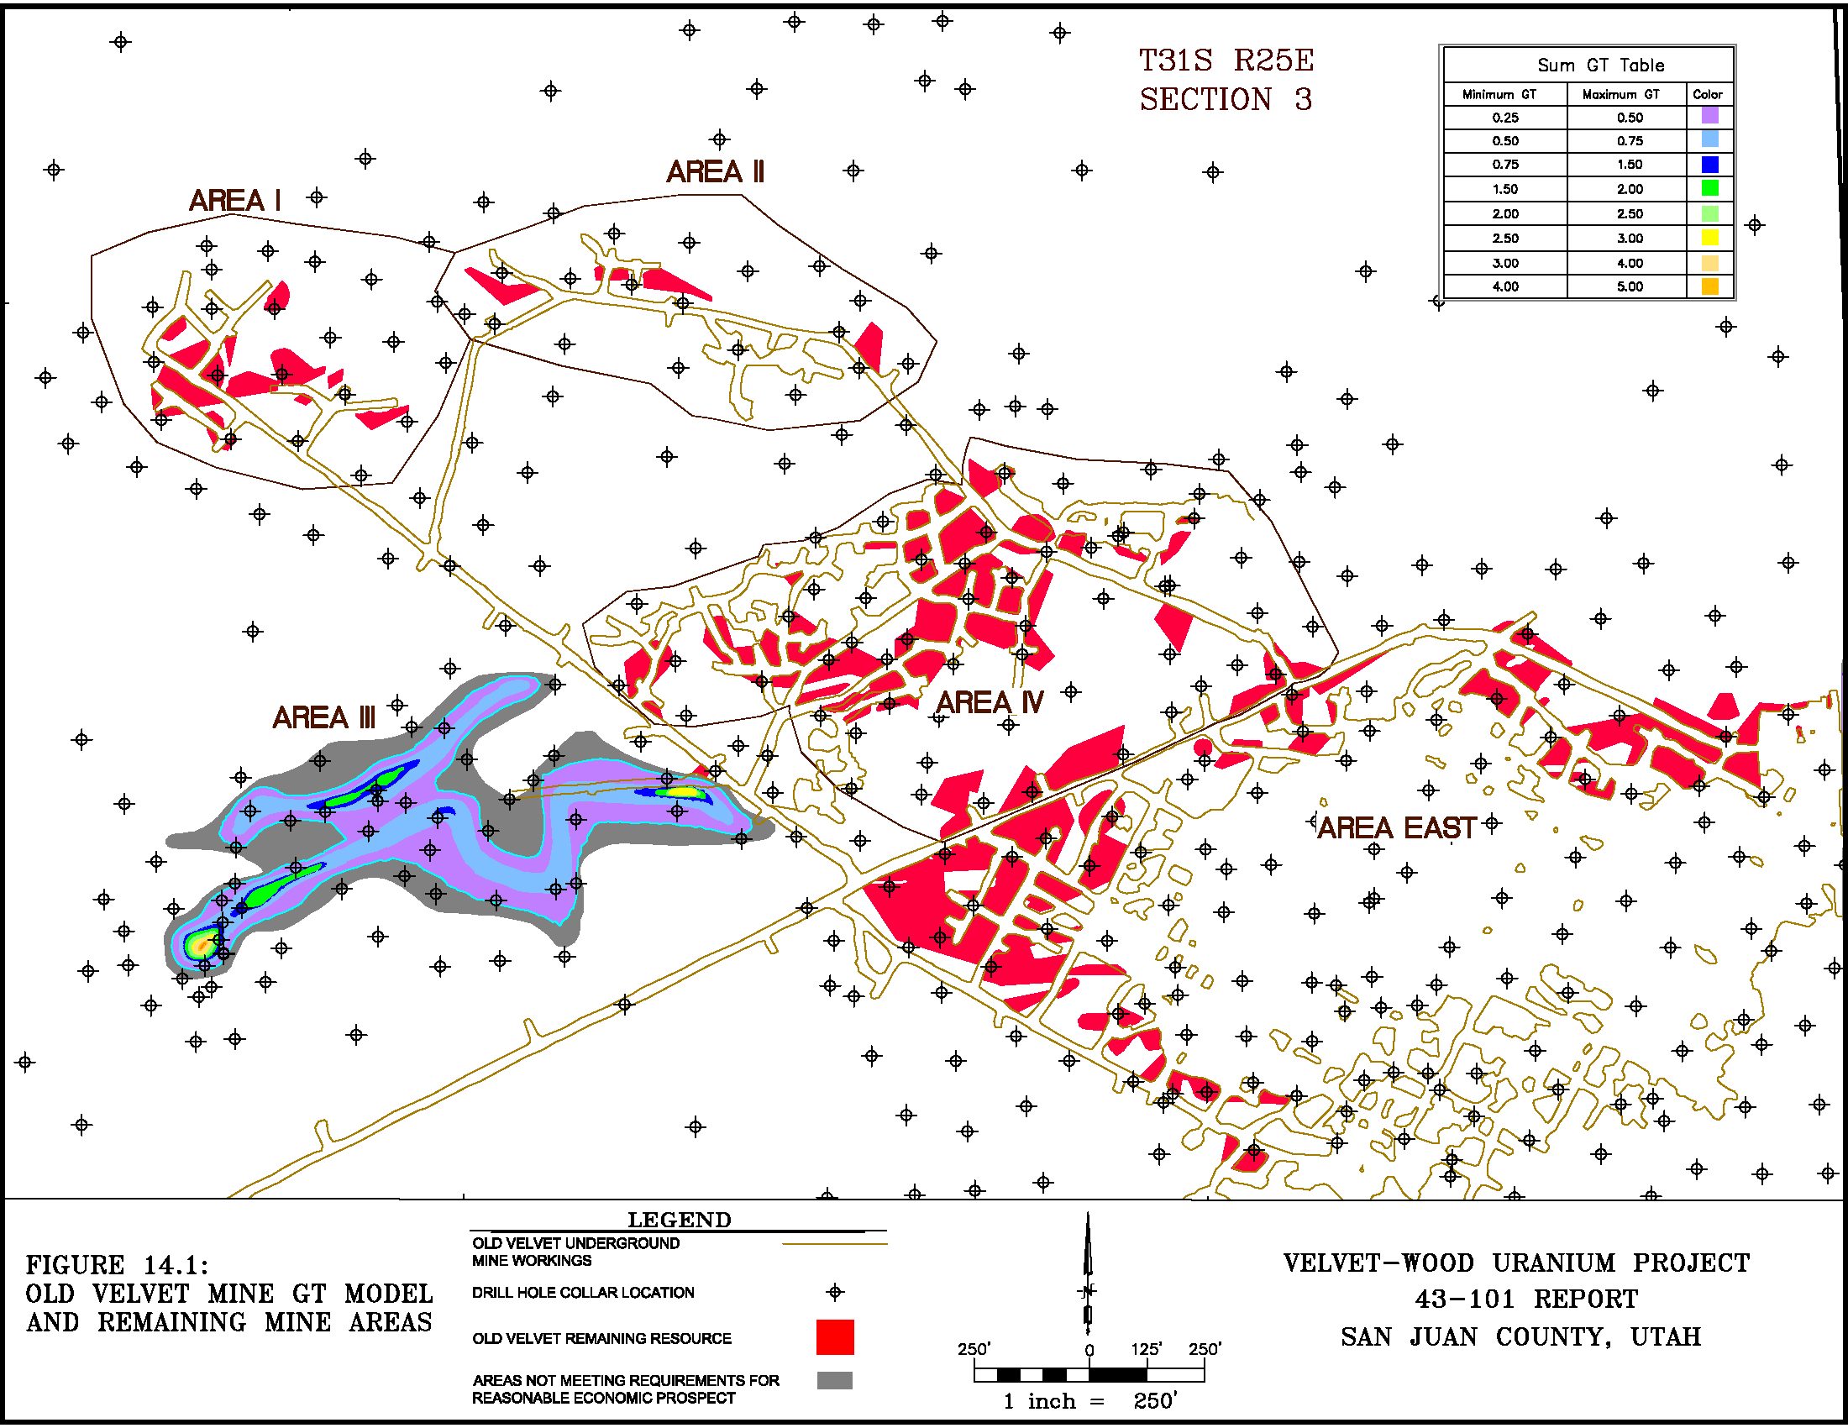
Figure 14.2 - Wood Resource GT Map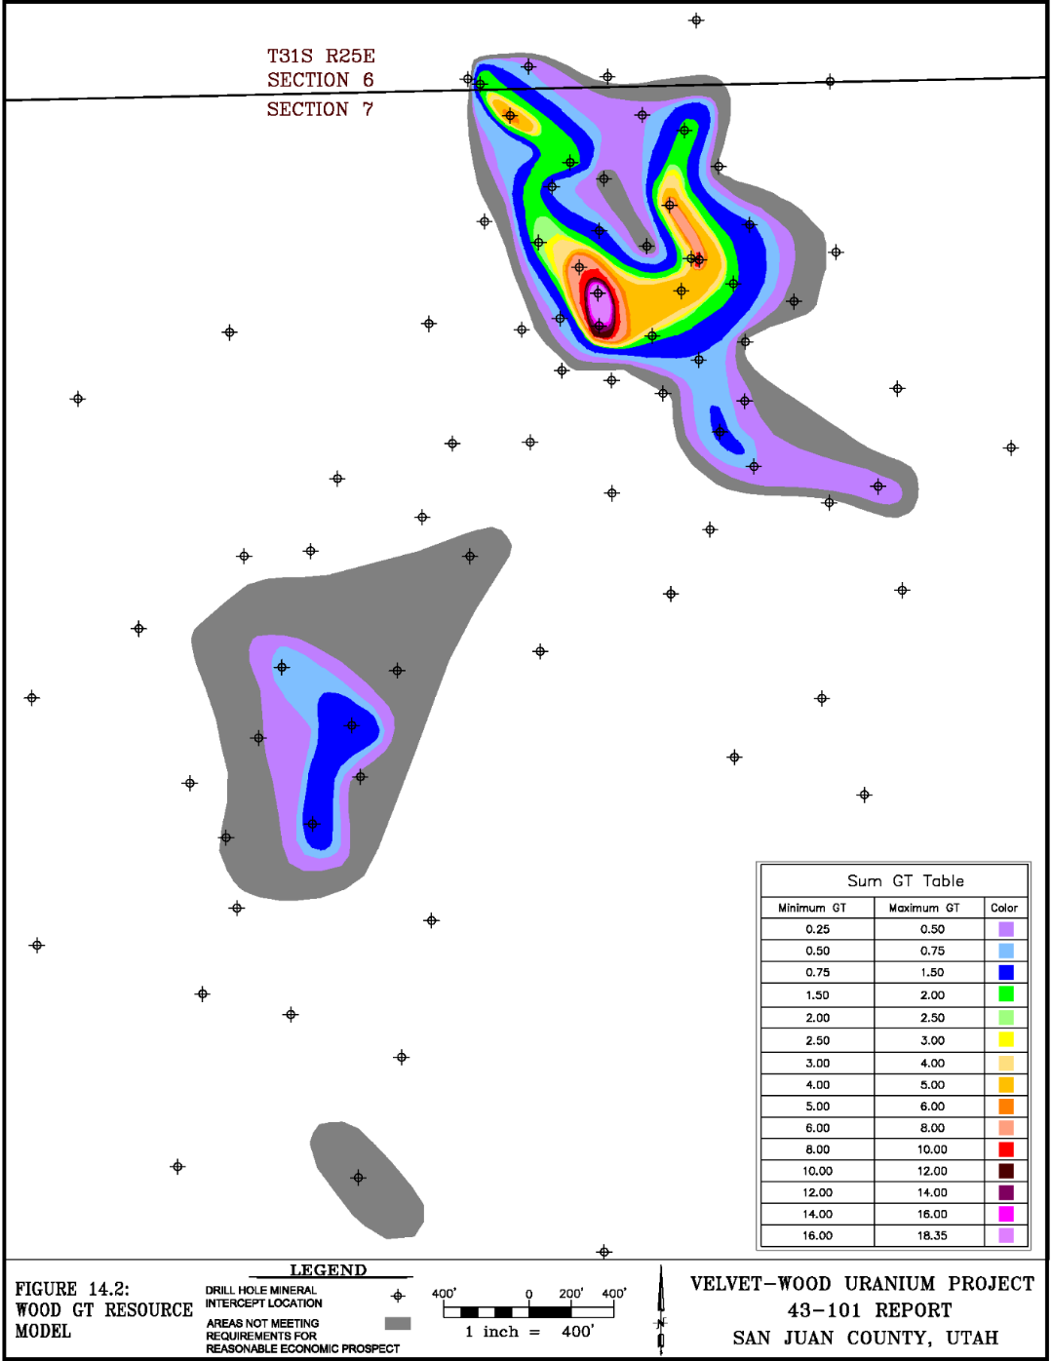
Figure 14.3 – New Velvet GT Map
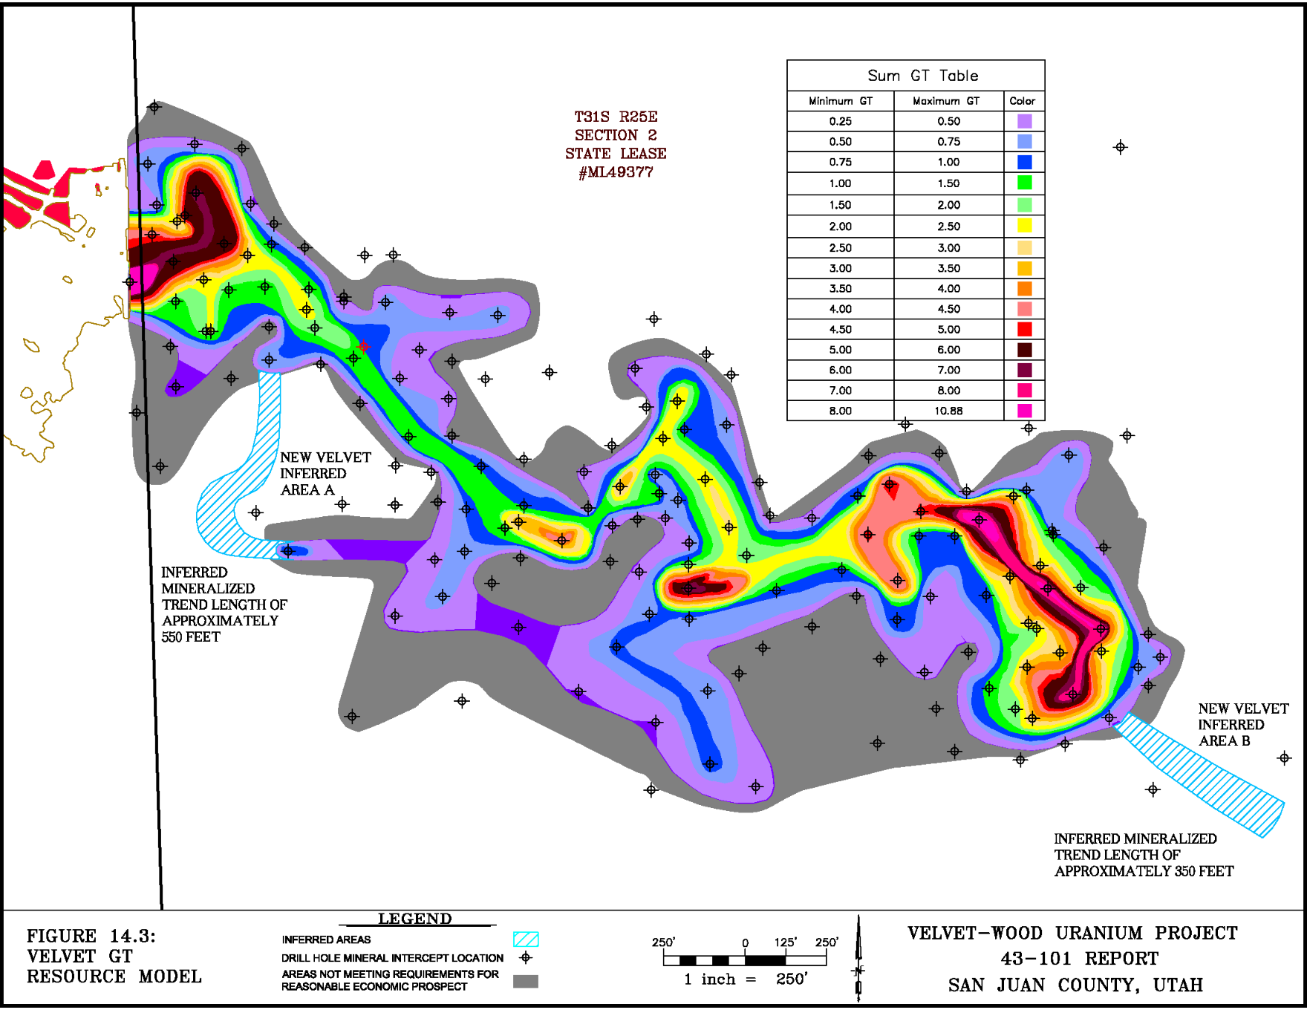
Figure 14.4 - Slick Rock Zone A GT Map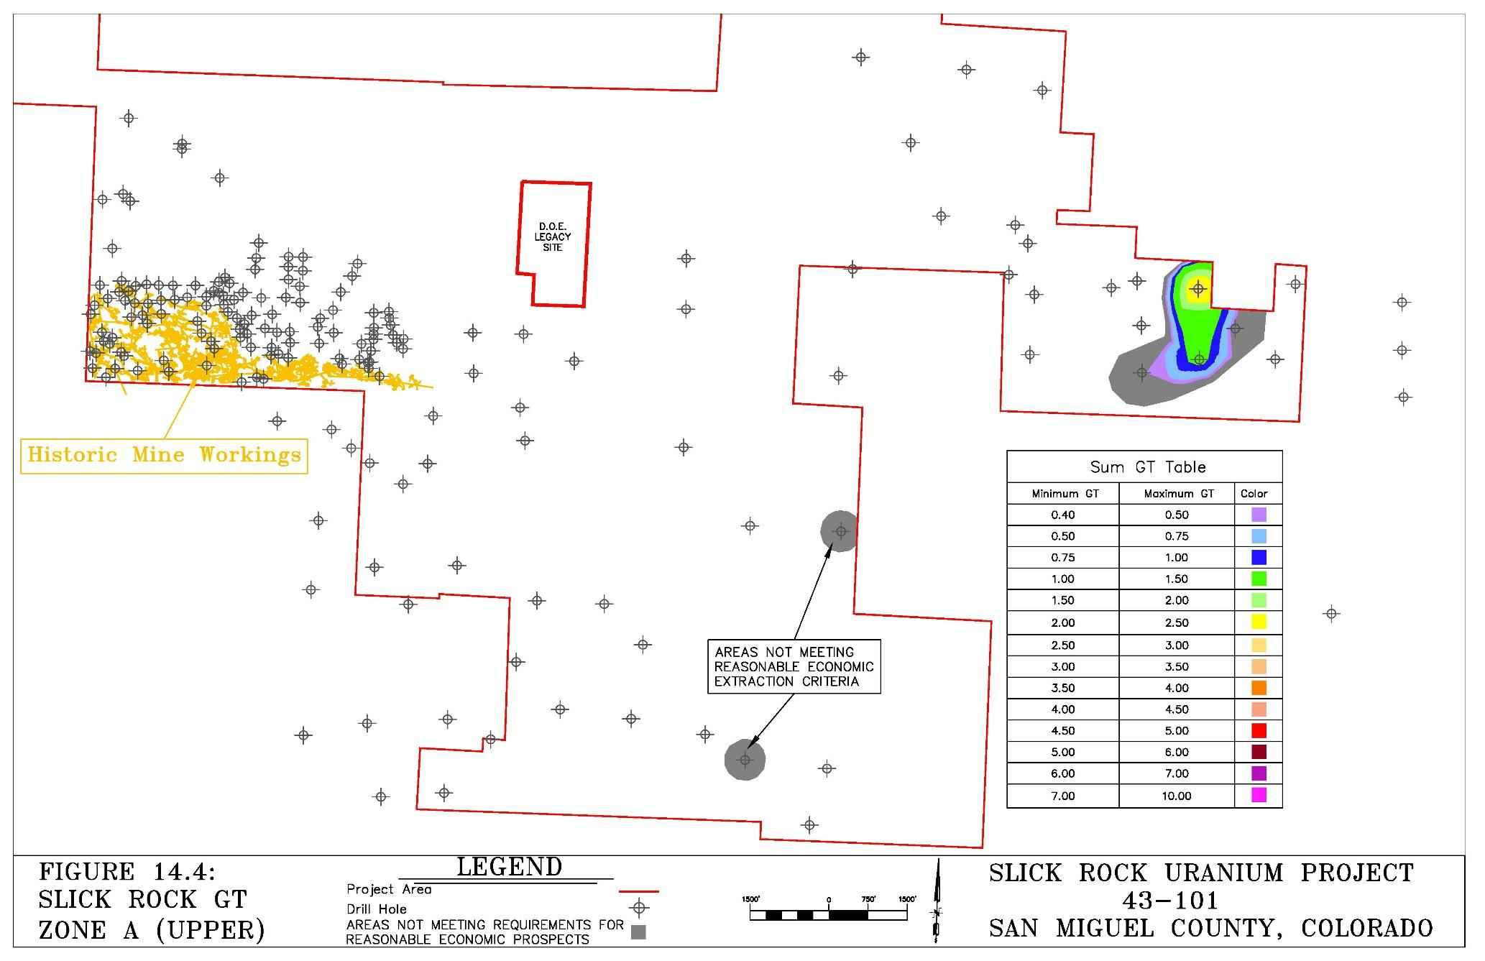
Figure 14.5 - Slick Rock Zone B GT Map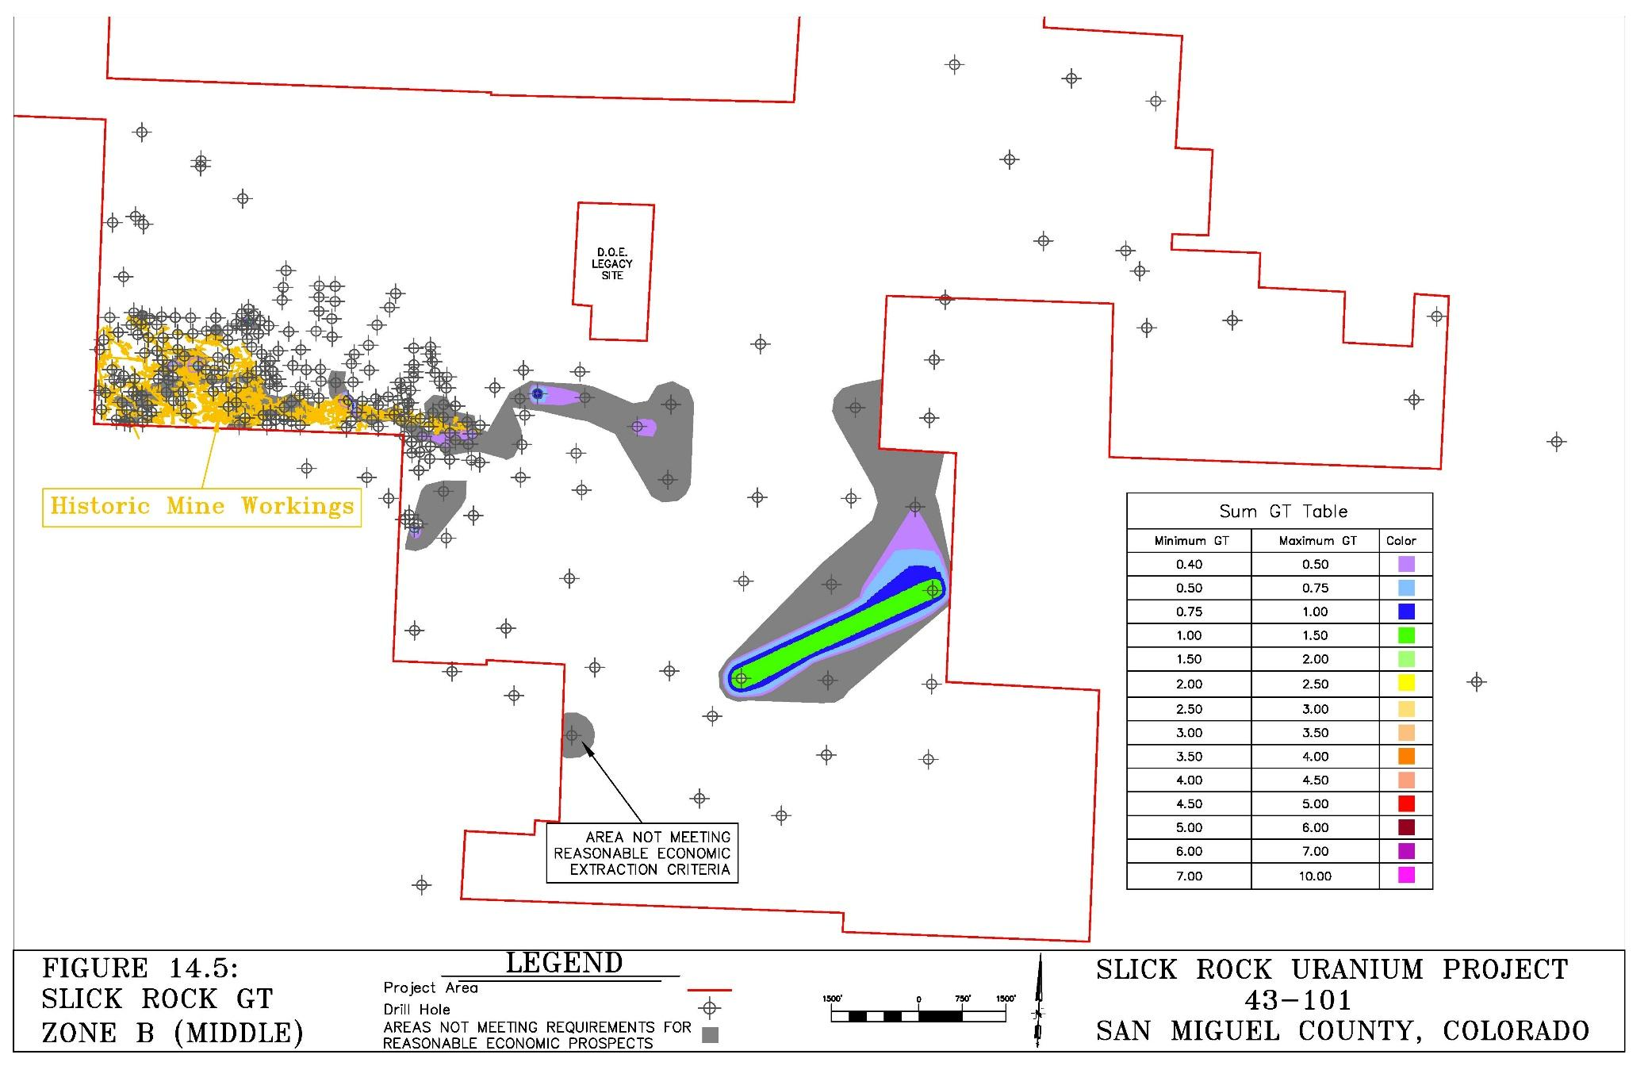
Figure 14.6 - Slick Rock Zone C GT Map
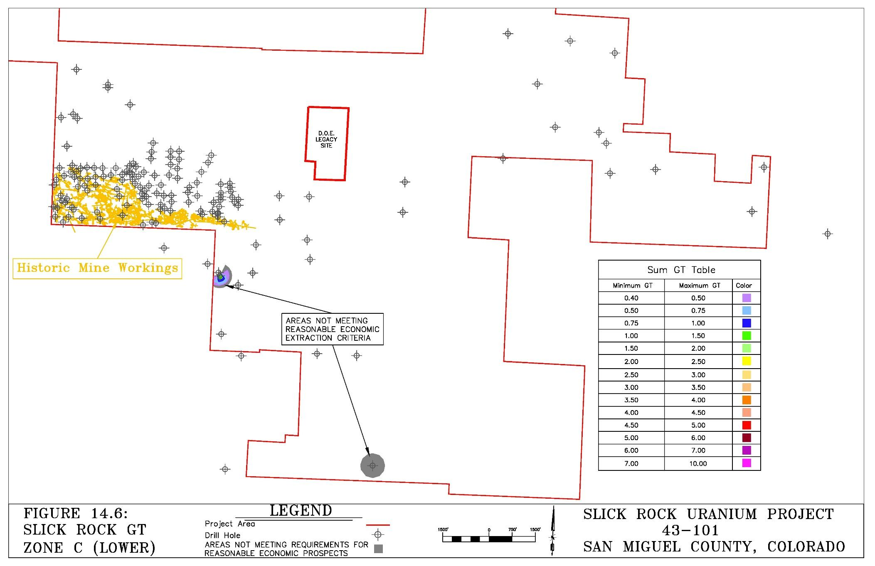

Section 15: Mineral Reserve Estimates
Not Applicable.

Section 16: Mining Methods

16.1 Mining Basis
The PEA is based on a random room and pillar mining method as was previously employed for underground uranium mining throughout the Colorado Plateau. The historic Velvet Mine, the old Wood Mine to the northwest of the Wood resource, and the Burro Mines directly west of the Slick Rock resource were all historically operated using a random room and pillar and retreat mining method. The room and pillar mining method is thus a proven method in both districts and is considered to be the best choice by the authors for the Velvet-Wood and Slick Rock projects. The characteristics of the Velvet-Wood and Slick Rock mineral deposits are compatible with this method in that their mineralization is generally tabular with some moderate rolls, low to moderate dip, and good rock strength with respect to both roof and floor. The randomness of the room and pillar extraction is due to the variations in uranium grade and thicknesses encountered. Typically, mining will follow the mineralization through underground long-hole drilling in advance of mining, face sampling, and geologic mapping concurrent with mining. Pillars are left where the mineralization is weaker in terms of concentration and/or thickness; however, in some cases temporary roof support will be necessary. The nature of mineralization lends itself to a high extraction rate but requires selective mining.
The conceptual mine layouts for Velvet and Wood are shown on Figures 16.1 and 16.2 and the conceptual mine layouts for Slick Rock are shown on Figure 16.3. The portions of the mineral resources included within the conceptual mine design and used in the PEA are summarized on Table 16.1 which follows.
Table 16.1 - Mineral Resources Included in PEA
 | Portion of Mineral Resource include in PEA
 | Velvet (M&I) | Wood (Indicated) | Slick Rock (Inferred) | Mill Stockpile
Tons | 429,313 | 251,358 | 1,685,000 | 77,514
Pounds eU₃O₈ | 2,714,432 | 1,923,187 | 7,719,000 | 250,188
Grade %eU₃O₈ | 0.316 | 0.383 | 0.229 | 0.161
Percent Extraction | 89.54% | 89.55% | 90.00% | 100%

Mineral resources not included in the PEA include Velvet-Wood inferred mineral resources (Table 14.7), Slick Rock Zone C inferred mineral resource (Table 14.9), and the Patty Ann stockpile (Table 16.2). While these areas were not included in the PEA, they do have reasonable prospects for eventual economic extraction especially after CAPEX has been recovered. Reasonable prospects for future economic extraction were applied to the mineral resource estimate herein through consideration of grade and GT cutoffs and by screening out areas of isolated mineralization which would not support the cost of conventional mining under current and reasonably foreseeable conditions.
In addition, Anfield controls mineralized stockpiles at two locations: a single stockpile at the Patty Ann mine area near the Velvet Mine, and several stockpiles at the Shootaring Mill. In March 2015, BRS completed measurement of the stockpile volumes via ground volumetric surveys using a sub centimeter Trimble GPS system and sampling to determine the average uranium grades of the stockpiles.
Stockpiles were sampled at the same time volumetric surveys were completed in March 2015 by BRS. Prior to sampling, surface gamma surveys were completed, and the sampling sites selected to represent approximate average conditions. While the samples are considered to be representative, actual concentrations may vary. A description of the stockpile sampling follows.
- The mill stockpiles are located within a licensed mill site. Sampling was conducted by Uranium One personnel at the locations selected by BRS using a small backhoe. The mill stockpiles consist of 4 smaller separate stockpiles (No. 1 through 4) and one large stockpile (No. 5). A single sample was taken from each of the smaller stockpiles which were analyzed separately. Samples from the larger stockpile were taken at 5 separate locating and composited into a single sample for analysis. Approximately 20 kg of sample was taken from Stockpile No. 5 along with approximately 5 kg from each of the stockpiles No. 1 through 4. Uranium One personnel shipped the mill stockpile samples to the laboratory directly along with along with proper chain of custody forms.
- The Patty Ann stockpiles are located near La Sal, Utah near the junction of the Big Indian and Lisbon Valley roads less than 20 miles from the Velvet mine. The Patty Ann stockpile samples were taken from five separate locations across the pile using a hand auger. Approximately equal volumes were taken from each location then combined into a single composite sample which was split using a rifling splitter prior to submission to the laboratory. BRS delivered the Patty Ann stockpile to the laboratory along with proper chain of custody forms.
Analysis of the samples was completed by Inter-Mountain Labs (IML) of Sheridan Wyoming. IML is a duly licensed and certified laboratory. Samples were analyzed of both uranium and vanadium content using standard ICP methods. (Refer to Beahm, et al, 2016). The results of the stockpile volumetric estimation and sampling are summarized on Table 16.2.
Table 16.2 - Velvet-Wood Existing Stockpiles
 | Uranium
Location | Tons | %U₃O₈ | Lbs
Shootaring Mill
Stockpile 1 | 965 | 0.238 | 4,594
Stockpile 2 | 6,734 | 0.211 | 28,418
Stockpile 3 | 2,680 | 0.081 | 4,341
Stockpile 4 | 2,320 | 0.061 | 2,835
Stockpile 5 | 64,815 | 0.162 | 209,999
Total Shootaring Mill* | 77,514 | 0.161 | 250,188
Patty Ann Stockpile** | 48,576 | 0.123 | 119,496
Total Stockpiles | 126,090 | 0.147 | 369,684

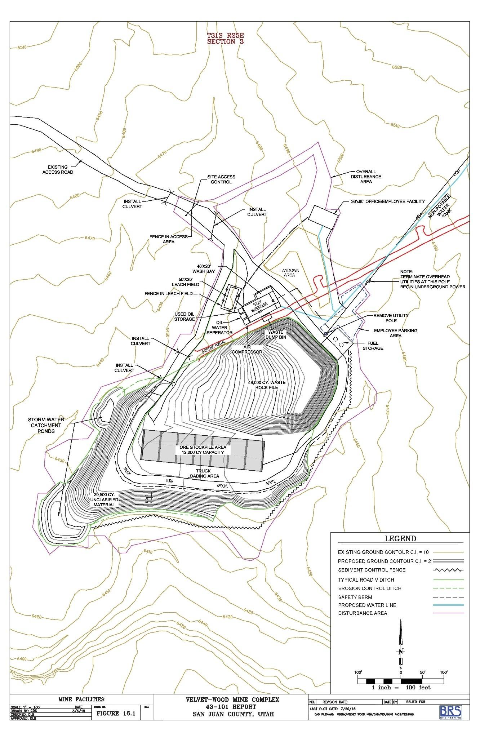
Figure 16.1 - Velvet-Wood Mine Surface Facilities Plan
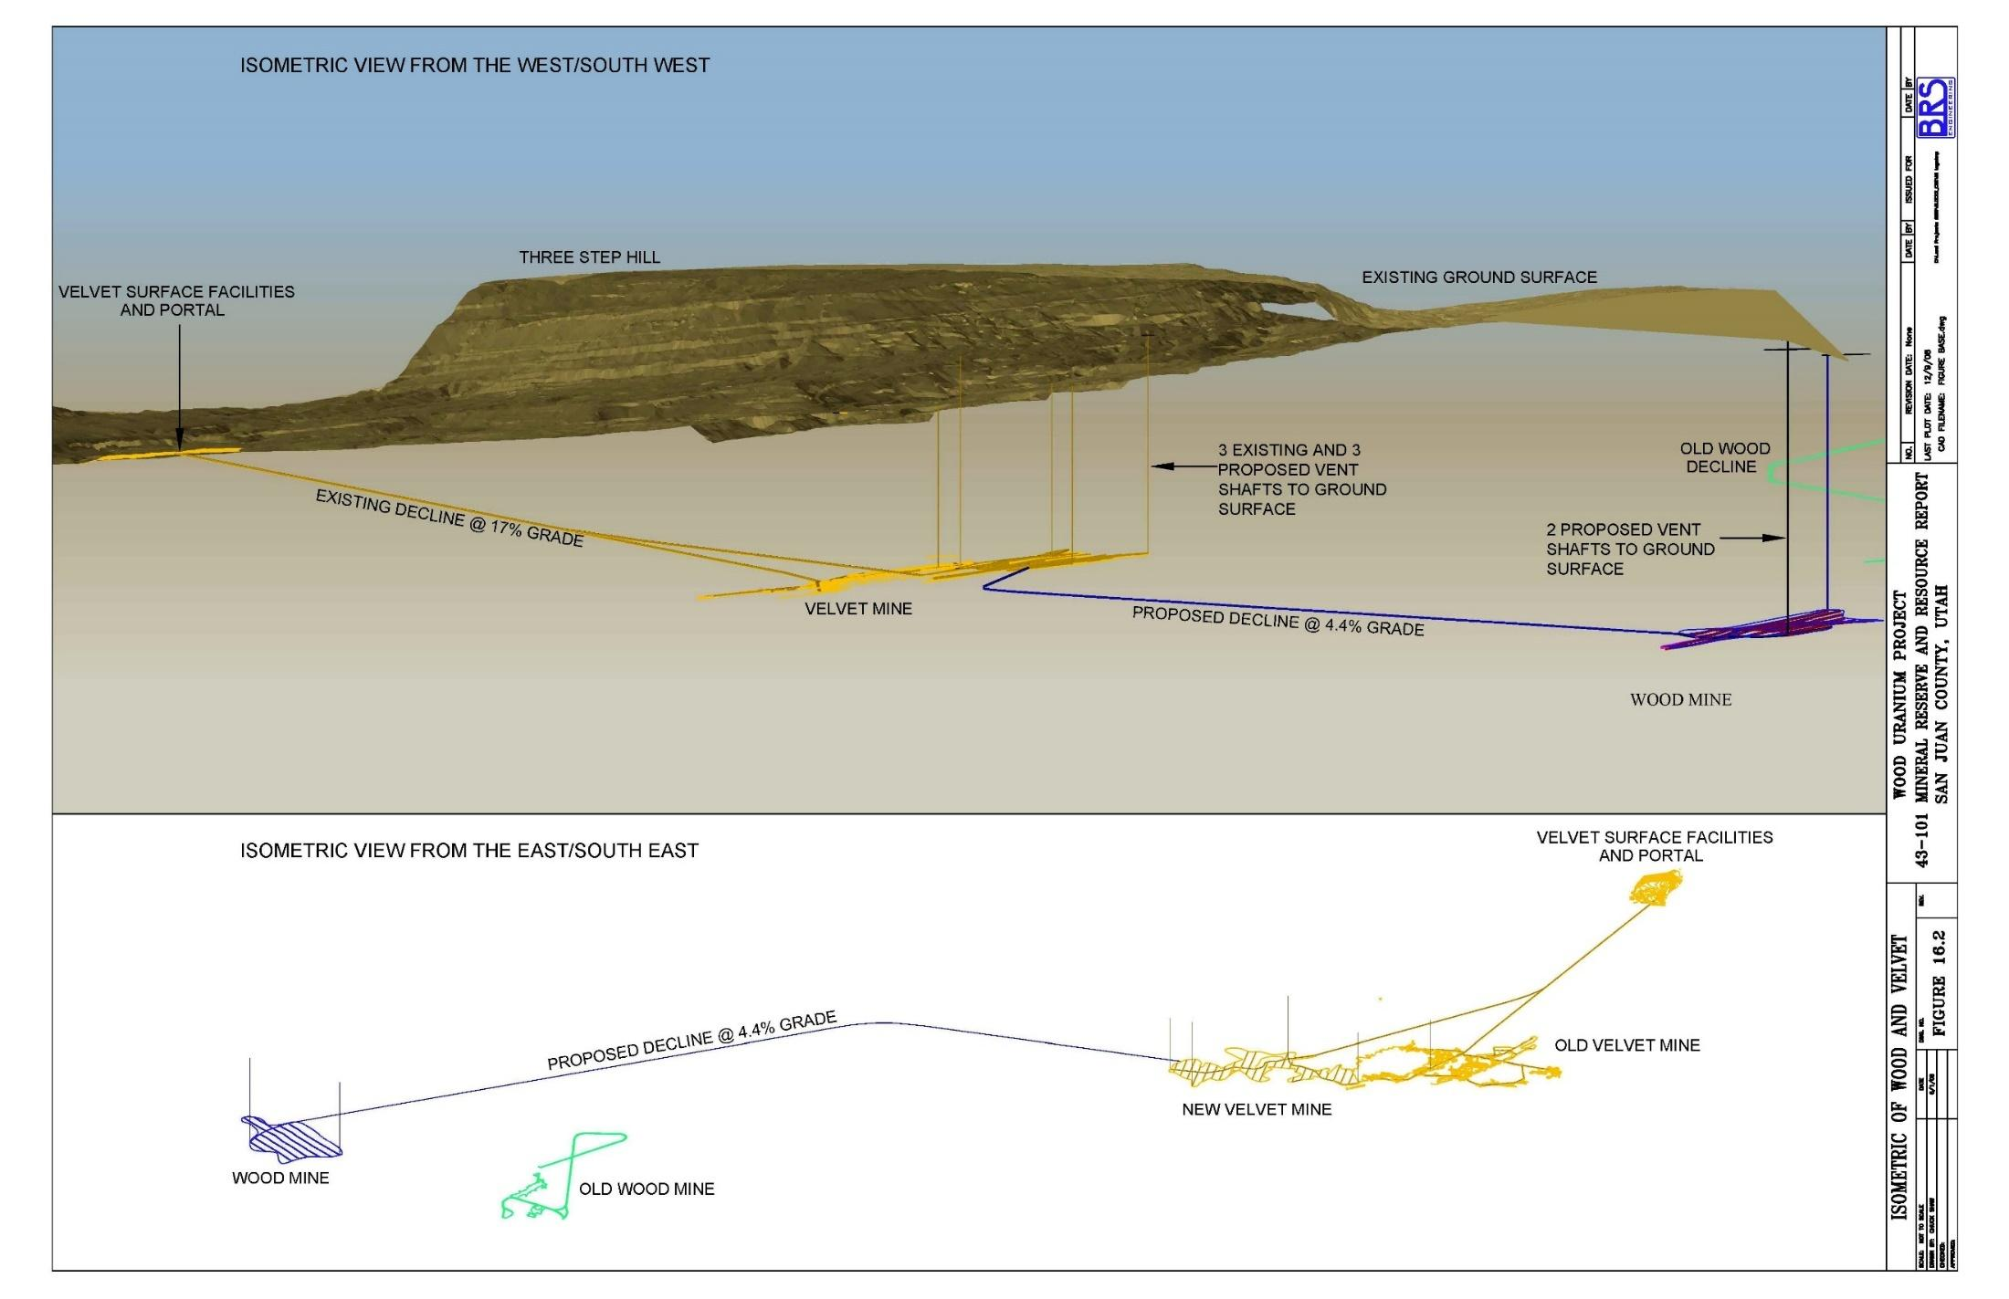
Figure 16.2 - Isometric of Wood and Velvet Underground Mine Plan
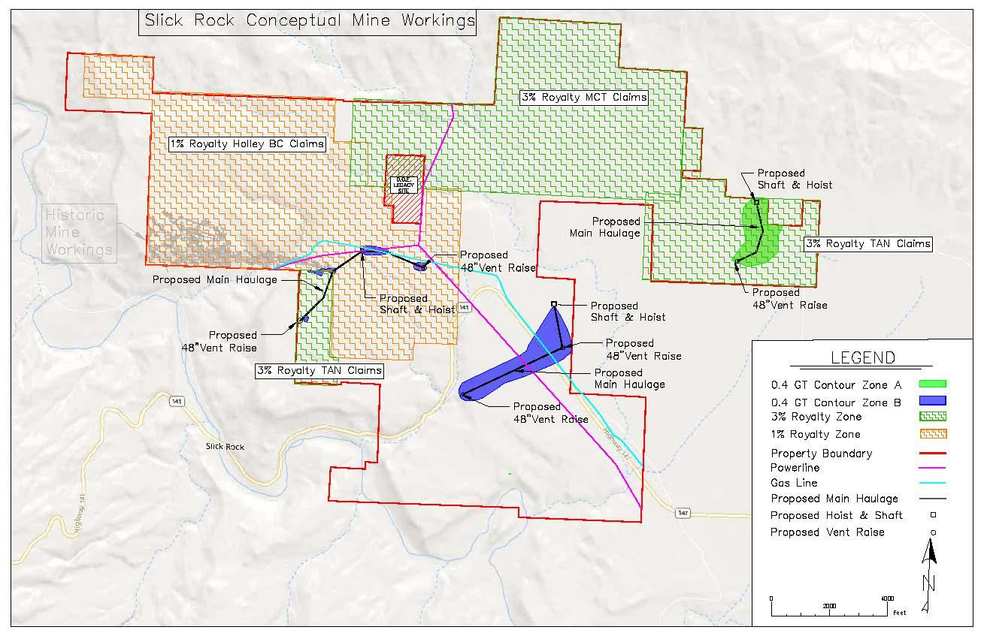
Figure 16.3 - Slick Rock Conceptual Mine Layout

16.2 Mining Methods
Mining methods will be very similar for each mine. Mining will be accomplished via random room and pillar mining methods using single boom jumbo drills for face blast holes drilling and 2 cubic yard Load Haul Dump mining equipment (LHD) used to help maintain clean mucking of mineralized material and of waste. Because of the variable grades, numerous headings are needed to maintain a consistent grade to the mineralized material stockpiles and to achieve the desired tonnage. Each crew will be scheduled to shoot a face 1.5 times per day. This will provide an average of 300 tons/day from each mine complex, for a daily average of 600 tons/day to the mineralized material stockpile while allowing significant time for shift changes, safety training, routine maintenance, and unscheduled breakdowns. The three LHD’s per shift can cycle all of the headings for a maximum of 1,250 feet from the mining face. 10-ton trucks will be used to transfer the muck to the surface.
Velvet Mine
There is an existing 12’ x 9’ decline from the surface, 3,500’ in length at the Velvet Mine. The PEA is based on re-entry and stabilization of this decline to access the Old Velvet Mineralization. Extending from this decline will be an additional 12’ x 9’ decline, 3,300’ in length, that will branch off to access the New Velvet Mineralization. Main entries, secondary entries, and development drifts (8’ x 10’) will be driven for the development and access to the New Velvet Mineralization. Main entries, once within the mineralized horizon, will follow the edge of the mineral deposit leaving one rib in waste rock and the other within mineralized material. This will provide some mineralized material and minimize waste while driving the mains and will provide some support along the main entries upon retreat mine. Secondary entries will be driven off the mains on 100’ centers and extended to the edge of mineralization using long-hole drilling and probes to map the mineralized material as development proceeds. Once the development drifts are finished, full face retreat mining will start working at the back and retreat toward the main entries. Selective mining will be conducted in these areas separating mineralized material from waste.
Agapito Associates, Inc. (AAI) was commissioned by Uranium One in 2008 to complete a study of the ground support and ventilation requirements for the proposed Velvet and Wood mines, (Agapito, 2008). The results of this study are summarized herein. The authors have reviewed this report and concludes that the study was completed in accordance with current industry practices and is applicable to the current PEA and where appropriate.
Based on the geotechnical report (Agapito, 2008), a 10-foot roof span is projected to stand unsupported for about 30 days. The stand-up times, roof spans, and interpretations of strength data suggest a high percentage of pillars can be recovered utilizing a room and pillar mining method at the Velvet and Wood Mine. For the purposes of the PEA, an approximate recovery of 90% was applied based on a retreat pillar extraction/stoping method.

Wood Mine
Several options were considered to access the Wood Mine as summarized on Table 16.3. The preferred alternative is to access the Wood Mine through the workings of the New Velvet Mine. This approach would minimize mine permitting, as a new surface entry would not be needed and all development would be completed underground, thus minimizing surface impacts. The Wood Mine will need additional mine haulage capacity to the Velvet Mine.
Table 16.3 - Options for Entry into the Wood Mine
Option | Max Grade | Length | Decline Size | Tons Muck | Additional Costs
From New Velvet Workings* | 1.4% | 11,442.9 | 12' x 9' | 85,121
From Old Wood Decline | 21.9% | 2,858.0 | 12' x 9' | 21,260 | Obtain Permits and Land Rights, Surface Facilities, Old Wood Decline Rehabilitation
From Old Wood Workings | 12.8% | 2,366.0 | 12' x 9' | 17,600 | Obtain Permits and Land Rights, Surface Facilities, Old Wood Decline Rehabilitation
New Portal from Surface | 10.0% | 9,620.0 | 12' x 9' | 71,561 | Obtain Permits and Land Rights, Surface Facilities
New Portal from Surface | 12.0% | 8,017.0 | 12' x 9' | 59,636 | Obtain Permits and Land Rights, Surface Facilities
New Portal from Surface | 15.0% | 6,413.0 | 12' x 9' | 47,704 | Obtain Permits and Land Rights, Surface Facilities
New Portal from Surface | 20.0% | 4,811.0 | 12' x 9' | 35,787 | Obtain Permits and Land Rights, Surface Facilities
New Portal: Shaft from Surface | 100.0% | 1,112.0 | 12' diam | 8,662 | Obtain Permits and Land Rights, Surface Facilities, Hoisting
*Preferred Alternative
Slick Rock
The Slick Rock Mine will use 12-foot diameter main shafts and hoists to access and haul out of the mine workings. There are three proposed shaft and hoist locations. The first main shaft would be located in the east, accessing the resource centered in the A Zone. The second main shaft would access the central portion of the B Zone, and the third access the north-northwest portion of the B Zone adjacent to the historic Burro Mine workings. A total of five 48 inch vent raises would provide for primary ventilation, with one in the eastern A Zone and two per B Zone developments.
Although it would be technically feasible to enter the north-northwest portion of the B zone from the existing Burro workings, no agreement currently exists with the owner of the Burro portals for access. As such it is presumed by this PEA that no access will be given and that all three main shafts would need to be driven from the top of the mesa.
The first hoist would be installed in the easternmost area of the deposit in the A zone while the driving of the central B Zone shaft concludes. After the first hoist is set, construction of the second hoist in the central area would begin. These two hoists will haul from their respective workings concurrently at an average total production of 300 tons/day until the eastern A zone is depleted. Following the depletion of the eastern A Zone, that hoist will be disassembled and relocated to a shaft driven down into the north-northwestern portion of the B Zone. See Figure 16.3 for the conceptual mine layout of Slick Rock Mine.

16.3 Pre-Production Mine Development
Before the production of the Velvet Mine begins, several aspects of the mine must first be running. The mine is currently flooded and will require dewatering. Dewatering is anticipated to take 3 to 6 months at a rate of approximately 250 gpm. In the first two months, the old portal to the Velvet Mine will be rehabilitated. Once the portal is opened, and as dewatering lowers the water level in the main decline, rehabilitation of the main Old Velvet access will begin. In months three and four, access to and stabilization of the existing Vent A will take place. In month five, a second crew will develop access to the west side for further production of Old Velvet, and in months five through ten the first crew will develop a new decline down to the New Velvet. Once these development activities have been completed, production can begin on the New and Old Velvet Mines.
Pre-production mine development for the Wood Mine includes the 11,500 ft access drift from the New Velvet, dewatering of the mineralized area, development work, and up-reaming of mine vents. In addition, permitting for the vents and the dewatering treatment and discharge facilities will be required.
Slick Rock pre-production mine development will include driving two main shafts, installation of hoists, and possible dewatering of the mineralization. After the first hoist is installed, construction of the second shaft and hoist will coincide with the production of the first resource area.

16.4 Mine Equipment
Table 16.4 provides a typical equipment list for a conventional room and pillar mine applicable to the Velvet-Wood and Slick Rock mine complexes.

Table 16.4 - Mining Equipment List
Equipment | Velvet-Wood  Quantity | Slick Rock  Quantity
Shaft Hoist (12-foot diameter shaft) | N/A | 2
Development Jumbo - Single Boom | 2 | 2
Drifter, Hydraulic | 3 | 3
Drifter Feeds | 3 | 3
Jackleg Drill w/ Leg | 4 | 4
Compressor 350 cfm | 2 | 2
LHD 2 cy | 2 | 2
Truck 10 ton | 3 | 2
Pump | 2 | 2
ANFO Loader | 3 | 3
Service Vehicle | 1 | 1
Scissor Lift Truck | 1 | 1
Main Ventilation Fan 5' | 4 | 5
Electric Motor 100 hp | 4 | 5
Accessories for 5' Fan | 4 | 5
Auxiliary Fan 14000 cfm | 9 | 9
Exploration Drill | 1 | 1
Cat 973C Track Loader/Dozer (surface) | 1 | 1
Water Truck 4000 gal (surface) | 1 | 1
Portable Power Center 150 Kva | 4 | 4
Refuge Chamber | 2 | 2

16.4.1 Operating Parameters
The random room and pillar mining method will utilize single boom jumbo drilling, 2 cubic yard LHD face mucking, and 10-ton truck haulage with the associated support equipment. The following are job specific operating parameters that each piece of equipment will be required to meet including but not limited to production rate, working heights, production volumes, turning radius, max operating grades, maintenance schedule, allowable down time, and operating cost.
A summary of equipment cycle times is given in Table 16.5.

Table 16.5 - Summary of Equipment Cycle Times
 | Summary of Equipment Cycle Times
Equipment |  | Decline & Main Haulage | Production & Development | Velvet-Wood Quantity | Slick Rock Quantity
LHD - 2 cy |  | 62.3 min/round | 64 min/round | 2 | 2
Jumbo - Single Boom |  | 378 min/round | 199 min/round | 2 | 2
Truck - 10 ton |  | 251 min/round | 142 min/round | 3 | 2

16.6 Mine Production Schedule
The mine production schedule is based on two primary mining crews for each mine complex, for a total of four mining crews. The first crew will open the mine and begin production on the New Velvet. The second crew will reestablish access to the Old Velvet Mine and take out mineralized material that is remaining there. The second crew will then continue over to the New Velvet area for mining. The third crew will start with the first shaft and hoist at Slick Rock. The fourth crew will start with the second shaft and hoist at Slick Rock. The GT and T contours were used to develop a block model for mine scheduling, equipment selection, and cost estimations. An annual schedule was developed to estimate the volumes of mine waste and mineralized material extracted from the mines and delivered to the mill, as shown on Table 16.6.
The production schedule is based on the existing tonnage capacity at the mill of 750 tons per day (TPD) or a maximum of 250,000 tons per year. The Velvet-Wood mine is anticipated to operate for 8 years with Slick Rock operating for 15 years. After year 8 additional capacity would be available at the mill.
Current studies have been commissioned and are underway to evaluate increasing the tonnage capacity of the mill.
Table 16.6 - Production Schedule (units x 1,000)
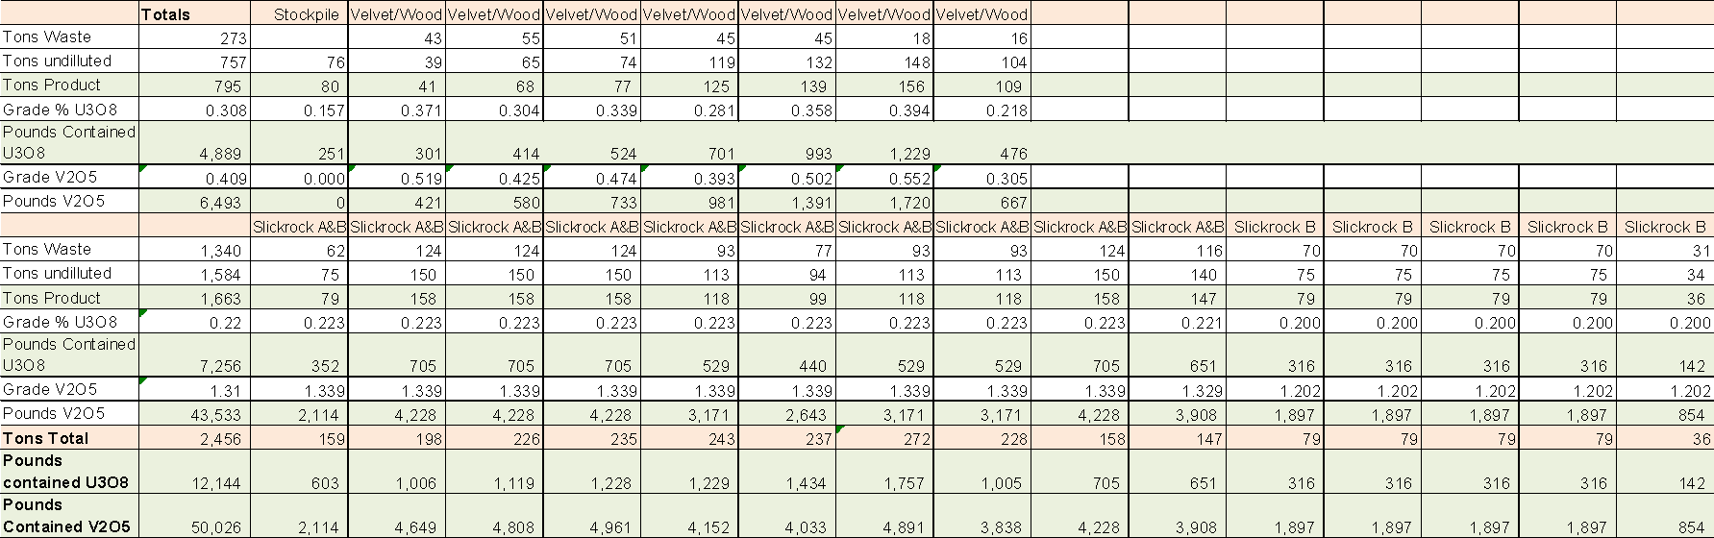

16.7 Mine Labor
Qualified mine labor is available in the region. Table 16.7 summarizes the personnel requirements by classification needed to meet the production estimates as summarized in Table 16.6.
Table 16.7 - Labor Requirements
Labor Requirements |  | Velvet-Wood |  | Slick Rock
Hourly Labor Requirements | Shifts/year | Personnel Per shift | Total | Personnel Per shift | Total
Jumbo Miners | 3 | 2 | 6 | 2 | 6
Jumbo Helper | 3 | 2 | 6 | 2 | 6
Utility Miners (Const., Utilities, etc.) | 3 | 1 | 3 | 2 | 6
UG Laborer | 3 | 1 | 3 | 2 | 6
LHD Operators | 3 | 1 | 3 | 2 | 6
UG Truck Operators | 3 | 2 | 6 | 2 | 6
Surface Operators | 3 | 1 | 3 | 1 | 3
Exploration Drillers | 1 | 2 | 2 | 2 | 2
Electricians | 3 | 1 | 3 | 1 | 3
Mechanics | 3 | 1 | 3 | 1 | 3
Control Room Operator (Dispatcher) | 3 | 1 | 3 | 1 | 3
Warehouse Laborer | 3 | 1 | 3 | 1 | 3
Subtotal Hourly |  | 16 | 44 | 19 | 53
Salaried Personnel Requirements
Chief Engineer/Manager | 1 | 1 | 1 | 1 | 2
Mine Foreman | 1 | 1 | 1 | 1 | 2
Foreman/Shifter | 3 | 1 | 3 | 1 | 6
Engineers and Surveyors | 1 | 2 | 2 | 2 | 4
Chief Geologist | 1 | 1 | 1 | 1 | 2
Geologists | 3 | 1 | 3 | 1 | 6
Maintenance Supt. | 1 | 1 | 1 | 1 | 2
Technicians | 1 | 2 | 2 | 2 | 4
Accountants – Clerk | 1 | 1 | 1 | 1 | 2
Purchasing Agent | 1 | 1 | 1 | 1 | 2
Personnel/Safety Manager | 1 | 1 | 1 | 1 | 2
Subtotal Salary |  | 13 | 17 | 13 | 17
Total Annual Payroll |  | 29 | 61 | 32 | 70

16.8 Mine Support and Utilities
Mine facilities located on the surface would include a mine office, warehouse, and workshop, change room and dry facility, a lined storage area for mined product, storage for explosives, and various appurtenances as summarized in Table 16.8. Utilities would include electrical power, a water supply, and a wastewater disposal system. Water would be supplied via treated mine wastewater and stored in a stock tank. Potable water will be trucked in as needed.
Table 16.8 - Surface Facilities
Mine Surface Facilities | Velvet-Wood | Slick Rock
Computer & Office Furniture | 1 | 1
Office | 1 | 1
Change Room and Dry | 1 | 1
Workshops | 1 | 1
Civils (Footers) for Buildings | 1 | 1
Magazines | 1 | 1
Fuel Tank | 1 | 1
Mined Product Bin | 1 | 1
Fencing and access control | 1 | 1
Workshop Tools | 1 | 1
Safety Equipment | 1 | 1
Septic Tank | 1 | 1
Spill Mats (Oil Areas) | 1 | 1
Water Supply System | 1 | 1

16.9 Mine Ventilation
Agapito performed a series of mine ventilation analyses to facilitate the proposed mine’s operating in compliance with applicable air quality regulatory standards (Agapito, 2008). Particular emphasis in the design was placed on the main fan and raise locations that should, with appropriate controls, enable the mine to meet applicable Mine Safety Health and Administration (MSHA) ventilation requirements. The primary contaminants of concern for the ventilation system include radon, diesel particulate matter (DPM), diesel exhaust gases (CO, CO₂, NOx, and SOx), blasting fumes, and silica dust. Once the mine is operational, a sampling program should be instituted to identify and quantify the airway contaminants.
Based on the analysis of the likely equipment and production demands, the estimated quantity of air needed to effectively manage the DPM is at least 166 thousand cubic feet per minute (kcfm). This volume of fresh air will allow an area 10 feet by 8 feet by 31,000 linear feet long to be replenished with fresh air every 15 minutes for control of radon daughters. While no site-specific data concerning radon is available at this time, this rate of air exchange should be a good first approximation until empirical testing can take place.

Section 17: Recovery Methods

17.1 Summary
The Shootaring Canyon mill is an existing facility which was constructed circa 1981 and operated sporadically until 1982. As discussed in Section 20, the mill has an existing radioactive materials license which would need to be amended to allow operations to resume. Although the mill has been on a care and maintenance program, various components have been salvaged and sold, including the Counter Current Decantation (CCD) thickeners and various pumps and related equipment. In addition, some of the equipment units, such as the diesel generators, are outdated and may be not useable. Nonetheless, the main process building was well-designed and is generally in very good condition.
For the purposes of this PEA, the capital and operating/maintenance cost estimates for mineral processing at the mill site were confined to the original conventional grinding and agitated leaching circuit, followed by yellowcake precipitation, drying, and drum filling. Two options were considered.
- The first optin envisioned renovating (“refurbishing”) the original equipment, including replacements where needed, and retaining the original building - at a significant net savings of roughly $4 million.
- The second option, retaining the original building and installing new equipment was used in the PEA as a conservative measure. Although more expensive than refurbishment, this option would include current state-of-the-art equipment and best available technology, which is in keeping with Anfield’s corporate philosophy, current regulatory requirements, and conservative guidance.
In both cases, the assumed mining plan includes mine production from the Velvet-Wood and Slick Rock mines plus processing of stockpiled material. Also, both cases include vanadium recovery, beginning with leaching at a higher free acid concentration (pH 0.8 to 1.2 versus 1.5 to 2.0) to ensure satisfactory extraction of vanadium. Vanadium recovery from uranium solvent extraction raffinate assumes installation in a relatively small new building near the existing process building.
The Shootaring Canyon Mill was constructed by Mountain States Engineers (Tucson) and was among the last 2 or 3 conventional mills built before the collapse of the uranium industry. Its design benefited from two decades of revolutionary changes, such as solvent extraction, and many evolutionary improvements based on an accumulation of industry-wide experience in operation and maintenance of dozens of mills. Among the most up-to-date features were the following:
- Semi-autogenous grinding (“SAG milling”) of run-of-mine ore replaced crushing, screening, and rod mill grinding, reducing requirements for capital, energy, operating & maintenance labor, and steel grinding media.
- Conventional grinding circuit particle size classification with rake or spiral classifiers or hydro-cyclones was replaced with a single DSM-type sieve bend that enabled gravity return of oversize to the SAG mill, while sieve undersize was delivered by gravity to the leaching circuit.
- Laboratory tests had revealed that uranium leaching kinetics were improved by increased temperature, so required heating was provided by circulation of process solutions through the radiators and cylinder blocks of on-site diesel generators.
- Some newer mills had been built with two-stage leaching which contacted fresh ore with fresh leaching solution for 2 to 4 hours in the first-stage tanks, then completed the leach with 12 to 16 hours retention in second-stage tanks at a lower free acid concentration and lower percent solids. This design generally led to lower overall acid consumption and was incorporated in the mill.
- The leach tanks were made of wood staves with external compression bands, resulting in inexpensive construction, good acid resistance, and freedom from leakage after presoaking in water.
- A six-stage counter-current decantation (CCD) circuit was installed to maximize recovery of dissolved uranium at +99% washing efficiency. Deep tanks were used, with a high-rate design embodying inter-stage mix tanks and slurry introduction into the settling zone, rather than old-style feeding into a center well.
- Advanced process condition sensors and automatic control instruments were installed throughout the plant and interfaced with both local control stations and centralized process data recording.
- Precipitated yellowcake was centrifuged after thickening and prior to filtering and thermal drying.

17.2 Shootaring Canyon Mill Partial Refurbishment vs. All New Equipment
An internal report entitled “Definitive Cost Estimate for the Restart of Shootaring Canyon Mill Ticaboo, Utah” was completed on March 28, 2008, by Lyntek, Inc. (Lyntek, 2008), and covered the restart of the mill which has not been operated since 1982. The Lyntek estimate proposed complete refurbishment of the mill and included some purchases of new equipment, including countercurrent decantation (CCD) thickeners, pumps, instrumentation, and scrubbers, with an allowance for personnel hours and materials for refurbishing or repairing equipment.
An alternative to refurbishing is complete removal of old equipment and replacement with new equipment, but within the original building. The original building is serviceable and a new one would cost approximately $4 to $7 million plus the cost of demolition of the original structure.
In either case, the basic processing flowsheet would be preserved, but some equipment types that were originally installed would be supplanted with the current generation. An example would be acquisition of a fully automated drum filling station capable not only of accurate weighing, but also of automated removal and replacement of the drum locking clamp ring, reducing exposure of personnel to dust.
Provisionally, the uranium section of the facility will follow the original design. The mill was designed by Mountain States Engineers, and construction was completed circa 1981 for the owner/operator, Plateau Resources. The design capacity was 750 short tons per day (tpd) of uranium ore. Although the ore contained potentially leachable vanadium, a vanadium recovery circuit was not designed or built.
Owing to the collapse of the domestic uranium industry, the mill was operated for only a brief period. Following cessation of production, the equipment was drained, cleaned, and “mothballed”, but some pieces of equipment, notably pumps and thickeners, were removed and sold. The following paragraphs describe the processing flowsheet as designed and built and depicted in Figure 17.1, “Original Shootaring Canyon Mill Flowsheet”.
Run-of-mine (ROM) ore was hauled by truck and dumped on a graded storage area from which it was reclaimed by a 3 cubic yard front-end wheel loader and dumped onto a grizzly with 14-inch square openings. Grizzly oversize was removed for secondary breaking, and undersize fell into a surge bin with approximately 75 tons live capacity. Coarse ore was withdrawn by a variable speed apron feeder and discharged onto a steeply inclined stationary grizzly with 3-inch square openings. Grizzly undersize fell onto a 42-inch wide by 316-foot mill feed conveyor, providing impact and wear protection from falling rock. Dust released during coarse ore handling was drawn through a wet scrubber by an exhaust fan. The scrubber slurry was pumped to the downstream grinding and classification circuit.
Coarse ore was conveyed beneath a metal detector and over a belt scale to a 12-foot diameter by 6½-foot long semi-autogenous grinding (SAG) mill driven by a 250 Hp motor. About 8 to 10 percent of the mill volume was charged with 6-inch diameter cast steel balls to crush resistant ore fragments. A slurry of ore particles at about 65 to 70% solids (by weight) overflowed through the SAG discharge trunnion into a pump sump and was pumped to a cluster of four DSM sieve bends (stationary banana-shaped screens) with 28-mesh aperture slots between self-cleaning wedge wires. Screen oversize was returned by gravity to the SAG feed spout along with sufficient process water to maintain the desired discharge density. The design circulating load in the grinding/classification circuit was 200 percent.
Screen undersize flowed by gravity into a sump and was pumped to two agitated leach feed holding tanks. Made of wood staves, the tanks were 20 feet in diameter by 28 feet high with a slurry capacity of 60,000 gallons apiece. The stave walls’ exteriors were pre-soaked, then continuously supplied with water to prevent drying and shrinkage of the staves. Each tank had a single agitator shaft with two marine-type propellers and a 50 Hp gear-reduced drive.
During leaching, tetravalent uranium was oxidized to the soluble hexavalent state with sodium chlorate, NaClO₃, and complexed with sulfuric acid. As was commonly done for ores with relatively high acid consumption, the leach circuit was 2-stage. The first stage contained three agitated tanks 14 feet in diameter by 18 feet high with an effective volume of 16,120 gallons apiece, and providing a total retention time of 2 hours at 29% solids. During this stage, the ore slurry was mixed with overflow from the #1 countercurrent decantation (CCD) thickener to which was added sufficient sulfuric acid and sodium chlorate to maintain an optimum pH and EMF. To this thickener and the remainder of the CCD circuit, a flocculent solution was added as needed to maximize underflow density and to reduce overflow turbidity. Partially leached slurry from the first stage leach circuit was pumped to a thickener with a 19.5-foot diameter and 8.75-foot side-wall height. The thickener underflow at about 50 percent solids was pumped to the second stage leach circuit.
The second stage leach circuit consisted of four agitated tanks 20 feet in diameter by 24 feet high with an effective volume of 46,400 gallons apiece, providing a total retention time of 16 hours at a design density of 48.8% solids. Sulfuric and sodium chlorate to maintain optimum pH and EMF were again added and the design criteria specified a total of 140 pounds of 93% H2SO4 and 1.171 pounds of NaClO₃ per dry ton of ore. It was anticipated that 93% of the uranium in the ore would dissolve. Although the presence of potentially soluble vanadium from carnotite mineralization in the ore was recognized, the leaching conditions were not intended to maximize vanadium extraction and a vanadium recovery circuit was not designed.
Maximum economic recovery of dissolved uranium from the second stage leach circuit discharge was to be achieved by washing of the leached residue in a 6-stage CCD thickener configuration. Leached residue slurry was pumped to the agitated mix box on the #1 CCD thickener and mixed with solution overflowing the #2 CCD thickener. The first five thickeners were high-rate type, 26¼ feet in diameter by 8 feet side wall height, with a design underflow slurry density of 50% solids by weight. Recycled solvent extraction raffinate entered the #6 CCD thickener mix box where it combined with #5 CCD thickener underflow. In this manner, washing solution advanced through the circuit countercurrent to the flow of solids.
In order to maximize the underflow density of the last CCD thickener, that unit was the high-density type, 26¼ feet in diameter x 28.2 feet side-wall height with a design underflow slurry containing up to 60% solids by weight. This slurry was pumped to the tailings impoundment pond from which clear supernatant water could be reclaimed and pumped back to the mill’s process water supply.
Overflow from the 1st stage leach discharge thickener was pumped to a clarifier-type thickener 27 feet in diameter by 18 feet side-wall height. Underflow slurry was periodically pumped to the head of the 2nd stage leach circuit while the overflow, which was intended to contain no more than 50 parts per million (PPM) solids, was pumped to three sand-type filters. The filters were operated in parallel and equipped for automatic back-washing. The design hydraulic capacity was 5 gpm/ft2 and each filter contained 38 square feet of effective area. Backwashed solids were pumped to the head of the 2nd stage leach circuit. The filtrate containing no more than 10 ppm solids was pumped to two pregnant leach solution (PLS) storage tanks, each with 23,000 gallons capacity.
Concentration and purification of uranium in the PLS were accomplished simultaneously with liquid ion exchange (“solvent extraction”), wherein aqueous uranyl sulfate ions were contacted with an organic liquid containing an extractant, a modifier, and a diluent. The extractant selected for the plant was a tertiary amine, Alamine 336. The modifier was a long-chain alcohol, isodecanol, chosen to improve phase separation and solubility of the amine in the diluent. The diluent was a type of kerosene with properties, such as a high flash point, that were specific to the needs of SX.
In practice, the uranyl sulfate was exchanged out of the aqueous PLS into a tertiary amine complex that remained dissolved in the organic phase. The amine concentration in the organic phase was maintained at 1.0 volume percent per gpl of U₃O₈ in the PLS. Isodecanol concentration was 5.0 volumetric percent and diluent made up the remainder. Mixer retention time was 2.0 minutes and the settler area was designed for a specific flow of 1.25 gpm/ft2. Organic flowed countercurrent to the aqueous phase and was recycled from each extraction settler and combined with the organic from the next stage in order to maintain the desired organic to aqueous (O:A) ratio in each mixer. After mixing, the resulting emulsion of fine droplets of the organic and aqueous phases overflowed from the mixer into its settler, where quiescent laminar flow permitted droplets to coalesce and allowed the denser aqueous phase to settle beneath the lighter organic phase. The uranium-loaded organic from the 1st stage extraction settler overflowed that settler’s weir and was pumped to the loaded organic storage tank. The aqueous phase flowed from the 1st stage settler into the 2nd stage mixer where it was contacted with organic from the 3rd stage settler. The aqueous stream exiting the 4th stage settler contained only a low concentration of uranium governed by equilibrium chemical relationships and flowed to the raffinate storage tank. From that tank, the raffinate was pumped to the 6th stage CCD thickener’s mix box for washing the leached residue.
By the mid-1970s, some uranium operations had abandoned sodium carbonate (“soda ash”) stripping in favor or so-called “controlled pH stripping” using ammonium sulfate solution whose pH was regulated by addition of ammonium hydroxide or anhydrous ammonia. This technique was the basis for the design of the Shootaring Canyon stripping circuit. Controlling the pH between about 4.0 and 4.3 was critical; below pH 4.0, stripping efficiency was inadequate and above pH 4.3, phase separation would have been poor and emulsions would have formed due to hydrolysis of uranium. A major advantage offered by this approach was the ability to make yellowcake containing very little sodium.
In a countercurrent manner identical to that used in extraction, stripping was conducted in four mixer/settler stages. Organic loaded with uranium was pumped from the storage tank to the 1st stage strip mixer along with aqueous ammonium sulfate solution from the 2nd stage strip settler. As in the extraction circuit, pumping mixer impellers were used to advance organic and aqueous streams between stages and to recycle organic as needed. Ammonia was added to each strip stage mixer to control pH. Organic overflowing the 3rd stage settler entered the 4th stage mixer along with barren (aqueous strip) solution, and organic overflowing the 4th stage settler was pumped to the barren (stripped) organic storage tank.
Amine extraction of uranium PLS is not entirely selective, with the result that there will be co-extraction of other metals including molybdenum and vanadium if they dissolve during leaching. In order to prevent an accumulation of these impurities in recirculating organic, the plant contained a single mixer/settler unit for “scrubbing” the stripped organic with aqueous sodium carbonate. The scrubbed organic was then pumped to a surge tank for re-use in the extraction circuit. Most of the aqueous phase was recycled to the scrub mixer to maintain a low O:A ratio, and a bleed stream was pumped to the tailings or evaporation ponds.
Precipitation of yellow cake was based on contacting the pregnant ammonium sulfate strip solution with anhydrous ammonia gas. First, the solution from SX was pumped through two carbon columns, arranged in parallel, to remove residual entrained organics. The PLS was then pumped through a heat exchanger, indirectly contacting diesel generator coolant water, exiting at about 80º C (176º F) into three agitated precipitation tanks arranged in series. Each precipitation tank had temperature control valves supplying hot water and the total residence time was 9 hours.
Precipitation was accomplished by direct neutralization with ammonia gas to a final pH in the range 6.5-8.0 at a design consumption of 0.18 lb NH₃ per pound of U₃O₈. Ideally, the product would be ammonium diuranate (“ADU”), (NH₄)₂ U₂O₇, although the precipitate will typically be a mixture of diuranates, basic uranyl sulfate, (UO₂)₂SO₄(OH)₂, hydrated oxides, and adsorbed impurities. Actual composition depends on pH and temperature, as well as PLS composition.
The precipitate slurry was pumped to a thickener 12 feet in diameter with 4-foot side-wall height. Thickener overflow was returned to a small surge tank ahead of precipitation and the underflow was pumped to two vacuum drum filters 3 feet in diameter by 3 feet wide, arranged in series with a “repulping” tank after the first stage. A centrifuge was available as an alternative. Filter cake fell into a trough, thence to a Moyno progressive cavity pump that extruded the thick paste into a multiple-hearth calciner with six 5-foot diameter rotating hearths. The calciner was designed for a maximum operating temperature of 870° C (1,600º F).
Drying of the precipitate occurred on the top hearth, then calcining up to about 650-700º C would have yielded a very dry yellowcake product that was essentially devoid of ammonia, sulfate, and chloride. The calciner and its enclosure envelope were designed to be operated under a negative pressure to prevent escape of yellowcake into the mill building. A wet scrubber on the exhaust gases captured fine dust and the slurry was pumped to the yellowcake thickener.
Calcined yellowcake, nearly pure U₃O₈, was passed through a pulverizer to eliminate lumps before being conveyed to a barrel sitting on a vibrator to ensure compaction during filling. Drums filled to about 800 pounds, including tare weight, passed over a roller conveyor to a batch scale, and then had lids attached and were taken to the product loading dock.
Leached and washed residues (tailings) were pumped to an impoundment cell located about 200 yards southwest of the plant. The impoundment net volume was 2,600-acre feet and remains capable of holding 5,475,000 dry tons of solids with an ultimate surface area of approximately 70 acres. A drainage network was installed in the bottom of the impoundment with the intent that a prescribed placement procedure would be followed that would avoid formation of slimes pockets.
Three Waukesha 850 kW “Enginator” diesel generators provided electric power to the plant with one of the units on standby. Expected fuel consumption was 64.8 gallons per hour for an average plant energy demand of 924 kW. Radiators and engine blocks were in closed loop with heat exchangers that allowed non-contact heating of leaching and precipitation solutions. These engines may no longer be capable of upgrading to current air quality standards and may be replaced, following a comprehensive evaluation.
Figure 17.1 depicts the original flowsheet and describes, with few exceptions, the future uranium processing flowsheet.

Figure 17.1 - Original Flowsheet for the Shootaring Canyon Uranium Circuit
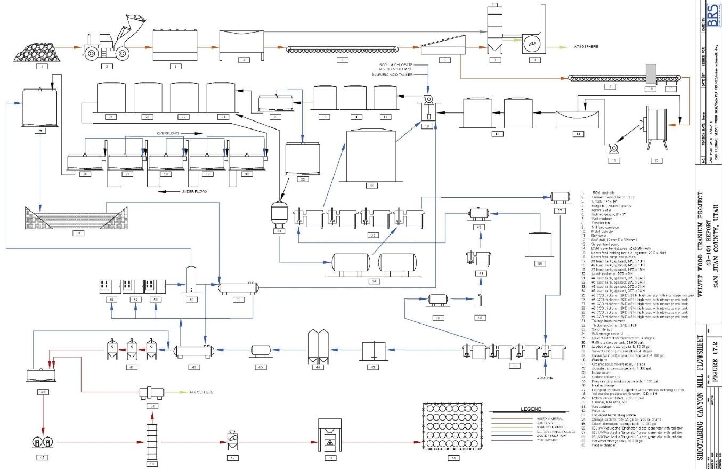

17.3 Vanadium Recovery Circuit
A facility for the recovery of vanadium is included in the mineral processing CAPEX and OPEX estimates herein. The depleted aqueous solution from uranium solvent extraction, the uranium raffinate, will serve as the feed for vanadium concentration. A sludge thickener will be used to enable settling and densification of particulate matter and the thickener underflow slurry will be discharged to the tailings facility. A solvent extraction (SX) circuit will concentrate the vanadium into a vanadium product liquor (VPL). The VPL will then flow to a conversion tank, anhydrous ammonia will be added, and steam will be used to indirectly heat the solution to above 180º F, promoting formation of dissolved ammonium metavanadate (“AMV”). The AMV cake will be dried in a fuel-fired rotary dryer, then treated in one of three ways, depending on market requirements:
- The AMV may be packaged and sold;
- It may be fed directly to a multiple-hearth calcining furnace (“deammoniator”), melted in a fusion furnace, tapped into a water-cooled casting wheel, and packaged as “black flake” containing a minimum of 98.0 %V₂O₅;
- It may be dissolved with dilute sulfuric acid in an “acidulation” tank, followed by addition of ammonium hydroxide to a neutralization tank, from which the liquor would flow through a water-cooled heat exchanger to a crystallizer. The slurry of re-crystallized AMV would be fed to a washing belt filter, thence to the deammoniator, fusion furnace, and casting wheel described above. This product could contain up to 99.9% V₂O₅ and would also be called “black flake”.
A simplified preliminary block flow diagram is presented below as Figure 17.2. Some elements of the flowsheet may change during detailed engineering when equipment alternatives will be considered in the interests of increased metallurgical efficiency, improved health and safety for personnel, and reduced costs.

Figure 17.2 - Vanadium Concentration Circuit, Page 1 of 2

Uranium Raffinate
Holding Tanks

pH/EMF Adjustment Tanks

Sludge Thickener
Tailings Facility
Flotation Column
Clarifier
Raffinate
Vanadium SX Feed Tank
Extraction Mixer/Settlers
Loaded
Solvent
Quiescent
O/A Disengager

Solvent
Recycle
Strip Feed Tank
Strip Mixer Settlers

Flotation Column for
O/A Disengagement

Vanadium Pregnant Liquor
Holding Tanks

Figure 17.3 - Vanadium Purification and Precipitation Circuit, Page 2 of 2
Vanadium Pregnant Liquor
Holding Tanks

Conversion Tank
Pressure Precoat Filter

Residue to
Tailings Facility
Crystallizer Feed Tank

Heat Exchanger
Cooling
Water

Crystallizers
Filter Feed Tank

Filtrate Evaporator

Washing Belt Filter
AMV Cake Bin

Rotary Dryer
Deammoniator

Fusion Furnace

Casting Wheel
Product Packaging

SHIPMENT
TO MARKET
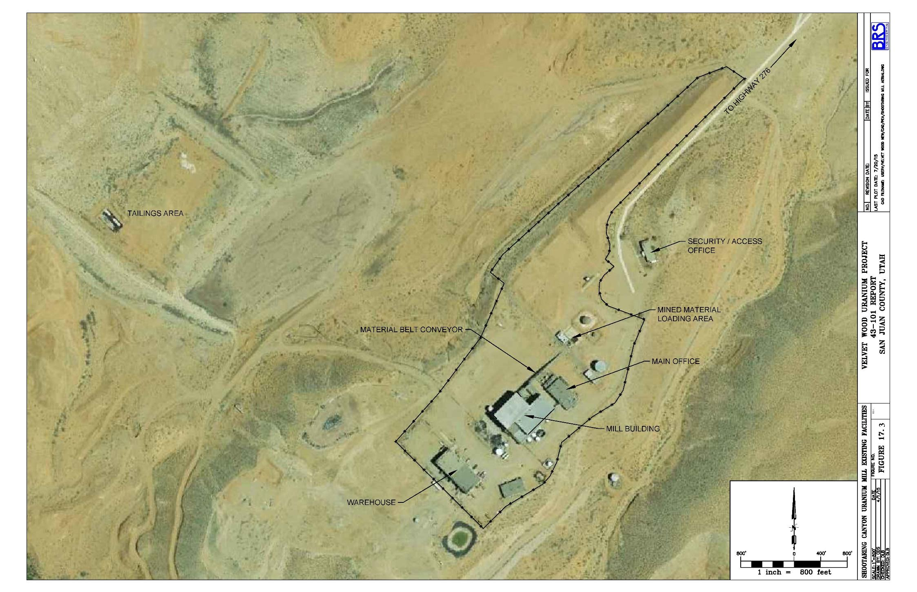
Figure 17.4 - Shootaring Canyon Property with Existing Facilities at Ticaboo, Utah

Section 18: Project Infrastructure

18.1 Existing Infrastructure
Existing conditions and infrastructure are shown on the following figures for the respective areas of the project.
- Figure 17.3 – Shootaring Canyon Mill
- Figure 18.1 – Velvet-Wood Mine
- Figure 16.3 – Slick Rock Mine

18.2 Access
The Shootaring Canyon Mill is located approximately 2 miles west of Utah Highway 276 and approximately 3 miles north of Ticaboo, Utah. By road, the distance is approximately 180 miles from the mill to the Velvet Mine area. Access to the mill is via paved highways with the exception of the 2-mile gravel road from the mill to Highway 276.
Portions of the Velvet deposit were previously mined and there is an existing access road and powerline to the portal location. The Velvet portal is accessible via existing roads beginning with the Big Indian Road, a paved road that exits U.S. Highway 191 about 19 miles north of Monticello, Utah or 34 miles south of Moab, Utah. The Big Indian Road extends eastward and loops into the Lisbon Road to serve properties in the Lisbon Valley area. A gravel road, San Juan County Road 112 (Williams Fork) exits the Big Indian Road about 5.5 miles east of its intersection with Highway 191. A private access road connects with County Road 112 about 6 miles southeast of its intersection with the Big Indian Road. The Velvet Mine portal is about one mile northeast along this road.
The Wood mine area is located about 3 miles east of Velvet along County Road 112 and is also accessible from the east via the Lisbon Valley Road and County Road 112. Access to the site is via existing dirt two-track roads.
The Slick Rock area is crossed by Colorado State Highway 141, a paved 2 lane highway providing major access to the site. From Highway 141, gravel county roads and existing dirt and two-track roads provide secondary access to the site.

18.3 Power and Utilities
No line power is available at the Shootaring Canyon Mill. When the mill was in operation, power was provided by diesel generators. On-site power generation will be necessary for the mill.
A power line terminates approximately 0.6 miles NNW of the old Velvet Mine portal pad, which is located in the SE ¼ of Section 3, T 31S, R25E, as shown in the Figure 18.1, Velvet-Wood Mine Surface Facilities Overview Map. All electricity for the mine and surface facilities will be provided by this power line.
For the Slick Rock area, gas pipelines crossing the project area are shown on the USGS base map. Electrical powerlines follow the major access roads, Figure 16.3. Slick Rock is an unincorporated locality. Residents have utility and phone service. Utility service was also once provided to the Burro and other mines in the area.

18.4 Water
Non-potable water is available from wells at the Velvet mine and Shootaring Canyon Mill sites for operations and fire suppression. Potable water will be supplied by commercial bottled water.
For the Slick Rock and Wood, detailed investigation of potential water sources has not been completed. As mineral processing will be accomplished offsite the only water demand will be for industrial and potable use at the mine site and as such the demand is modest. The preferred alternative for process water is to utilize water developed from the dewatering of the mine, estimated for cost purposes at 200 gpm, which in turn would reduce costs related to water treatment and discharge. This water may not be suitable as a potable water source for the office and dry facility. Potable water sources could be developed from local ground or surface water sources and/or hauled into the site.

18.4 Surface Mine Facilities
Surface mine facilities for Velvet-Wood (existing and planned) are described in Section 16 and are shown on Figure 16.1. Mine facilities located on the surface would include a mine office, warehouse, and workshop, change room and dry facility, a lined storage area for mined product, storage for explosives, and various appurtenances as summarized in Table 16.8. Utilities would include electrical power (existing at site), a water supply, and a wastewater disposal system. A septic system would be permitted and constructed for wastewater.
For the Slick Rock area, mine support facilities will consist of an office, mine shop and warehouse, and a dry facility. In consideration of the remote nature of the site and the potential for hazardous winter driving conditions, emergency stores of non-perishable food and water will be kept on-site along with portable cots should it be necessary for personnel to remain on-site during such conditions.

18.5 Shootaring Canyon Mill Facilities
The existing Shootaring Canyon Mill facilities include the main mill building, shop and warehouse, office and security buildings, a non-potable water system for processing and fire suppression, a septic system, and the entire facility is fenced. The existing facilities are discussed in Section 17 and are shown on Figure 17.3.

Figure 18.1 - Velvet-Wood Existing Infrastructure
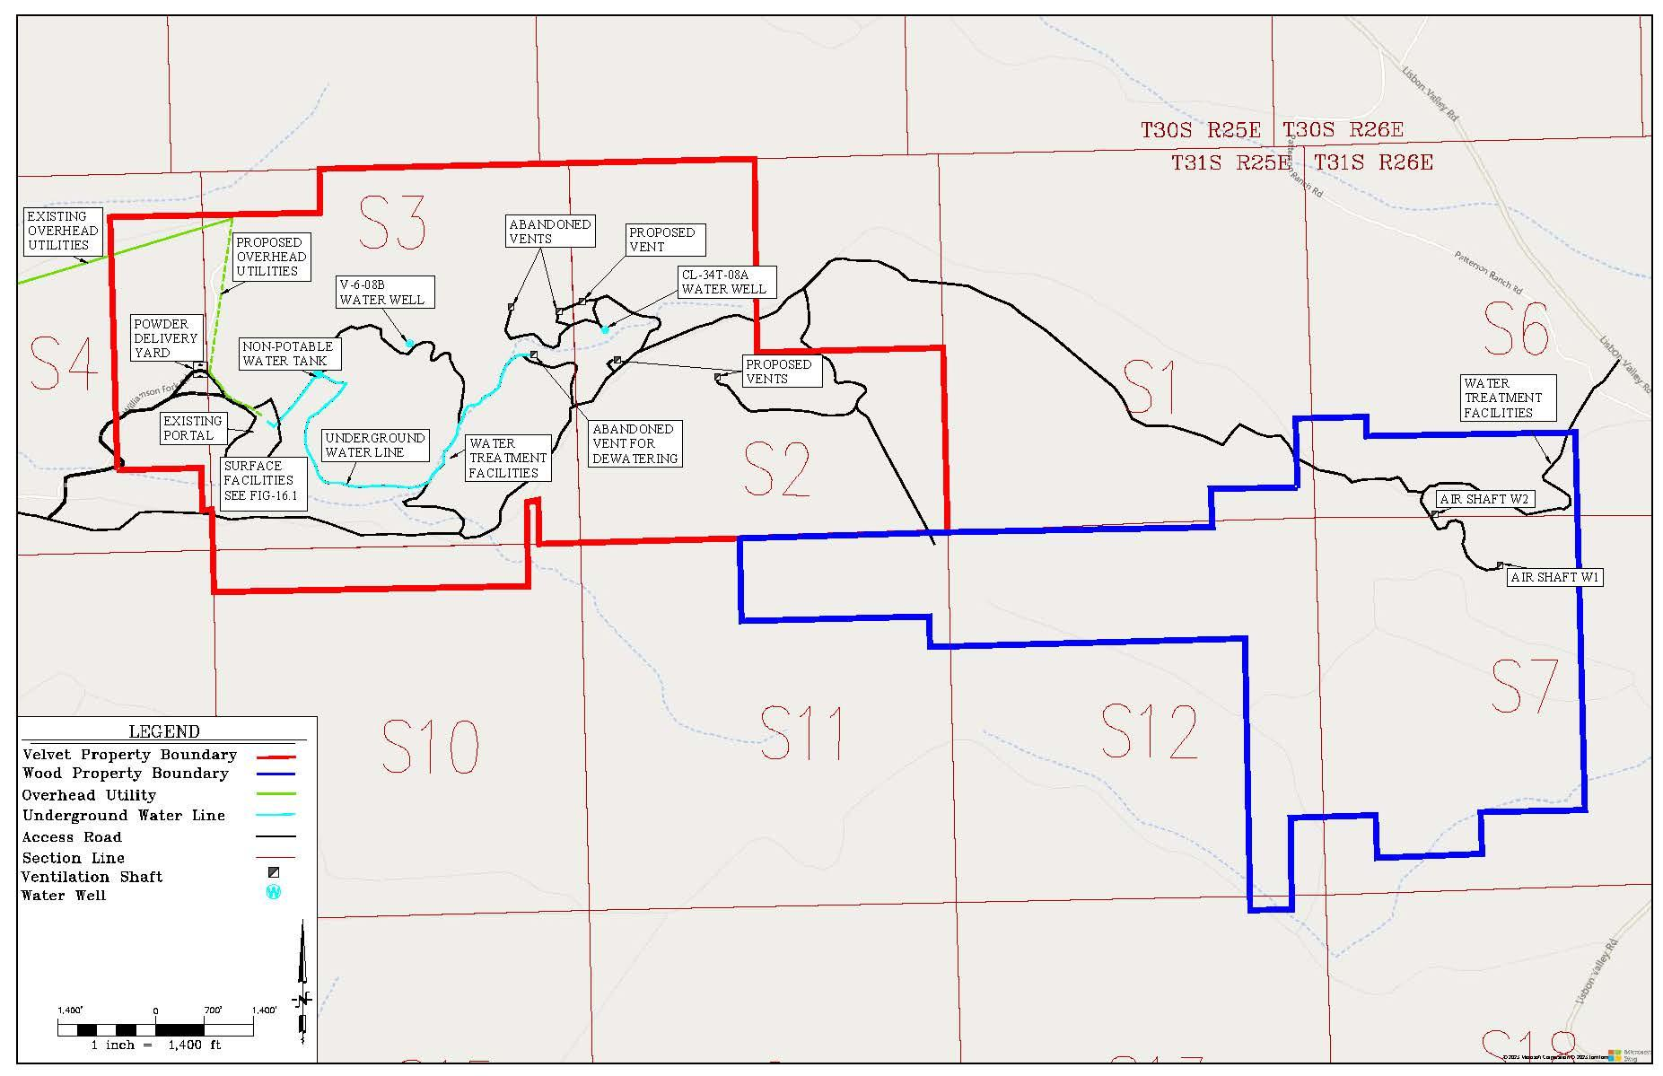

Section 19: Market Studies and Contracts

19.1 Uranium Price Forecast
Uranium does not trade on the open market, and many of the private sales contracts are not publicly disclosed since buyers and sellers negotiate contracts privately. Monthly long-term industry average uranium prices based on the month-end prices are published by Ux Consulting, LLC, and Trade Tech, LLC. Anfield has not begun any negotiations of any contracts to develop the property, including those associated with uranium sales, which is appropriate for a project at this level of development. The following table provides a Long-Term Uranium Price Forecasts from TradeTech LLC™ (“TradeTech™”) 2022: Issue 3. The Forward Availability Model (FAM 2) forecasts how future uranium supply enters the market assuming restricted project development because of an unsupportive economic environment. Currently most US producers are in a mode of care and maintenance and numerous facilities globally are also slowing or shutting in production at least on a temporary basis. This condition aligns with the FAM 2 projections.
Term forecasts beginning 2025 or later and extending into the future are considered the most reasonable for purposes of this report, as they consider the effects of prices on future existing and new production. In addition, larger projects are typically supported by long-term contracts with investment-grade nuclear utilities. Therefore, term prices are most appropriate for purposes of this report.
Figure 19.1 - TradeTech Uranium Market Price Projections- FAM2 (Nominal US$)
From TradeTech™ 2022
The Term price projections for uranium oxide (USD) from TradeTech™ 2022, for 2023, FAM 2, Term Ref, exceed $75/lb. Projections of uranium price through 2040 increase from these values. The author recommends, as a conservative measure, the use of a long-term uranium price of $70.00 USD per pound uranium oxide for the consideration of reasonable prospects of economic extraction (Beahm, 2023).

19.2 Vanadium Price Forecast
Vanadium prices are more transparent than uranium prices. Vanadium pentoxide price ranged from $6.70 to $16.40 per pound in a five-year period from 2017 through 2021. The lowest price occurred in 2020 during the Covid pandemic and the highest price preceding the pandemic in 2019 (U.S. Geological Survey, Mineral Commodity Summaries, January, 2022).
As recently as August 9, 2022, Energy Fuels Inc. announced their Q2-2022 results which states; “As a result of strengthening vanadium markets, during the six months ended June 30, 2022, the Company sold approximately 575,000 pounds of V₂O₅ at a gross weighted average price of $13.44 per pound of V₂O₅.”
Based on the foregoing, a price of $12.00 per pound for vanadium pentoxide is recommended as the base case for this PEA.
By their nature, all commodity price assumptions are forward-looking. No forward-looking statement can be guaranteed, and actual future results may vary materially.

Section 20: Environmental Studies, Permitting, and Social or Community Impact
A range of different permits and licenses would be needed for the mining and various mineral processing options considered in this report. Similarly, a variety of additional environmental studies would be required. Agencies with jurisdiction include;
- Utah Department of Environmental Quality (UDEQ) Division of Radiation Control (DRC), source material licensing.
- Utah Department of Environmental Quality (UDEQ) Divisions of Air Quality (DAQ), Water Quality (WQD, mill and mines.
- Utah Department of Natural Resources (UDNR) Division of Oil Gas and Mining (DOGM), Velvet-Wood Mine and drilling permits.
- Utah State Engineers Office (SEO) water rights.
- SEO and UDNR tailings dam permit and monitor well permits.
- Bureau of Land Management (BLM) Plan of Operations and Notice of Intent, mining and drilling.
- Colorado Mined Land Reclamation Board (CMLRB) Slick Rock Mine and drilling permits.
- Source Materials License*; Colorado Department of Public Health and Environment (CDPHE), only if uranium is recovered onsite including water treatment.
- Local county permits mine and mill depending on project specifics.
Major actions needed include;
- Reactivation of the mill
  - The existing Source Material License, UT0900480, issued by UDEQ/DRC, requires an amendment to convert from the current care and maintenance status to operational status.
  - Current investigations include a study by PSE which will provide substantial designs for the rehabilitation of the mill and provide basis amending the mill license. and a reclamation design for the mill tailings by Engineering Analytics. These studies are scheduled to be completed by June and the fall 2023, respectively.
  - The mill is being maintained along with all additional permits and licenses and required environmental monitoring programs.
- Velvet-Wood Mine
  - The existing Large Mine Permit, UTU68060, issued by DOGM and the Plan of Operations issued by BLM require an amendment to convert from current care and maintenance status of operational status and to include the Wood portion of the mine.
  - The existing ground water discharge permit, UGW170003, issued by UDEQ/WQD will require amendment. If uranium is recovered from the ground water this would require licensing action by UDEQ/DRC.
- Slick Rock Mine
  - A new Large Mine Permit and Plan of Operations is required issued by CMLRB and BLM, respectively.
  - If it were necessary to recover uranium onsite from ground water treatment in order to meet discharge permit requirements, a source materials license from CDPHE would be required.
- Permits common to all operations.
  - Air quality permits.
  - Water quality permits, storm water discharge (construction and operations).
  - Monitor well permits.
  - Water rights for consumptive use.
  - Federal Mine Safety for mine and mill under the Mine Safety and Health Administration (MSHA).

20.1 Regulatory Status
The Shootaring Canyon Mill is located on private land. The Shootaring Canyon Mill is an existing facility which was constructed in 1980 and operated sporadically until 1982. The mill license has been maintained but will require a major amendment for operations. The tailings dam is in place, however individual lined tailings disposal cells would need to be permitted and constructed within the overall containment facility.
The Shootaring Canyon Mill has a Radioactive Materials License (RML; UT0900480) that is administrated by the UDEQ-DWMRC. This license currently authorizes possession of byproduct material (tailings and other milling wastes) and reclamation activities only. On June 29, 2016, Anfield submitted a renewal of the Radioactive Materials License to the UDEQ/DWMRC and a revised application in September 2018. The UDEQ/ DWMRC completeness review of the application indicated that there were two deficiencies, one related to the Reclamation and Decommissioning Plan and one related to the need for a mill refurbishment plan demonstrating use of best available technology. Anfield has initiated commissioning of these additional work products and expects them to be completed and submitted to UDEQ/DWMRC in the third quarter of 2023.
The Velvet-Wood mines are located on BLM lands. The Velvet mine was operated and has an existing Permit to Mine (Large Mine Permit No. M/037/040). Moving forward the mine permit will need to include the Wood mine and updating of the Velvet mine plan under the existing Velvet Mine permit. This will require an updated BLM Plan of Operations (PoO), a new Reclamation Plan and a new reclamation surety basis of estimate and bond. However, the mine portal could be opened, underground workings inspected, and the underground mine workings rehabilitation initiated, and large scale, bulk sampling of the mineralized material could be performed under the permit. Discussions have been held with DOGM and BLM and additional NEPA studies for wildlife, vegetation, and archeology are being commissioned due to the age of the original base line studies. Velvet also has existing air quality and ground water and surface water discharge permits which will require updating and amendment. Wood will require air quality and ground water and surface water discharge permits either separately or as amendments to the Velvet mine permit.
The Slick Rock mine has no current permits. Commercial uranium mining at Slick Rock occurred from 1955 through 1983; however, mining has a longer history with radium mining reported from the early 1900s through 1923, and vanadium mining beginning in 1931.
The Slick Rock Project is situated entirely on federal land and minerals administered by the Bureau of Land Management (BLM). Permitting will require a Large Mine Permit and Plan of Operations from CMLRB and BLM, respectively. These permits will require complete NEPA studies. However, there are private land holdings, the DOE Legacy site, and DOE uranium reserves in the vicinity. It is important to note that the DOE Legacy site, which is the permanent repository of the former Slick Rock mill tailings, is within the project area. The Slick Rock tailings were relocated from their original site near the Dolores River to the Legacy site. This site was selected based on US NRC criteria for the long-term disposal and isolation of uranium mill tailings including the completion of an EIS. The site is also subject to ongoing monitoring. The environmental data and assessments from the legacy site are of public record and can be used for reference. A summary of the regulatory status and required permits follows in Table 20-1.

20.2 Social and Community Impact
The Shootaring Canyon Mill is isolated in the far eastern portion of Garfield County, Utah. There would be essentially no viewshed impacts to the community from the different processing options and, as described in Section 20.2.3, the net socioeconomic impacts would be positive through increased employment and tax revenue with minimal long-term adverse impact on local civil infrastructure, housing, and services. Despite expected local support there is a risk of opposition from various Non-Government Organizations (NGOs)
The Velvet-Wood and Slick Rock mines are brownfield sites within the Colorado Plateau which has a long history of uranium and vanadium mining. The surrounding communities have a long history of working with and for the region’s mining and mineral resource industry, and their support for this project has been strong. Despite expected local support, recent mineral development in the area has received opposition from various Non-Government Organizations (NGOs) and this should be anticipated for the Velvet-Wood and Slick Rock mines.
No potential social or community related requirements, negotiations, and/or agreements are known to the authors with respect to local communities and/or agencies. No outstanding environmental liabilities to Anfield are known to the authors.
According to the Fraser Institute Annual Survey of Mining companies, 2021, Utah ranks seventh of eighty-seven ranked jurisdictions with respect to the policy perception index. Within the US Utah ranks slightly behind Nevada in the policy perception index. Colorado is ranked thirty-third out of eighty-seven jurisdictions. The Policy Perception Index provides a comprehensive assessment of the attractiveness of mining policies in a jurisdiction and can serve as a report card to governments on how attractive their policies are from the point of view of an exploration manager (Fraser Institute, 2021).

Table 20.1 - Summary of Regulatory Status for Required Permits and Licenses
Permits/Licenses | Lead Agency/Cooperating Agency | Purpose | Status
Shootaring Canyon Mill
Radioactive Material License | UDEQ-DWMRC | License to possess and process uranium ores and associated wastes | In timely renewal, partial submittal, submittal completion in process
Bond | UDEQ-DWMRC | Reclamation Surety | In place for current facility reclamation, updated bond required for return to operational status
Dam Permit | UDNR-DWR/SEO | Tailings Impoundment Embankment permit | In place, updated submittal pending approval of Radioactive Materials License
Air Authorization Order (minor source) | UDEQ-AQD | Air quality | In process
Groundwater Discharge Permit | UDEQ-WQD | Groundwater protection from water treatment | In timely renewal, approval pending
State Well Permits | UDEQ-DWMRC/SEO | Permitting groundwater wells for mill process water supply and environmental monitoring | Water supply wells in place and permitted. New wells proposed for new tailings impoundment, permitting of new wells pending DWMRC approval of Groundwater Discharge Permit renewal application
Water Rights | UDEQ-DWMRC/SEO | Mill processing water supply | Transfer from previous owner in process.
Velvet-Wood Mine
Large Mine Permit | UDNR-DOGM/BLM | Mining permit | Existing, Update in Progress
UPDES Permit | UDNR-DOGM | Discharge of treated mine water | Approved in 2008, expired, renewal in progress
Groundwater Discharge Permit | UDNR-DOGM/UDEQ-WQD | Groundwater protection from water treatment | Approved in 2008, expired, renewal in progress
Air Authorization Order (minor source) | UDNR-DOGM/UDEQ-AQD | Air quality | Approved in 2008, expired, renewal in progress
County Septic System | San Juan County | Mine surface operations septic system | Pending application
Source Material License | UDEQ-DWMRC/UDNR-DOGM/BLM | Management or radioactive solid material generated from mine water treatment | Pending application
State Well Permits | UDNR-DOGM/SEO | Permitting groundwater wells for environmental monitoring | Complete
Water Rights | UDEQ-DWMRC/SEO | Mill processing water supply | Transfer from previous owner in process.
Slick Rock Mine
Large Mine Permit | CDRMS/BLM | Mining permit | Pending application
Stormwater Discharge Permit | CDHPE | Discharge of treated mine water | Pending application
Groundwater Discharge Permit | CDHPE | Groundwater protection from water treatment | Pending application
Air Permit (minor source) | CDHPE | Air quality | Pending application
County Septic System | San Miguel County | Mine Surface Ops Septic system | Pending application
Source Material License | CDHPE | Management or radioactive solid material generated from mine water treatment | Pending application
State Well Permits | CDWR | Permitting groundwater wells for environmental monitoring | Pending application
Water Rights | CDWR | Mill processing water supply | Transfer from previous owner in process.

Table 20.2 - Summary of Environmental Data and Studies
Environmental Data/Studies | Lead Agency/Cooperating Agency | Status
Shootaring Canyon Mill
Geology and Soil | UDEQ-DWMRC | Complete
Groundwater | UDEQ-DWMRC-WQD | Complete
Surface Water | UDEQ-DWMRC-WQD | Complete
Ecological Resources | UDEQ-DWMRC | Complete
Air Quality and Meteorology | UDEQ-DWMRC-AQD | Update in progress
Cultural Resources | UDEQ-DWMRC-SHPO | Complete
Velvet Wood Mine
Geology and Soil | DOGM/BLM | Complete/Historical Data
Groundwater | DOGM/BLM | Update study in progress
Surface Water | DOGM/BLM | Update study in progress
Ecological Resources | DOGM/BLM | Update study in progress
Air Quality and Meteorology | DOGM/BLM | Update study in progress
Cultural Resources | DOGM/BLM | Update study in progress
Slick Rock Mine
Geology and Soil | CDRMS /BLM | Complete/Historical Data
Groundwater | CDRMS /BLM | New study required
Surface Water | CDRMS /BLM | New study required
Ecological Resources | CDRMS /BLM | New study required
Air Quality and Meteorology | CDRMS /BLM | New study required
Cultural Resources | CDRMS /BLM | New study required

Section 21: Capital and Operating Costs
Project cost estimates are based on a conventional random room and pillar underground mine operation at the Velvet and Wood and Slick Rock mine areas. Mined material would be hauled by truck to the Shootaring Canyon Mill approximately 180 miles from Velvet and 200 miles from Slick Rock. The mill would be fully refurbished and would process mined material for both uranium and vanadium recovery.
All costs are estimated in constant 2022 US Dollars. Operating (OPEX) and Capital (CAPEX) costs reflect a full and complete operating cost going forward including all pre-production costs, permitting costs, mine costs, and complete reclamation and closure costs for of the mine and mineral processing facility. CAPEX does not include sunk costs or acquisition costs.
A current investigation and design study for the reactivation of the Shootaring Canyon Mill has been commissioned by Anfield who has engaged the firm of Precision System Engineering (PSE) of Salt Lake City, Utah for this study. The PSE study will provide substantial designs for the rehabilitation of the mill, will provide a basis updating the mill license, and will consider options for increasing the mill throughput. The initial study is scheduled to be completed by June 2023, while a report outlining advanced engineering and design is expected to be completed in fall 2023. Mine design and permitting for the Velvet Wood and Slick Rock mines are also ongoing. It is recommended that this PEA be revised following completion of these investigations and studies.
Mining and mineral recovery methods are described in Sections 16 and 17, respectively.
A summary of key assumptions follows:
- CAPEX Estimates
  - Underground Equipment based on InfoMine Mining Cost Service data and/or recent vendor quotes with 15% added contingency.
  - Pre-Production Expenditures based on InfoMine cost data and/or direct calculations with 25% contingency added.
  - Surface Facilities based on InfoMine cost data and/or recent vendor quotes with 25% added contingency.
  - Refurbishment of the Shootaring Canyon Mill to recover both uranium and vanadium, based on a current and updated evaluation of the Lyntek, 2008 study by the author Dr. Terry McNulty. The current mill CAPEX estimate includes a 15% contingency.
- OPEX Estimates
  - Underground Mine operating costs were based on continual operations of two 10 hour shifts per production day; productivity was based on 330 days per year or 90% utilization; cycle times were based on a 50-minute hour (83% reduction) to account for inefficiencies related to availability and utilization.
  - Salary and labor rates for mine workers were taken from Bureau of Labor Statistics data published by the states of Utah and Colorado, though 2021.
  - Transportation of mined product to the Shootaring Canyon Mill was based costs annual analyses published by the American Transportation Research Institute (ATRI) and the Energy Information Administration (EIA). No contingency was added but the higher of the range of cost per ton mile estimates was used.
  - Salaried and hourly personnel requirements for mineral processing were tabulated and fully burdened payrolls were derived from the annually updated InfoMine Mining Cost Service.
  - Consumptions of sulfuric acid and sodium chlorate were derived from test work performed for Uranium One by Hazen Research. Usages of other chemicals such as Alamine 336, isodecanol, and soda ash were based on industry averages. Prices for most chemicals were obtained from Ryan Johnson, Western Region Sales Manager for Univar in Salt Lake City. The prices include delivery from plant or distribution point to Ticaboo.
  - Estimates for maintenance and repair parts and supplies and for laboratory reagents and supplies were based on experience with similar projects.
Estimated Capital Expenditures (CAPEX) are summarized on Tables 21.1. CAPEX estimates include:
- Pre-production expenses related to engineering design, metallurgical testing, and permitting.
- Mine facilities and equipment.
- Direct processing plant refurbishing costs.
- Tailings related costs.
Estimated Operating Expenditures (OPEX) are summarized on Tables 21.2. OPEX estimates include:
- Direct mining costs.
- Haulage and handling costs related to the delivery of mined and stockpiled material to the Shootaring Canyon Mill.
- Direct mineral processing costs.
- Reclamation and bonding costs.
- Royalties and taxes.
Table 21.3 compares the OPEX and CAPEX cost per ton to the gross value of the recovered uranium and vanadium.
Table 21.1 - Capital Expenditure Summary
Capital Expenditures: $ x 1,000
 | Year -1 | Year 0 | Year 1
Permitting and Licensing Mill | $2,000 | $1,500
Permitting and Licensing Mines | $750 | $500
Mine CAPEX
(Velvet-Wood and Slick Rock)
Engineering and Design | $1,250 | $1,000
Mine Facilities | $2,500 | $2,500
Pre-Development | $2,600 | $2,600
Mine Equipment | $15,150 | $15,150
Shootaring Mill CAPEX
New Plant within facility |  | $31,400
Vanadium circuit |  | $13,400
Tailings |  | $20,000
Working Capital | One Time |  | $6,000
Replacement Mine Equipment @5% | Annual |  | $545
Replacement Plant Equipment | Annual |  | $460
TOTAL CAPITAL EXPENDITURES | $24,250 | $88,050 | $6,000
INITIAL CAPITAL (Years -1 and -2) |  | $112,300

Table 21.2 - Operating Expenditure Summary
Direct Mine Costs:
UG Mining Velvet-Wood | Per Ton Mined  Material + Waste | $ 63.00
UG Mining Slick Rock | Per Ton Mined  Material + Waste | $ 67.00
Handling Stockpile at Plant | Per Ton | $ 2.00
Weighted Average  Direct Mine Cost Per Ton: | Per Ton to Mill (Rounded) | $ 104.00
Haulage/Handling Costs |  | per ton
Velvet-Wood | 360 Miles @$2.30/mile | $ 20.70
Slick Rock | 400 Miles @ $2,30/mile | $ 23.00
Weighted Average  Haulage/Handling Costs: | Per Ton to Mill (Rounded) | $ 22.00
Mineral Processing Costs: |  | per ton
Includes Vanadium Circuit |  | $ 69.70
Weighted Average  Direct Processing Costs: | Per Ton Processed (Rounded) | $ 70.00
Other Direct Costs:
Reclamation Bond Mine (all mines) | $ 8,000.00
Reclamation Mine |  | $ 8,000.00
Reclamation Tailings/Plant |  | $ 15,000.00
Reclamation Mill/Tailings: Current Bond is $12.3 Million - Use $15 Million | $ 15,000.00 | $ 15,000.00
Annual Bond Cost (Mine/Plant)) | 2% annual rate | $ 340.00
Velvet Royalty (8% Utah, 1-2.5% private) | Use 5% average | 5%
Slick Rock Royalty 4% |  | 4%
Severance Tax | 2.25% | 2.60%
Shootaring Canyon Mill Property Tax | Use Mil Levy 0.01 | $ 115.00
Weighted Average  Other Direct Costs: |  | $ 50.00
Weighted Average  ALL Direct Operating Costs | Per Ton Processed | $ 244.00

Table 21.3 - OPEX and CAPEX Summary
Weighted Average  ALL Direct OPEX | Per Ton Processed | $ 244.00
CAPEX Cost Per Ton | Per Ton Processed | $ 46.00
Total Cost | Per Ton Processed | $ 290.00
Gross Value:  Uranium ($70/lb) and Vanadium ($12/lb) | Per Ton Processed | $ 741.00

Section 22: Economic Analysis

22.1 Summary
For the purposes of this PEA, the Shootaring Canyon Mill would be refurbished to its original 750 tons per day capacity and a vanadium recovery circuit would be added. The PEA considers simultaneous mine feed from the Velvet-Wood decline and two production shafts at Slick Rock. Given the selective nature of the mining and the geometry of the mineralization, three production centers are needed to meet the mill tonnage capacity. Referring to the cash flow model Table 22.4 at the end of this section, the currently defined mineral resource at Velvet-Wood would be mined out in 8 years while production from the two shafts at Slick Rock would continue for 15 years. Thus, additional mill tonnage capacity would be available beginning in year 9. Additional mill feed could be sourced as captive feed from other Anfield mineral resource holdings in the Colorado Plateau or from mineral resource holdings of others under toll milling agreements.
The financial evaluations that follow represent constant 2022 US dollars. All costs are forward looking and do not include any previous project expenditures or sunk costs. Operating costs include all direct taxes and royalties and are presented for both pre- and post-State of Utah and US Federal Income Taxes. Estimation of US corporate income tax is complex as income tax relates to the overall income and expenses of the reporting entity, not a specific project. This analysis reflects the taxes that would be due if the project was stand-alone and subject to State of Utah, State of Colorado, and U.S. income tax. Due to the favorable regular tax depletion deduction, most mining companies' effective tax rate is the Alternative Minimum Tax (AMT) rate. The AMT rate is 20%. The mill is located in Utah which has a 5% corporate state income tax. Note the corporate tax rate in Colorado is slightly less than Utah at 4.4%.
Table 22.1 summarizes the estimated internal rate of return (IRR) and net present value (NPV) for the base case at a commodity price of $70/pound uranium oxide, a commodity price of $12/pound for vanadium oxide, and a discount rate of 8%.
Table 22.1 - Base Case Economic Criterion ($ x 1,000)
Pre-Income Tax |  | Post-Income Tax
IRR 40% | NPV $238,398 | IRR 33% | NPV $196,768

22.2 Breakeven Commodity Price
The base case commodity price for uranium and vanadium are $70/lb and $12/lb, respectively. Reducing these commodity prices by 40% to $42/lb and $7.20/lb, respectively, results in a breakeven condition.

22.3 Sensitivity Analysis
Tables 22.2 summarizes the Net Present Value (NPV) and Internal Rate of Return (IRR) before and after income tax over a range commodity prices and discount rates.
Table 22.2 - Sensitivity to Commodity Price and Discount Rate
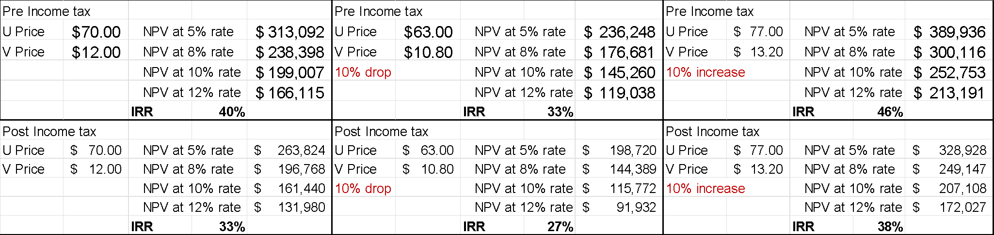

22.2 Sensitivity to Price
This project, like all similar projects, is quite sensitive to commodity prices as shown in Figure 22.1 and 22.2 for pre and post income tax NPV, respectively.
Figure 22.1 – NPV Price Pre-Tax Sensitivity Chart

Figure 22.2 – NPV Price Post-Tax Sensitivity Chart

22.3 Sensitivity to Other Factors
Table 22.3 summarizes the % change in IRR and NPV based on a 10% variance in the base case relative to process recovery, mine dilution, CAPEX, and OPEX.
The factors to which the project has the greatest sensitivity are mined grade and process recovery. The project is much less sensitive to changes in CAPEX and OPEX.
Table 22.3 - Sensitivity to Other Factors
10 Percent Change | Change in IRR
Recovery (U & V) | 7 Percent
Mine Dilution | 1 Percent
CAPEX | 3 Percent
OPEX | 3 Percent

22.4 Alternative CAPEX and Recovery
A current investigation and design study for the reactivation of the Shootaring Canyon Mill has been commissioned by Anfield who has engaged the firm of Precision System Engineering (PSE) of Salt Lake City, Utah for this study. The PSE study will provide substantial designs for the rehabilitation of the mill, will provide a basis updating the mill license, and will consider options for increasing the mill throughput. The initial study is scheduled to be completed by June 2023, while a report outlining advanced engineering and design is expected to be completed in fall 2023.
The current mill refurbishment study is evaluating cost and benefit of various options with respect to mill equipment. Preliminary indications are that there will be a benefit in more complete replacement of equipment resulting in higher CAPEX than the base case provided herein.
With these additions, it is the authors’ opinion, as expressed in Section 11, that is very likely that the Shootaring Canyon Mill will be able to achieve at least 96 percent U₃O₈ recovery, especially given the high average feed grades of 0.24 to 0.29% U₃O₈ and the high free acid concentration during leaching necessary for vanadium recovery. Also, the vanadium plant will have the advantage of state-of-art instrumentation and process control and may readily achieve 80% V₂O₅ recovery. For this alternative the internal rate of return would be essentially the same as the base case and the NPV, at an 8% discount rate, would increase approximately 8%.

22.5 Cash Flow Model
The case flow model for the base case is provided in Table 22.4 which follows.

Table 22.4 - Cash Flow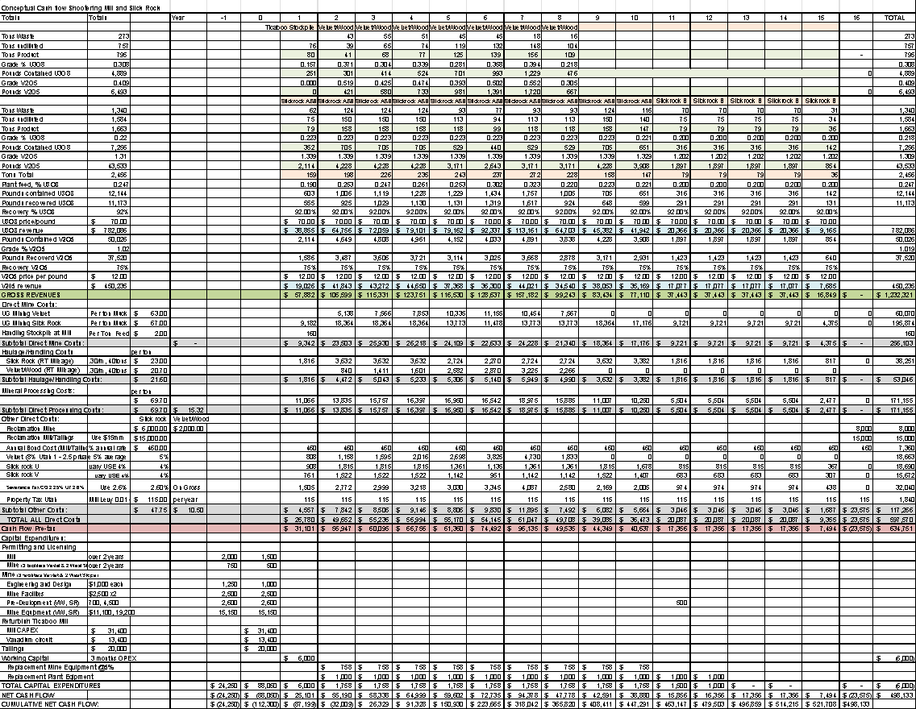

Section 23: Adjacent Properties
Significant mine developments within and near the Lisbon Valley in which neither the authors nor Anfield have any material interest include:
- The Energy Fuels White Mesa Uranium Mill located in Blanding, Utah approximately 40 miles from the Velvet-Wood Project.
- The Lisbon Valley Copper Mine and heap leach facility is located approximately 3 miles north of the Velvet-Wood Project.
- The Energy Fuels Tony M mine is located approximately 2 miles north of the Shootaring Canyon Mill.
Significant mine development and recovery of uranium and vanadium products has occurred in the Uravan Mineral Belt. The mining history dates from the early 1900s for vanadium and to the 1940s for uranium.

Section 24: Other Relevant Data and Information
The authors are not aware of any other relevant data or information that would materially change the overall conclusions of this report.

Section 25: Interpretations and Conclusions
This report summarizes mineral resources for the Velvet-Wood and Slick Rock mines with mineral processing at common facility, the Shootaring Canyon Mill. The total estimated uranium mineral resources are summarized in Table 14.1. The associated vanadium mineral resource which will be mined as a co-product are summarized in Table 14.2. In addition to these in situ mineral resources, Anfield controls mineralized stockpiles at the Shootaring Mill and in the Lisbon Valley near the Velvet-Wood mines, as described in Section 16.1.
This is a restricted disclosure as allowed under section 2.3(3) of NI 43-101 which includes a Preliminary Economic Assessment (PEA) and is preliminary in nature such that it includes a portion of the inferred mineral resources as reported in Section 14 of the report. Mineral resources are not mineral reserves and do not have demonstrated economic viability in accordance with CIM standards. Inferred mineral resources are too speculative to have the economic considerations applied to them that would enable them to be categorized as mineral reserves, and there is no certainty that the outcomes estimated in the PEA will be realized. Mineral reserves are not estimated herein.
The Velvet-Wood Project is located in the Lisbon Valley Uranium District which historically was the largest uranium producing area in Utah. Portions of the project have been mined successfully in the past by conventional underground methods. The current mineral resource estimate is based on development of the resource in a similar manner. Uranium mineralization is found in the Cutler Formation near the unconformable contact with the Mossback Formation.
The Slick Rock Project is located in San Miguel County, Southwest Colorado, approximately 23.9 miles north of the town of Dove Creek. Surficial to shallow uranium/vanadium mineralization has been known in the Slick Rock area since the early 1900s (then called the McIntyre district) and was successfully mined through the early 1980s using conventional underground methods. Uranium/vanadium mineralization is hosted by the Upper Jurassic Morrison Formation and is typical of Colorado Plateau-style uranium/vanadium deposits.
Both projects contain mineralization which are strata bound and tabular based on available data and descriptions of each deposit in the literature. Both deposits contain uranium and vanadium. Both uranium and vanadium were recovered as co-products during past production.

25.1 Economic Analysis
Project cost estimates are based on a conventional random room and pillar underground mine operation at the Velvet-Wood and Slick Rock mine areas. Mined material would be hauled by truck to the Shootaring Canyon Mill approximately 180 miles from Velvet and 200 miles from Slick Rock. The mill would be fully refurbished and would process mined material for both uranium and vanadium recovery.
For the purposes of this PEA, the Shootaring Canyon Mill would be refurbished to its original 750 tons per day capacity and a vanadium recovery circuit would be added. The PEA considers simultaneous mine feed from the Velvet-Wood decline and two production shafts at Slick Rock. Given the selective nature of the mining and the geometry of the mineralization, three production centers are needed to meet the mill tonnage capacity. The currently defined mineral resource at Velvet-Wood would be mined out in 8 years while production from the two shafts at Slick Rock would continue for 15 years. Thus, additional mill tonnage capacity would be available beginning in year 9. Additional mill feed could be sourced as captive feed from other Anfield mineral resource holdings or from mineral resource holdings of others under toll milling agreements.
The base case is based on commodity prices of $70 per pound for uranium oxide and $12 per pound for vanadium pentoxide with mill recoveries of 92% and 75%, respectively. The base case economic evaluation shows:
- Pre-tax IRR 40%
- Post-tax IRR 33%
- Pre-Tax NPV (8% discount rate) $238,398 $US x 1,000
- Post-Tax NPV (8% discount rate) $196,768 $US x 1,000
Breakeven with respect to commodity price occurs when the base case commodity prices are reduced by 40% to $42/lb and $7.20/lb, respectively.
A current investigation and design study for the reactivation of the Shootaring Canyon Mill has been commissioned by Anfield who has engaged the firm of Precision System Engineering (PSE) of Salt Lake City, Utah for this study. The current mill refurbishment study is evaluating cost and benefit of various options with respect to mill equipment. Preliminary indications are that there will be a benefit in more complete replacement of equipment resulting in higher CAPEX than the base case resulting in higher recoveries of uranium and vanadium. This alternative, as discussed in Section 22, shows the internal rate of return would be essentially the same and the NPV, at an 8% discount rate, would increase approximately 8%.

25.2 Summary of Risks
It is the authors’ opinion that the technical risks associated are low for the following reasons:
- Portions of deposit have been successfully mined in the past.
- Uranium has been successfully extracted from mined material via conventional milling.
- The Project has some of the required operating permits and facilities in place.
The Project does have some risks similar in nature to other mining projects in general and uranium mining projects specially, i.e., risks common to mining projects including:
- Future commodity demand and pricing.
- Environmental and political acceptance of the project.
- Variance in capital and operating costs.
- Mine and mineral processing recovery and dilution.
- Continuity of mineralization with respect to thickness and grade may vary.
- Mining claims are subject to the Mining Law of 1872. Changes in the mining law could affect the mineral tenure.
- There is a risk that underground conditions at the Velvet Mine and/or the Slick Rock Mine may limit access to mineral resources.
The authors are not aware of environmental, permitting, legal, title, taxation, socio-economic, marketing, political, or other relevant factors which would materially affect the mineral resource estimates, provided the conditions of all mineral leases and options, and relevant operating permits and licenses are met.
Permitting and Licensing Risks:
- The BLM could require updated baseline environmental studies and initiate the National Environmental Policy Act (NEPA) process if the updated mine plan deviates significantly from the scope of the currently approved but outdated plan. This could have substantial cost and schedule impacts, as discussed in Section 20.
- The Colorado Department of Health and/or Utah Department of Environmental Quality - Division of Waste Management and Radiation Control could require a Source Materials License if mine dewatering treatment wastes exceed the minimum quantities identified in 10 CFR §40.22 (more than 150 lbs of material with greater than 0.05% natural uranium), which would incur risks of additional costs and extended schedule.
There are risks associated with any such permitting actions which could affect project schedule and costs. The Velvet-Wood and Slick Rock mines are brownfield sites within the Colorado Plateau which has a long history of uranium and vanadium mining. The mill is an existing facility. The surrounding communities have a long history of working with and for the region’s mining and mineral resource industry, and their support for this project has been strong. Despite expected local support, recent mineral development in the area has received opposition from various Non-Government Organizations (NGOs) and this should be anticipated for the Velvet-Wood and Slick Rock mines.

Section 26: Recommendations
The following recommendations relate to potential improvement and/or advancement of the Project and fall within two categories; recommendations to potentially enhance the resource base and recommendations to advance the Project towards development. Both may be conducted contemporaneously.
All areas of Inferred Resource will require exploration to delineate the potential resource and upgrade the estimated quantities in those areas.

26.1 Phase 1
The Slick Rock project will require a Phase 1verification drilling program to confirm the existing database and upgrade the resource category. This would be followed by Phase 2 work, including delineation drilling, updating resource model, and preparation of a PEA update or PFS.
The Velvet mine does not require an initial phase of verification and would be included along with Slick Rock in Phase 2.
Based on the successful completion of the Phase 1 verification drilling program as shown in Table 26.1 below and a decision to move the Slick Rock Project forward to production, Phase 2 would be recommended as discussed in Section 26.2. Only the Phase 1 verification drilling program is recommended currently for the Slick Rock Project
Table 26.1 - Slick Rock Phase 1: Verification Drilling Cost Estimate
Item | Cost (USD)
Permitting and Reclamation | $20,000
20 Conventional Mud Holes (1,200ft average 24,000 ft total) | $450,000
Site Supervision Including Geological Services | $40,000
Geophysical Logging 20 Holes | $30,000
Road Maintenance | $10,000
Total Phase 1 Cost Estimate | $550,000

26.2 Phase 2
The Velvet Mine Area and resources are well delineated in the west and fairly well delineated in the east. The eastern portion of the Velvet mine resource will need to be drilled from the underground workings during any future development to classify resources into the Measured and/or Reserve categories ahead of mining extraction operations. The Wood resource area is less well delineated and will require additional surface and/or underground drilling to better define and quantify the resource prior to development.
The Phase 2 recommendations and cost estimates for the Velvet-Wood Project are provided in Table 26.2. The Phase 2 recommendations and cost estimates for the Slick Rock Project are provided in Table 26.3. The total Phase 2 cost is estimated at $4.5 million USD.
Table 26.2 - Velvet-Wood Exploration Drilling Cost Estimate
Item | Cost (USD)
Permitting and reclamation | $150,000
10 Air Rotary Collars for DDC Tails (1,200 ft average, 12,000 ft total) | $180,000
10 Diamond Core Tails (400 ft average, 4,000 ft total) | $400,000
20 Conventional Mud Holes (1,500 ft average 60,000 ft total) | $600,000
Site Supervision Including Geological Services | $200,000
Geophysical Logging 50 Holes (1,500 ft average) | $120,000
Assay of Core and Drill Chips (2,000 samples by ICP-MS) | $200,000
Resource Model Update, Reporting and Preparation of PFS | $300,000
Road Maintenance | $50,000
Total | $2,200,000

Table 26.3 - Slick Rock Phase 2: Exploration Drilling Cost Estimate
Item | Cost (USD)
Permitting and Reclamation | $150,000
10 Air Rotary Collars for DDC Tails (800 ft average, 8,000 ft total) | $120,000
10 Diamond Core Tails (200 ft average, 2,000 ft total) | $200,000
40 Conventional Mud Holes (900 ft average 36,000 ft total) | $720,000
Site Supervision Including Geological Services | $200,000
Geophysical Logging 50 Holes (850 ft average) | $120,000
Assay of Core and Drill Chips (2,000 samples by ICP-MS) | $200,000
Metallurgical Heap Leach Testing | $240,000
Resource Model Update, Reporting and Preparation of PFS | $300,000
Road Maintenance | $50,000
Total | $2,300,000

Section 27: References
Previous Reports:
Agapito Associates, Inc., “Ground Support Recommendations for the Velvet and Wood Mines”, P. 1-1 to 5-19, November 7, 2008.
Beahm, D.L., “VELVET-WOOD URANIUM PROJECT, TECHNICAL REPORT, MINERAL RESOURCES, AMENDED AND REESTAED, NATIONAL INSTRUMENT 43-101, SAN JUAN COUNTY, UTAH, USA", June 5, 2015. Available on SEDAR.
Behre Dolbear and Company (USA) Inc., 2007, Technical Report on Nine Properties Held by Cotter Corporation in Montrose and San Miguel Counties, Colorado, USA, 80p.
Crossland, D. J., Atlas Minerals, “Preliminary Property Evaluation of the Velvet – Section 2 Project”, January 1990. (Two Reports)
Energy Fuels Resources Preliminary Feasibility Study for the Sheep Mountain Uranium Project, Fremont County, Wyoming, USA, December 31, 2021
Hazen Research, Inc., “FEEDSTOCK AMENABILITY PROGRAM FOR SHOOTARING CANYON MILL FEASIBILITY”, P. 1-10, 42-84, July 11, 2008.
JS Redpath Corporation, “The Conceptual Mine Design for Section 2, Lisbon Valley Project, Utah”, July 1980.
MRC, “Section 2 Mine Plan”, January 1983.
NRC, 2003 Environmental Assessment for Plateau Resources Limited’s Shootaring Canyon Uranium Project Garfield County, Utah. September 2003.
Price, Michael J., “Updated Measure Geologic Reserves, Measured Mining Reserves and Indicated and Inferred Reserves, Velvet Mine, San Juan County, Utah, April 1987.
Publications Cited:
Beahm DL and McNulty, TP, “Velvet-Wood Mine Uranium Project, Preliminary Economic Assessment, National Instrument 43-101, Utah, USA, June 2016.
Beahm DL, “Technical Report Summary for the Alta Mesa Uranium Project, Brooks and Jim Hogg Counties, Texas USA” January 2023.
Bon, RL and Krahulec, KA, “2007 Summary of Mineral Activity in Utah”, Utah Geological Survey, 2007.
Botinelly, Theodore, and Weeks, A. D., “Mineralogic classification of uranium-vanadium deposits of the Colorado Plateau”: U.S. Geological Survey Bulletin 1074-A, P. 1-5, 1957.
Bush, A.L., Stager, H.K., 1954. "Appraisal of the Accuracy of U.S Geological Survey Ore Reserves Estimates for Uranium-Vanadium Deposits on the Colorado Plateau," U.S. Geological Survey Trace Elements Investigations Report 288.
Bush, A.L., Stager, H.K., 1956. "Accuracy of Ore-Reserve Estimates for Uranium-Vanadium Deposits on the Colorado Plateau" Geological Survey Bulletin 1030-D.
Carter, F.W., Jr., 1954, Geologic Map of the Bull Canyon Quadrangle, Colorado, USGS Geological Quadrangle Map 33, 1 plate, 1:24,000 scale.
Cohenour, R, “Uranium in Utah” Utah Geological and Mineral Survey, B-82, 1969
Campbell, John A. and Steel-Mallory, Brenda A., “Depositional Environments of the Uranium bearing Cutler Formations, Lisbon Valley”, Utah: U.S. Geological Survey Open-File Report 79-994, 1979.
Chenoweth, WL, “Lisbon Valley, Utah’s premier uranium area, a summary of exploration and ore production” Utah Geological and Mineral Survey, OFR-188, 1990.
Denis, John R., “The Location and Origin of Uranium Deposits in the Cutler”, December 1982.
Dodd, P. H., and Droullard, R. F., “Borehole logging methods for exploration and evaluation of uranium deposits”, U.S. Atomic Energy Commission, 1967.
Doelling, HH, “Uranium-Vanadium Occurrences of Utah”, Utah Geological and Mineral Survey, OFR-18, 1974.
Hasan, Mohammad, “Geology of Active Uranium Mines During 1982 in Parts of Paradox Basin, Southeastern, Utah”, Utah Geological and Mineral Survey, OFR-89, 1986.
McKay, A. D. et al, “Resource Estimates for In Situ Leach Uranium Projects and Reporting Under the JORC Code”, Bulletin November/December 2007.
Merritt, R. C., “The Extractive Metallurgy of Uranium”, prepared for the USAEC by the Colorado School of Mines Research Institute, 1971.
Roscoe Postle Associates, Technical Report on the Lisbon Valley Uranium Properties,
Shawe, D. R et. Al, 2011 “Uranium-Vanadium Deposits of the Slick Rock District, Colorado,” USGS Professional Paper 576-F, p. 19-20, 27.
Utah, Prepared for U.S. Energy corp., Report NI 43-101, dated September 14, 2005
Talbot, David, “Metals and Mining, Uranium Sector” Dundee Capital Markets, pp21-26, January 13, 2016
Tax Bulletin 12-93, State of Utah, July 1993.
U.S. Geological Survey, Mineral Commodity Summaries, January 2022
Weeks, A.D., 1956, Mineralogy and Oxidation of the Colorado Plateau Uranium Ores, US Geological Survey Paper 300, p. 187-193.
Weir, D.B., 1952, Geologic Guides to Prospecting for Carnotite Deposits on the Colorado Plateau, in U.S. Geological Survey Bulletin 988-B, P. 15-27.
Weir, Gordon W., and Puffett, Willard P., “Incomplete manuscript on stratigraphy and structural geology and uranium-vanadium and copper deposits of the Lisbon Valley area”, Utah-Colorado: Open-File Report 81-39, U.S. Geological Survey, 292p, 1981.
West, J., “Uranium Logging Techniques”, Cent
IRS, 2004, Publication 535, Business Expenses.

Section 28: Signature Page and Certification of Qualified Person
SIGNATURE PAGE AND CERTIFICATE OF QUALIFIED PERSON
DOUGLAS L. BEAHM
I, Douglas L. Beahm, P.E., P.G., do hereby certify that:
- I am the Principal Engineer and President of BRS, Inc., 1130 Major Avenue, Riverton, Wyoming 82501.
- I am the principal author of “The Shootaring Canyon Mill and Velvet-Wood and Slick Rock Mines, Preliminary Economic Assessment, National Instrument 43-101”, dated May 6, 2023 (the “Technical Report”).
- I graduated with a Bachelor of Science degree in Geological Engineering from the Colorado School of Mines in 1974. I am a licensed Professional Engineer in Wyoming, Colorado, Utah, and Oregon, a licensed Professional Geologist in Wyoming and a Registered Member of the Society for Mining, Metallurgy, and Exploration.
- I have worked as an engineer and a geologist for over 49 years. My work experience includes uranium exploration, mineral resource estimation, reserves estimation, mine production, and mine/mill decommissioning and reclamation. Specifically, I have worked as an exploration geologist, chief geologist, chief mine engineer and consultant with numerous uranium projects hosted in sandstone environments in the Western US.
- I have visited the site previously on many occasions during 2007 and 2008. I made recent site visits to Slick Rock on February 14, 2023, and the Shootaring Canyon mill on February 16, 2023. I attempted to visit Velvet-Wood on February 14, 2023 but winter conditions precluded access to the site.
- I am responsible for all sections of the report of the Technical Report.
- I am independent of the issuer in accordance with the application of Section 1.5 of NI 43-101. I have no financial interest in the property and am fully independent of Anfield. I hold no stock, options or have any other form of financial connection to Anfield, Anfield is but one of many clients for whom I consult.
- I do have prior work experience on the project for a previous owner during 2007 and 2008 as discussed in the Technical Report.
- I have read the definition of “qualified person” set out in National Instrument 43-101 and certify that by reason of my education, professional registration, and past relevant work experience, I fulfill the requirements to be a “qualified person” for the purposes of NI 43-101.
- I have read NI 43-101 and Form 43-101F1, and the Technical Report has been prepared in compliance with same.
- As of the date of this report, to the best of my knowledge, information and belief, the parts of the Technical Report for which I am responsible contain all scientific and technical information that is required to be disclosed to make the Technical Report not misleading.
May 6, 2023
“original signed and sealed”
/s/ Douglas L. Beahm
Douglas L. Beahm, SME Registered Member
SIGNATURE PAGE AND CERTIFICATE OF QUALIFIED PERSON
CARL DAVID WARREN
I, Carl David Warren, P.E., P.G., do hereby certify that:
- I am a Project Engineer for BRS Engineering, located in Riverton Wyoming, at 1130 Major Ave.
- I am a contributing author of “The Shootaring Canyon Mill and Velvet-Wood and Slick Rock Mines, Preliminary Economic Assessment, National Instrument 43-101”, dated May 6, 2023 (the “Technical Report”).
- I graduated with a Bachelor of Science in Geological Engineering from the Colorado School of Mines in 2009 and have a Master of Science Degree in Nuclear Engineering from the Colorado School of Mines in 2013. I am Licensed Professional Engineer in the State of Wyoming.
- I have worked as both an engineer and a geologist for a cumulative 14 years and have over 15 years of working experience in the mining industry. My relevant work experience includes underground mining, ore control, geological mapping, core logging and data management, uranium exploration, and uranium resource modelling.
- I last visited the site on April 12 and 13, 2023.
- I am independent of the issuer in accordance with the application of Section 1.5 of NI 43-101. I have no financial interest in the property and am fully independent of Anfield. I hold no stock, options or have any other form of financial connection to Anfield.
- I am responsible for portions of Section 14 and 15 and contributed to all portions of the Technical Report.
- I do not have prior working experience on the property.
- I have read the definition of “qualified person” set out in National Instrument 43-101 and certify that by reason of my education, professional registration, and past relevant work experience, I fulfill the requirements to be a “qualified person” for the purposes of NI 43-101.
- I have read NI 43-101 and Form 43-101F1, and the Technical Report has been prepared in compliance with same.
- As of the date of this report, to the best of my knowledge, information and belief, the parts of the Technical Report for which I am responsible contain all scientific and technical information that is required to be disclosed to make the Technical Report not misleading.
- I consent to the filing of the Technical Report and the Annual Information Form referencing the Technical Report with any stock exchange and/or other appropriate regulatory authority.
May 6, 2023
“original signed and sealed”
/s/ Carl David Warren
Carl David Warren, SME Registered Member
SIGNATURE PAGE AND CERTIFICATE OF QUALIFIED PERSON
HAROLD J. HUTSON
I, Harold J. Hutson, P.E., P.G., do hereby certify that:
- I am the Senior Engineer for BRS Engineering, located in Riverton Wyoming, at 1130 Major Ave.
- I am a contributing author of “The Shootaring Canyon Mill and Velvet-Wood and Slick Rock Mines, Preliminary Economic Assessment, National Instrument 43-101”, dated May 6, 2023 (the “Technical Report”).
- I graduated with a Bachelor of Science in Geological Engineering from the Colorado School of Mines in 1995. I am a Licensed Professional Engineer and Licensed Professional Geologist in the State of Wyoming.
- I have worked as both an engineer and a geologist for 28 years. My relevant work experience includes mine and mine land reclamation design, minerals exploration, and mineral resource modelling. My work in mineral commodities has included uranium, gold, mineral sands, rare earths, and coal.
- I last visited the site on April 12 and 13, 2023.
- I am independent of the issuer in accordance with the application of Section 1.5 of NI 43-101. I have no financial interest in the property and am fully independent of Anfield. I hold no stock, options or have any other form of financial connection to Anfield.
- I am responsible for peer review of the Technical Report.
- I do have previous work experience on the property including preparation of the mine reclamation plan and assistance in the preparation of the large mine permit for Uranium One.
- I have read the definition of “qualified person” set out in National Instrument 43-101 and certify that by reason of my education, professional registration, and past relevant work experience, I fulfill the requirements to be a “qualified person” for the purposes of NI 43-101.
- I have read NI 43-101 and Form 43-101F1, and the Technical Report has been prepared in compliance with same.
- As of the date of this report, to the best of my knowledge, information and belief, the parts of the Technical Report for which I am responsible contain all scientific and technical information that is required to be disclosed to make the Technical Report not misleading.
- I consent to the filing of the Technical Report and the Annual Information Form referencing the Technical Report with any stock exchange and/or other appropriate regulatory authority.
May 6, 2023
“original signed and sealed”
/s/ Harold J. Hutson
Harold J. Hutson, SME Registered Member

SIGNATURE PAGE AND CERTIFICATE OF QUALIFIED PERSON
Terrence P. (“Terry”) McNulty
I, Terrence P. (“Terry”) McNulty, D. Sc., P.E., do hereby certify that:
- I am the owner and President of T. P. McNulty and Associates, Inc., located at 4321 North Camino de Carrillo, Tucson, AZ, 85750-6375. My email address is tpmacon1@aol.com.
- I am a co-author of “The Shootaring Canyon Mill and Velvet-Wood and Slick Rock Mines, Preliminary Economic Assessment, National Instrument 43-101”, dated May 6, 2023 (the “Technical Report”).
- I obtained a Bachelor of Science degree in Chemical Engineering from Stanford University in 1961, a Master of Science degree in Metallurgical Engineering from Montana School of Mines in 1963, and a Doctor of Science degree from Colorado School of Mines in 1966. I am a Registered Professional Engineer in the State of Colorado (License # 24789) and a Registered Member (# 2,152,450RM) of the Society of Mining, Metallurgy, and Exploration, Inc.
- I have worked as a metallurgical engineer for a total of 62 years, including years worked between degrees. My recent experience for the purpose of the Study is as follows:
  - I have worked as a consultant on 35 uranium projects during the last 17 years and have contributed to NI 43-101 compliant studies for many of those.
  - I was Manager of Corporate R&D and Technical Services for a large, diversified mining firm, The Anaconda Company, which was a major uranium producer.
- I have visited the site previously (2007-2008) but did not make a current site visit, as disclosed in the report.
- I am responsible for Sections 13 and 17 of the Technical Report.
- I am independent of the issuer in accordance with the application of Section 1.5 of NI 43-101. I have no financial interest in the property and am fully independent of Anfield. I hold no stock, options, nor have any other form of financial connection to Anfield. Anfield is but one of many clients for whom I consult.
- I have prior work experience on the project, being involved with an engineering study completed by a former owner of the project during 2007 and 2008.
- I have read the definition of “qualified person” set out in National Instrument 43-101 and certify that, by reason of my education, professional registration, and past relevant work experience, I fulfill the requirements to be a “qualified person” for the purposes of NI 43-101.
- I have read NI 43-101 and Form 43-101F1, and the Technical Report has been prepared in compliance with same.
- As of the date of this report, to the best of my knowledge, available information, and belief, the parts of the Technical Report for which I am responsible contain all scientific and technical information that is required to be disclosed to make the Technical Report not misleading.

May 6, 2023

“original signed and sealed”
/s/ Terrence P. McNulty

Terrence P. McNulty, SME Registered Member

